HARDWARE MODELING AND SIMULATION Of Embedded ApplicationS

By

Aditya Agrawal

Thesis

Submitted to the Faculty of the

Graduate School of Vanderbilt University

in partial fulfillment of the requirements

for the degree of

MASTER OF SCIENCE

in

Electrical Engineering

May, 2002

Nashville, Tennessee

Approved: Date:
________________________________________________ ____________________
________________________________________________ ___________________

To my source of Inspiration,
My parents
ACKNOWLEDGEMENTS
This research was sponsored by the Defense Advanced Research Projects Agency (DARPA), Information Technology Office, Power Aware Computing and Communicating (PACC) program.
To start with I would like to thank Dr. Gabor Karsai my graduate advisor for channelizing my efforts and showing me how to do productive research. I am very grateful to Dr. Akos Ledeczi the co PI for MILAN for motivating me with challenging targets. His patience when I would be behind schedule and belief that I would finish before the deadline gave me courage and confidence. His constant support and guidance were instrumental in keeping me motivated without loosing sight of the goal.
Dr. James Davis, Dr. Sandeep Neema, Brandon Eames and Karthikeyan Nagarajan and the folks from USC all deserve my heartiest thanks for being there for me whenever I needed their help.
Last but definitely not the least I would like to thank mom and dad for believing in me all through the journey and encouraging me to push forward whenever I was tired. Without the training I have received from them I would never have reached where I am. The rest of my family, Jiten, Shilpa, Roma, Sandhir and Mona has played a vital role in my endeavor. They have supported, motivated and guided me at every crossroad of life helping me take the right decision and standing by my side through thick and thin. Finally I would like to thank my soul mate Pramila for being so understanding and supportive.

TABLE OF CONTENTS
Page
DEDICATION ii
ACKNOWLEDGEMENTS iii
TABLE OF CONTENTS iv
LIST OF TABLES vi
LIST OF FIGURES vii
LIST OF ABBREVIATIONS viii
Chapter
INTRODUCTION 3
Traditional Embedded System Development Cycle 4
Problems With The Traditional Approach 6
Modern Design Methodologies 7
Requirements For A New Design And Development Framework 9
Problem Statement 11
BACKGROUND AND LITERATURE SURVEY 13
Comparative Study Of Representational Models 13
Finite State Machines 13
Discrete-Event Systems 15
Petri Nets 15
Data Flow Graph 16
Results Of The Survey 18
Survey Of Embedded System Design Tools 19
Polis 19
COSYMA 21
Chinook 23
PTOLEMY 25
MILAN 27
Comparison 33
Different Hardware Description Languages 34
VHDL 34
Verilog HDL 35
SystemC 35
Summary 36
THE HARDWARE DESCRIPTION PARADIGM 38
The Requirements 38
The Basic Hardware Description Paradigm 39
Data Typing Of Ports And Memory 41
Parameterized Modules 43
Multiple Aspects 44
Software Description Paradigm 45
Composing Of Software And Hardware 45
Alternatives 46
Comparison With Other Hardware Description Languages 47
Summary 47
MODEL INTERPRETATION AND SIMULATION 49
Overview 49
Heterogeneous Interpreter 52
Input and Output 52
Separating Hardware And Software Components 55
Inserting Proxies 57
SystemC Code Generator 59
SystemC Document Object Model 59
Translation 61
CASE STUDY 63
The ATR Application 63
Evaluation Of The Case Study 69
CONCLUSIONS AND FUTURE WORK 71
Conclusions 71
Future Work 73
Appendix
A. Tutorial On Uml Class Diagrams 74
REFERENCES 76

LIST OF TABLES
Table Page
- Comparison of different models of computation 18
- Comparison of embedded system design tools 33
LIST OF FIGURES
Figure Page
- Development cycle of embedded system 5
- Design Flow of Polis [17] 20
- Design flow of Cosyma [20] 22
- The Chinook Co-synthesis System [22]. 24
- Design Methodology Management using Ptolemy [23] 26
- MILAN Architecture 30
- Basic hardware description paradigm 40
- Typing of ports and signals 42
- Parameter specification 43
- Composing of Software and hardware 45
- Block diagram of Interpretation 50
- Class diagram of the MILAN specific classes 53
- Class diagram of the hardware graph 54
- Class diagram of the shadow classes 55
- Algorithm for creating the hardware graph 56
- Three stages in the process of adding proxies. 58
- Class Diagram of CPP Dom and SystemC Dom 60
- ATR application block diagram 63
- do_peaks model of the ATR application 64
- Alternatives in ATR application 65
- Sub modules of the PerformCalculation module 66
- Two Aspects of Stage1Rows module 68
LIST OF ABBREVIATIONS

MILAN - Model-based sImuLAtioN integration framework.
FPGA – Field Programmable Gate Array.
ASIC - Application-Specific Integrated Circuit.
FSM - Finite State Machine.
CFSM - Codesign Finite State Machine.
HPN - Hierarchical Petri Nets.
SDF - Synchronous Data Flow.
ADF - Asynchronous Data Flow.
StDF - Structural Data Flow.
COSYMA - COSYnthesis of eMbedded Architectures.
ESG - Extended Syntax Graph.
DFG - Data Flow Graph.
MIC - Model Integrated Computing.
GME - Generic Modeling Environment.
OCL - Object Constraint Language.
VHDL – Very High Scale Integrated Circuit Hardware Description Language.
COM - Component Object Model.
API - Application Programming Interface.
BON - Builder Object Network.
RMI - Remote Method Invocation.
DOM - Document Object Model.
SCG - SystemC Code Generator.
XML - eXtensible Markup Language.
ATR - Automatic Target Recognition.
PSR - Peak to Surface Ratio.
CHAPTER I
INTRODUCTION
Embedded systems or applications are computer-based systems that interact directly and dynamically with their environment. These interactions are often facilitated through sensors to discern the state of the environment, and actuators to change or update the environment. Primary application areas for such embedded systems are:
- Signal processing: software radio, missile guidance systems.
- Automotive: engine controllers, anti-lock brake controllers.
- Telecommunications: telephone switches, cellular phones.
- Consumer Electronics: microwave ovens, camera, compact disk players.
The scale of integration of electronic circuits keeps increasing exponentially [42]. Configurable FPGAs and fast ASICs are pushing embedded applications to be implemented in hardware [1]. Due to increasing complexity of embedded applications, and the requirement for shortening the development cycle and increasing variety of design choices, the need arises for innovative approaches and greater tool support for development of such systems. Separation of various design concerns is essential for representing and exploring alternative solutions [1]. Simulation in hardware application development plays an integral role in eliminating unsuccessful design alternatives. Simulation provides a means to develop, test, and evaluate designs prior to committing to implementation, allowing design flaws to be detected and corrected early in the design process [2]. Integration of design, simulation and testing tools is required for speeding up the development cycle and to better explore alternative solutions.
Traditional Embedded System Development Cycle
As shown in Figure 1, the development of embedded systems starts with the marketing department studying the market to determine the requirements of a new product. In the next stage, the requirements need to be analyzed for feasibility. Architects will then convert the requirements into an architecture of the product. The architecture is broken down into manageable components and these components are partitioned into hardware and software implementations. Partitioning is the process of deciding weather a particular component should be implemented in software or on hardware. With context to this paper hardware implementation refers to implementation of applications on Field Programmable Gate Arrays (FPGAs) and Application Specific Integrated Circuits (ASICs). The interfaces of such a partition need to be designed and sent to the individual hardware and software groups. The technologies and components required to support the system design will be selected and acquired. The hardware and software design teams will individually design their subsystems. Testing is the next stage and test cases need to be developed. Hardware and software components need to be integrated and integration testing needs to be performed. The last stage is system wide testing and verification with respect to system requirements [3].
The design stage for hardware and software applications is now explained in greater detail. This process starts from the high level architecture of the product and ends at a low-level implementation of the system. The first stage consists of creating the architecture and high-level design to understand the system better. This is normally in the form of a block diagram and is used to break down the system into manageable parts. A high-level functional prototype, based on the high-level design is used to verify the functional correctness of the system. This stage is similar for both hardware and software components. For software, scripting languages like MATLAB [4] are used to create prototypes for the desired functionality while for hardware, high-level description languages such as SystemC [5] are used. These functional units are then simulated for testing functional correctness.
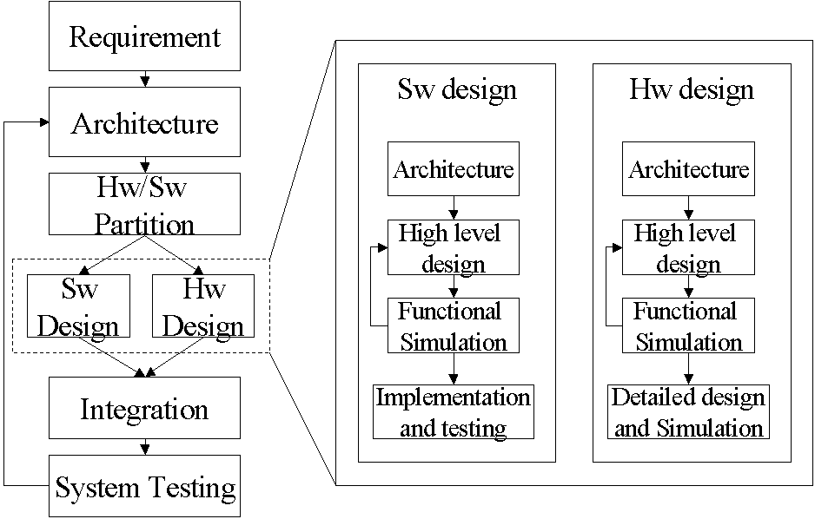
Figure 1. Development cycle of embedded system
After verifying the functional correctness, the next stage is to refine the design and develop an efficient low-level implementation that meets the performance constraints such as timing, power, memory and size. The low level implementation for software is typically specified in languages such as C, C++ or assembly code, while for hardware, description languages such as VHDL, Verilog or SystemC are used. At this stage there is a stark difference between the software and hardware components. In software, the implementation can directly be tested, while for hardware, simulation is used. Simulation is an integral part of hardware testing, as fabricating different implementations is infeasible and time consuming. Using simulation, the design is refined to meet requirements and only when the results are satisfactory, the system is implemented on real hardware. Thus we see a great need and value for reliable simulation of hardware applications. After the individual sub systems are developed and implemented, integration is performed and integration testing is done. Finally, the complete system is ready for system wide testing and verification with respect to overall system requirements.
Problems With The Traditional Approach
The traditional approach has been around for a while and is still in practice. However, this approach is rigid and doesn’t offer the desired flexibility required for application development. To start with, the partitioning of hardware and software is done early in the design cycle, committing the system to a particular partition. Required design changes are rarely made because changes usually need to alter the partition and this requires a lot of re-engineering, making it a time consuming and expensive. Thus, engineers try to adapt the sub systems so that the partition is maintained. This causes sub optimal systems to be built and may also result in incorrect design. Furthermore, the architecture, high-level design and low-level implementations are represented in different tools and more often than not there is no method of communication between these tools. This requires the migration of design and idea by hand, opening the doors for human error.
A single architecture is developed, giving rise to a single high-level design and finally a single low-level implementation. This process leaves no room for error. If the system fails to meet the requirements the complete effort is wasted and designers needs to go back to the drawing board. Even small changes are done in an iterative manner by going back and updating the architecture or the high-level design, and propagating the changes down to the implementation. The systems built are rigid and even minor changes in requirements may cause considerable re-engineering because the intention of the system designer is lost in the implementation. To address these problems new methodologies have been proposed and will be discussed.
Modern Design Methodologies
In lieu of the drawbacks of the traditional development cycle many new ideas have been proposed to improve the quality and efficiency of embedded system design and development. An essential requirement of a system design paradigm is the orthogonalizations of concerns, that is, to separate various aspects of design in order to effectively explore alternative solutions [6]. For example, system requirements and implementation, or computation and communication, are good candidate concerns that should be separated.
Separation of system requirements and implementation is desirable. Requirements capture the intention of the system, in other words they describe ‘what’ the system is supposed to do. On the other hand, implementation achieves the intention by specifying ‘how’ the system should behave. Furthermore, requirements are at a higher level of granularity and provide the bigger picture while the implementation specifies the low-level details of a solution. By separating the intention and the implementation, the high level abstraction is preserved, allowing the user to specify alternate implementations for the same intent. These alternatives may be in the form of different algorithms to solve the same problem, a choice between hardware and software implementations, or a selection of programming languages. Furthermore, implementation is a refinement of the intent and needs to be captured at different levels of granularity. Initially a coarse grain implementation is used for prototyping. This can be transformed in stages to a detailed low-level implementation.
By capturing alternative implementations at different levels of granularity we gain the flexibility of choosing the implementation according to the exact constraints and /or requirements of the system. For example, a system may have a power consumption constraint, performance requirement and/or space restrictions. The development cycle starts from a coarse grain implementation. This is tested for functional correctness and is then refined to alternative implementations. The feasibility of these alternatives is explored by profiling them. This is followed by simulation of a few feasible system wide implementations, to validate the system with respect to the requirements. Simulation becomes more important as testing of these applications on actual hardware is expensive and time consuming, especially for applications implemented in hardware such as Field Programmable Gate Arrays (FPGA) or Application-Specific Integrated Circuits (ASIC).
Furthermore, it is desired to design the application based upon an abstract computational model (e.g. data flow and state machine), which is at a level of abstraction higher than the target hardware (processors, FPGAs and ASICs). This helps to simulate and validate the application before partitioning it into hardware and software. Moreover, the partitioning can then be done using algorithms that are based on simulation results as opposed to intuition and experience. This helps to explore a greater spectrum of solutions and develop better applications. These principles are part of hardware software codesign philosophies that have gained favor in recent times [59].
Another approach to design and development of embedded applications is called platform-based design. This approach advocates the design of applications based on either a specific platform or a family of applications. For example, development for a personal computer is based on the i386 architecture. Thus, i386 is the common abstraction characterized by a set of constraints on the architecture of the product. The advantages of this approach are that development of product families can be easily supported and development and manufacturing tools can be developed for the platform and hence, cost is reduced. For more complex designs platform stacks can also be used, where there is a clear mapping from one layer to a lower layer [60].
These philosophies are being accepted in today’s world and are being incorporated into the design cycle of embedded systems. However, there is a compelling need to have an integrated design and development environment that incorporates the best of these methodologies and the different stages of design and development into one framework.
Requirements For A New Design And Development Framework
Based on the description of the state of design and development in the field of embedded systems, the primary objective is to devise a new method to design and develop such applications. The new method should incorporate the good qualities of the traditional approach and also include modern design philosophies.
At the beginning of the design cycle, while creating the architecture of a new system, it is required that alternative architectures and solutions be captured. These alternative solutions need to be carried on till the low-level implementation where design choices can be made based on results obtained from simulation. Furthermore, partitioning choices can be made much later in the development cycle, allowing for better exploration of alternative solutions. Separation of concerns [1] is another key point of a new design paradigm as the architecture and the implementation of the system should both be maintained till the very end of the development cycle. This enables better maintenance of the system as well as facilitates change. Modularization of design is an important concept of the traditional approach and needs to be a part of the new paradigm as well. The system description should start from a high-level block description and finally be refined to a low-level modular implementation.
Moreover, there is a need for a framework to incorporate these design and development ideas, and to provide a common platform to facilitate the use of the above mentioned design philosophies. The tool needs to provide a common representation of the system, starting from the architecture of the system till the low-level implementation. It should capture alternative solutions to facilitate modular design. The tool is also required to capture the system design in an abstract form realizable in various implementation languages, and to support various forms of simulation. The tool needs to support different kinds of simulations required at different stages of the design and development. It should support high-level functional simulation to validate the functional correctness and feasibility of the system at the high-level design stage. Simulation of individual modules is required for component testing and needs to be supported. During integration of hardware and software, there is a need for simulating the hardware in a heterogeneous environment. A heterogeneous environment is one where a system consists of both hardware and software components interacting with each other. Finally, the tool should support extensive system simulation for performance for the final stage of development.
The Model-based Integrated simuLAtioN framework (MILAN) [27] is a suite of tools developed to integrate the following design and development needs:
- Single design representation to use in different simulations and software synthesis,
- Separation of implementation from intention and computation from communication.
- Capture different levels of hierarchy for refinement.
- Synthesize code to drive various simulation methodologies: isolated simulation, multi-granular simulation, full system simulation,
- Speed up the design and development cycle for rapid application development.
Problem Statement
The aim of this thesis is to develop a complete hardware modeling and simulation toolset within the framework if MILAN. The first step comprises developing a modeling environment for applications implemented in hardware. The next step is to integrate the hardware environment with the existing software environments to create a heterogeneous environment for the design of embedded application. The integrated environment should allow the users to specify modular system design with alternative implementations. At the lowest level, designers will provide SystemC or VHDL implementations for the hardware modules.
The tools should have the capability to interpret the system models and generate code for various simulations that verify functionality and performance. The kinds of simulation that need to be supported are isolated simulation of components, multi-granular simulation of the system, complete system simulation and simulation of hardware in heterogeneous hardware/software systems.
This task begins in Chapter II with a survey of different relevant models of computations (MOCs) and other embedded system design tools. The chapter also discusses the MILAN framework in greater details. In Chapter III, the modeling paradigm for hardware along with its integration with MILAN is discussed. This is followed by the interpretation of the models to drive various simulations in Chapter IV. A case study is presented to validate the tools and design philosophies in Chapter V and the conclusions are drawn in Chapter VI.

CHAPTER II
BACKGROUND AND LITERATURE SURVEY
Comparative Study Of Representational Models
In hardware/software co-design of embedded system applications modeling is the first step. However, the model of computation (MOC) to use to represent the application is not an easy choice. By definition MOC is a formal, abstract definition of a computer and it helps to better represent and analyze applications built using it without dealing with many implementation issues [41] [50]. The MOC chosen should be able to capture the features of the system and describe its functionality in an intuitive manner. Furthermore, it should be formal or well established to allow systematic synthesis of a design from specification to implementation [7]. Thus it is important to come up with the right representation model for such applications.
Finite State Machines
Finite State Machine (FSM) is a well-established representation. It can be defined as a model of computation consisting of a set of states, a start state, an input alphabet, and a transition function, which maps input symbols and current states to a next state. This representation is useful in describing applications that are tightly coupled with the environment. It is also suited for control-dominated and reactive applications. However, concurrency is not easily captured and results in the exponential growth in the number of states with linear increase in degree of concurrency. This problem is also known as the state space explosion problem. Furthermore, small changes to the requirements may result in large changes to the corresponding FSM. In order to overcome various weaknesses of the classical FSM a number of extensions such as hierarchy and concurrency have been developed. A few such variants are discussed in brief [7].
SOLAR [8], a design representation for high-level control flow dominated systems is an extension of FSM. Concurrency is achieved by capturing parallel components of the system as separate FSMs that communicate with each. The communication between FSMs is either with the help of ports that are wired together or with the help of communication channels that implement a protocol. Each component can either be a FSM or be composed of smaller FSMs. Thus the model allows hierarchical decomposition of the system.
Codesign Finite State Machine (CFSM) is another model based on the FSM. It is intended to describe embedded applications with low algorithmic complexity. Both hardware and software can be depicted using this model of computation. It can be used to partition and implement applications. The basic communication primitive is an event and the behavior of the system is defined as a sequence of events. The events are broadcast and have zero propagation time. This model of computation is used as an intermediate representation that high-level languages can map to [7][9].
Statecharts by Harel [10] is another extension of FSMs that provides three major facilities, namely hierarchy, concurrency and communication. Statecharts are high-level Finite State Machines having AND and OR states. The AND states primarily achieve concurrency while the OR states are for representing hierarchy. Communication is based on events that are broadcasted instantaneously. This representation is well suited for large and complex reactive systems.
Discrete-Event Systems
“Discrete-Event System is a timed system where for each tuple s of signals that satisfies the system, there is an order-preserving bijection from (a) the integers (for a two-sided DE system) or (b) the natural numbers (for a one sided DE system) to T(s), where T(s) is the set of tags in s.”
Edward. A. Lee [58]
In other words, systems having discrete states and driven by events over a period of time are referred to as Discrete-Event Systems [11]. These systems are asynchronous in nature and react to discrete events over time. An event is considered instantaneous, that is, the transition and action due to the event occur with no execution time.
Signals form the primary method of communication between tasks. They consist of a set of events over time. The events are time stamped and are sorted and processed in chronological order. Discrete-Event Systems are backed with formal mathematical description [12] that allows modelers to do formal verification and build deterministic systems. Though these systems are good for real time applications the primary disadvantage is the computational cost of sorting the events globally to maintain the chronology.
Petri Nets
Petri-Nets [13] is a graphical representation introduced by Carl Adam Petri. With mathematical formalisms and abstraction, Petri Net is a powerful tool that can be used to represent many diverse applications ranging from data-dominated to control-dominated application. Semantics can be added to the models according to the domain of interest, such as communication protocols, distributed software, compilers and operating systems. A Petri-Net is described as a 5-tuple, PN={P, T, F, W, Mo} where:
P = {p1, p2, p3, …. ,pm } is a finite set of places
T = {t1, t2, t3, …….,tm } is a finite set of transitions
F is a subset of (P x T) U (T x P) is a set of arcs giving flow relations
W: F -> {1, 2, 3, … } is the weight function
Mo: P -> {0, 1, 2, ….} is the initial marking
The places hold tokens and a transition can occur if the number of tokens required for the transition is present in the place. A transition removes a specific number of tokens from its source and adds tokens to the destination. A snapshot of places with the number of tokens describes the state of the system.
The primary feature of Petri Nets is its concurrent and asynchronous nature. Along with concurrency and asynchronicity, there are a number of mathematical analyses that can be performed on Petri Nets. The lack of hierarchy makes Petri Nets difficult to be used for large systems.
Hierarchical Petri Nets (HPNs) [14] have been developed to mitigate the complexity of a flat representation. HPNs are modeled by bipartite directed graphs with inscription on the nodes and edges. There are two types of nodes, transitional nodes that represent activity and places that represent data or the state of the system [7]. This approach extends the Petri Net semantics with hierarchy making it suitable for large and complex systems.
Data Flow Graph
The classical programming structure of computer-based systems is control dominated. An alternative approach is data-dominated where the control flow is determined by availability of data. These systems have nodes describing computation and edges between nodes denoting a data path. Here the control is based on the availability of data. In other words the scheduling of the computation is tied to the availability of data. If a node has sufficient data available on its incoming edges then it is ready to fire and will use the input data to generate output data. Transfer of data between computational modules is typically done with the help of buffers. This allows the tasks to run independently.
Various flavors of data flow are seen in literature. The two popular and distinct ones are Synchronous Data Flow (SDF) and Asynchronous Data Flow (ADF). In SDF the number of token produced and consumed is fixed and needs to be known at the system design stage. This requirement allows SDF to be statically scheduled [15] and optimized for minimum buffer requirement. ADF is defined as a data flow graph with unbounded buffers and the computations can produce and consume variable number of tokens. Since the consumption and production of tokens can change at runtime ADF cannot be scheduled statically and hence, it has a greater run-time cost. However, it can represent a vast majority of systems and is more flexible that SDF. Similarly, in hardware, structural description is widely used. The structural layout of hardware is data driven and on a closer look it is very similar to an unbuffered asynchronous data flow. Thus, for hardware description I introduce a new dataflow semantics called Structural Data Flow (StDF). It is defined is a variant of ADF with the buffer length being zero. In other words there is no buffering of data.
Furthermore, many extensions have also been proposed to augment the data flow representation with hierarchy, strong data typing of tokens and parameterized nodes. The primary feature of data flow is its inherent parallelism and intuitive design for data-dominated systems.
Table 1. Comparison of different models of computation [7]
 | Main Application | Clock Mechanism | Communication Method | Hierar-chy | Non-Determinism
SOLAR  [8] | Control oriented | Synchronous | Remote procedure call | Yes | No
CFSM  [9] | Control oriented [9] | Asynchronous | Even broadcast | Yes | Yes
Statecharts  [10] | Reactive | Synchronous | Instant broadcast | Yes | Yes
Discrete-Event  [12] | Real-time | Synchronous | Wired signals | No | No
HPNs  [14] | Distributed | Asynchronous | N. A. | Yes | Yes
SDF  [15] | Signal processing | Asynchronous | Unbounded FIFO | Yes | No
ADF | Data oriented | Asynchronous | Bounded FIFO | Yes | No
StDF | Hardware layout | Synchronous | Direct wires | Yes | No
Results Of The Survey
Most of the models of computation discussed are suitable for either data-dominated or control-dominated systems. SDF and ADF are good for the signal-processing domain while StDF is well suited for describing the structural layout of hardware. Similarly FSM is useful in representing control-dominated systems. There is no single model well suited for both control and data requirements. Thus, depending upon the target application area, the model of computation needs to be chosen. Composing different models of computation is also worth considering [43] [51].
Survey Of Embedded System Design Tools
This section reviews the existing research and tools for co-design of embedded systems and contrasts their methodologies.
Polis
Polis is a framework, for hardware/software co-design of reactive embedded systems, developed at University Of California at Berkeley. The Polis system uses CFSM representation as its model of computation.
Systems are specified in a synchronous reactive language called Esterel [16]. A system is represented as a set of concurrent modules in Esterel, which communicate with each other using signals and events. Esterel also supports hierarchy of modules, facilitating manageable and efficient design representation. The system description in Esterel is then transformed into a network of CFSMs [18].
Figure 2 shows the design flow of an embedded application using Polis. The design starts with specification of the application in a formal language that is followed by behavior verification. The next stage constitutes of partitioning the application into hardware and software components. These components are then individually developed and tested. The final stage is integration and production.
Polis uses Ptolemy for co-simulation. Each CFSM will ultimately be implemented in hardware or software. During co-simulation the designer can dynamically choose between hardware and software implementations of each CFSM, type of clock and clock speed of the processor on which the software runs and the type of scheduler (pre-emptive or not) [18].
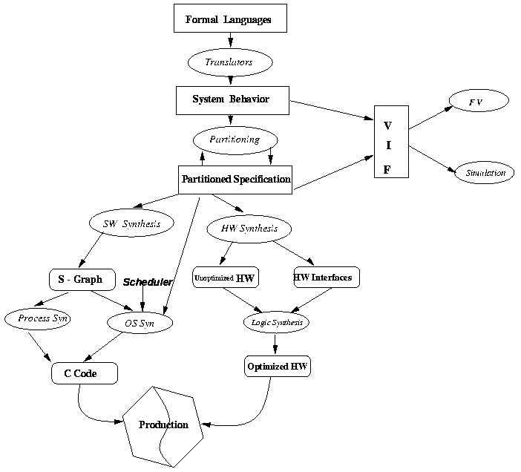
Figure 2. Design Flow of Polis [17]
The hardware-software partitioning process is not automated and the decision is based heavily on design experience. Polis provides the designer various feedback mechanisms like verification and co-simulation to quickly evaluate such decisions. Each sub-network chosen for hardware is optimized and synthesized using synthesis techniques of SIS [24]. A CFSM is interpreted as a register-transfer level specification and can be mapped into BLIF [44], XNF [45], VHDL [46] or Verilog [47]. The software implementation is mapped into a software structure that includes a procedure for each CFSM, together with a simple real-time operating system. Polis generates an operating system, which provides communication between SW-HW and SW-SW modules, schedules the SW CFSMs, generates device drivers for HW-SW communication and generates an event driven layer which implements the CFSM event emission/detection primitives [18].
Polis also has support for formal verification. The formal specification and synthesis methodology embedded within POLIS makes it possible to interface directly with existing formal verification algorithms that are based on FSMs. POLIS includes a translator from the CFSM to the FSM formalism which can be fed directly to verification systems like VIS [19]. In addition to uncovering bugs in a design, formal verification is also used to guide the synthesis process [18].
COSYMA
COSYnthesis of eMbedded Architectures (COSYMA) is a platform to help explore the hardware-software co-synthesis process, developed at IDA, Germany [20]. The resulting target architecture is limited to a processor and co-processor configuration. COSYMA covers the entire design flow, from specification, hardware-software partitioning to hardware and software synthesis. It is thus a complete system for hardware-software co-synthesis. The COSYMA target architecture consists of a standard RISC processor core, a fast RAM for program and data with single clock cycle access time and an automatically generated application specific co-processor. Communication between processor and co-processor is via shared memory [21].
Figure 3 shows the design flow of an application using COSYMA. The system is specified in C_{x}, an extension of C with support for parallel processes and timing constraints. The C_{x} specification is then converted into an Extended Syntax Graph (ESG), which is the central data structure used to represent the complete system. The ESG describes a sequence of declarations, definitions and statements and is overlayed with the Data Flow Graph (DFG) containing information about data dependencies [21].
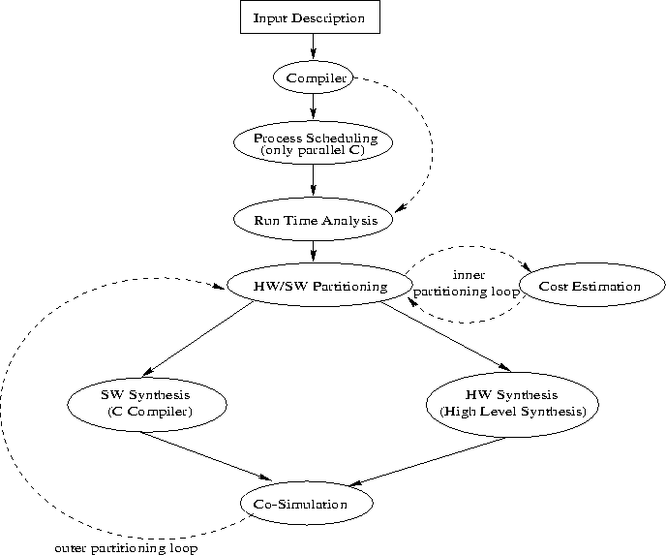
Figure 3. Design flow of Cosyma [20]
If the C_{x} description contains parallel processes, then they shall be scheduled and considered as a single serialized process. Scheduling is done using scalable performance scheduling. The speedup factor for the resulting serialized process is determined, which indicates the amount by which the speed of the given processor should be increased to meet the timing constraints of the system. Cosyma explores the option of moving parts of the process into a fast co-processor [21].
The hardware-software partitioning process in COSYMA is automated. The partitioning is done using basic blocks as the primitive elements. A basic block consists of a sequence of C_{x} statements. The partitioning process starts from an all software solution and moves basic blocks from software to hardware until the timing constraints are met. It estimates the incremental cost of moving a block from software to hardware and tries to bring the estimated execution time close to the required execution time. A simulated annealing algorithm is used for this purpose [21].
Chinook
Chinook is a framework for the development of reactive embedded systems. It supports various simulations and generates design specifications from a single high-level specification. Developed at University of Washington, Chinook is intended for control-dominated systems [22].
This co-simulation and co-synthesis system tries to addresses the automation of the most time consuming and error prone tasks in embedded controller design. These tasks being; the synthesis of hardware and software interfaces, migration of functions between processors and custom logic and co-simulation of the design [22]. Figure 4 shows the Chinook co–synthesis system. It consists of a parser, device driver synthesizer, interface synthesizer, communication synthesizer, scheduler and simulator.
Systems are specified in a single Verilog file containing both behavioral and structural constructs. The behavioral style is based on modes, which are very similar to hierarchical state machines. The structural component lists the processors, peripheral devices and communication interfaces that will be used. In the behavioral specification, Chinook expects the designer to tag tasks or modules with the processor that is preferred for their implementation. This separation of functionality from components allows the designer to quickly explore the design space by using different processors and alternative peripheral devices without modifying the behavioral specification [22].
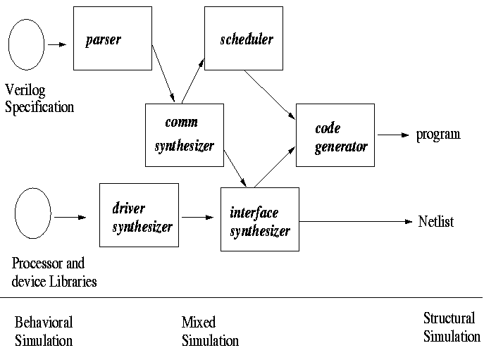
Figure 4. The Chinook Co-synthesis System [22].
Applications can be simulated at different levels of detail. The initial specification is compatible with behavioral Verilog and is simulated without exact timing or detailed input-output. As abstract communications and operations become refined into more concrete signals and components, outputs from intermediate design steps and the final implementation can also be simulated with cycle level accuracy. To simulate the specification during the early stages of the design, the simulation is bound to a behavioral simulation model. Chinook uses RTL level processor models for simulating the final system implementation. It interprets the same machine code that runs on the actual processor. The binary code is disassembled and the registers, program counter, stack, internal memory and built in devices are displayed in the processor status window. The processor model faithfully reproduces, within cycle level accuracy, the appropriate waveforms on the processor's pins [22].
Chinook takes input in the form of Verilog code and hence it starts at a lower level of implementation. The model of computation is very similar to hierarchical state machines making it suitable for control-dominated systems. Although it does not partition the code and requires the user to come up with a partition it has good simulation support for various levels of simulation.
PTOLEMY
Ptolemy is a project dedicated to modeling, simulation and design of real-time, embedded applications started in 1990 at University Of California at Berkeley with focus on component-based design. The philosophy of this project is centered on using different models of computation and developing an environment that allows the mixing of these models of computation to create a heterogeneous application [26].
The primary aim of the Ptolemy project is to build a framework for modeling, designing and development of embedded applications. Figure 5 shows the design management strategy proposed by the Ptolemy project. Design starts with application specification using different models of computation and constraints. Different tasks of the system are evaluated and estimates are drawn. These estimates decide the hardware and software partition of the application. This is followed by hardware and software synthesis and verification. The final stage is the integration and system wide simulation [23].
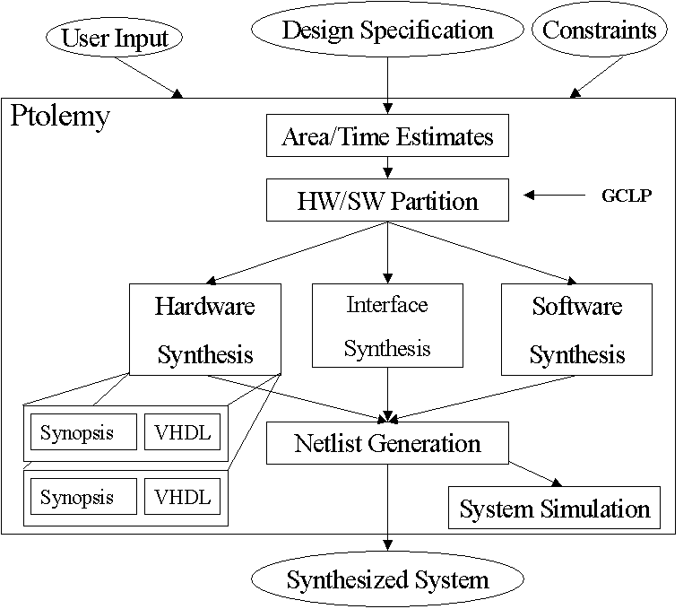
Figure 5. Design Methodology Management using Ptolemy [23]
A Java-based framework called Ptolemy II has been developed that implements the project ideas. The framework has an environment for the simulation and prototyping of heterogeneous systems. It is an object-oriented system allowing interaction between diverse models of computation. The Ptolemy software is extensible and publicly available. It allows experimentation with various models of computation, heterogeneous designs and co-simulation. The primary feature of Ptolemy is the facility to compose various models of computation. Some of the models of computation supported by Ptolemy are hierarchical finite state machine, data flow graphs, discrete-event and synchronous/reactive. After specifying the application using heterogeneous models, the next step is to partition the application. This is done using different partitioning algorithms like GCLP [25]. Ptolemy facilitates mixed mode system simulation and synthesis. Software synthesis is supported for various models of computation along with support for composing these models. Hardware portions of the application are synthesized to VHDL. A register transfer level simulator (THOR) has also been added for simulating hardware applications [26].
Other key features of the project are the representation of modern theories in a block diagram specification, modular approach, a mathematical framework for comparison between models of computation and simulation and scheduling of complex heterogeneous systems [26].
MILAN
The Model-based Integrated simuLAtioN framework (MILAN) is a framework to facilitate rapid development of efficient heterogeneous embedded system applications. The framework is extensible and supports various kinds of simulation by integrating existing widely used simulators [27]. The project is currently under joint developed by Institute for Software Integrated Systems (ISIS), Vanderbilt University and University of Southern California with the primary aim to integrate the design, development and simulation of embedded system applications into a unified environment. MILAN is based on Model Integrated Computing (MIC) [28].
MIC is a philosophy that advocates the use of domain specific concepts to represent system design. The models capturing the design are then used to synthesize executable systems, perform analysis or drive simulations. The advantage of this methodology is that it speeds up the design process, facilitates evolution, helps in system maintenance and reduces the cost of the development cycle [28].
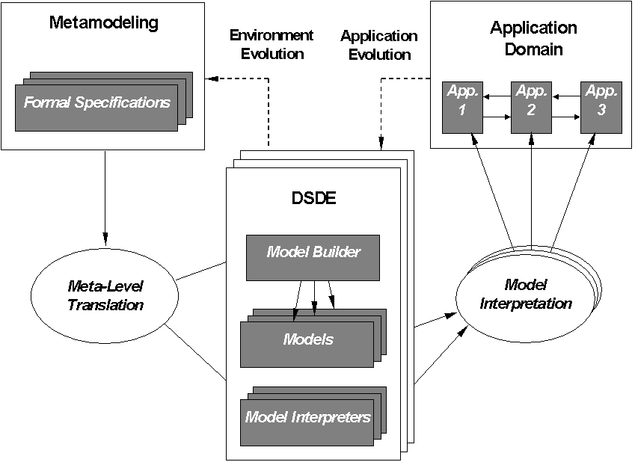
Figure 6 Design flow from metamodeling to application synthesis using GME [52]
A metaprogrammable toolkit called Generic Modeling Environment (GME) implements the MIC methodology. It provides an environment for creating domain-specific modeling environments [29]. GME provides a graphical interface similar to UML [30] class diagrams (tutorial in appendix A), in which the user can specify the modeling environment to be developed for the specific domain. The graphical description is referred to as a metamodel, and it capture, the syntax, semantics and visualization rules of the target environment. In the metamodels the user can specify the set of entities or objects that can be created in the target environment, their organization and interactions with other entities along with associations, grouping and ordering of these objects. The target environment implements a modeling language, which consists of a set of all possible models that can be created using the target environment. A tool called the meta-interpreter interprets the metamodels and generates a configuration file for GME. The file is used to automatically configure GME so that it behaves like the target environment. Thus GME is used as both the metamodeling environment and the target environment.
GME models are entity relationship diagrams that are graphical and hierarchical with multiple aspects and attributes. The semantics of the models are enforced in two stages. The first stage is in the form of constraints that are applied to the models to enforce the static semantics. These constraints are specified in the metamodel using an Object Constraint Language (OCL) type specification and are applied on the models using a built in constraint manager. In the second stage dynamic semantics are enforced with the help of model interpreters. Model interpreters parse the application models and generate source code, configuration files and analysis as output.
GME was used in MILAN to create the embedded system modeling paradigm and is used to create embedded system application models using this paradigm. Paradigm is used in this context as a formal definition of a modeling language. The paradigm has been designed to capture the design space of the application models. Design space refers to a number of possible designs for an application and is captured in MILAN by capturing alternative designs explicitly. The application models are represented using data flow, which is the model of computation in MILAN. Three different data flow semantics are supported and an application can be build with a composition of these. The supported data flow semantics are Synchronous Data Flow (SDF), Asynchronous Data Flow (ADF) and Structural Data Flow (StDF). SDF and ADF capture portions of the application targeted to software while StDF captures portions of the application implemented in hardware. Each model of computation supports hierarchy, strong data typing of communication ports and multiple aspects. Hierarchy helps to handle complexity, while strong data typing allows for type checking and making the system type safe, and multiple aspects separate orthogonal information.
Apart from the application, hardware resources are also captured in MILAN using a resource modeling sub paradigm. The resource modeling paradigm captures the hardware in the form of processing nodes (processor cores, FPGAs, ASICs), memory (cache, main memory) and interconnects. Thus, complex hardware can be described using these building blocks. Each of these models has attributes specifying its performance characteristics. This helps to configure the simulators to simulate the particular hardware. [40].
Figure 7. MILAN Architecture and Design Flow
Application blocks need to be mapped to resources to completely specify a system. The mapping in MILAN allows for partial specification, wherein an application node can be mapped to more than a single hardware node, specifying a choice in the design. Thus another dimension in the design space can be captured. Along with the huge design space, non-functional requirements are captured in MILAN in the form of constraints, which capture performance requirements and mapping constraints. For example, an application may have a constraint stating that the end-to-end latency of the application should be less than 15ms. Similarly there may be a constraint that binds a particular processing node to a particular hardware.
The constraints put restrictions on the design space and hence, invalidating large portions of the space. Thus, only subsets of designs satisfy the constraints that specify the non-functional requirements. This subset is determined using a design space exploration tool [31] that applies the constraint to the design space and only returns valid designs. Thus, using a design space exploration tool the design space can be pruned leaving a small subset of the designs to work with. The user can then choose a single design from this pruned space and run different kinds of simulations on various simulators. The different simulations (isolated simulation, multi-granular simulation and system wide simulation) are supported by means of model interpreters that parse the application model and generate code and configuration files for the required simulation. These model interpreters can generate code for various simulators.
To start with, the user will use functional simulation to check and see if the functional requirements are met. Functional simulation can be invoked on applications implemented entirely in software, hardware or both. Currently, simulation of software is supported in MATLAB. However, hardware simulation and co-simulation of heterogeneous systems needs to be supported. After the user is satisfied with the functional requirements of the system low-level simulators can be used to verify non-functional requirements. For software, the available low-level simulators are SimpleScalar [32] and PowerAnalyzer [33]. On the other hand there is currently no such support for applications implemented in hardware. Results of the simulations are fed back to the models to update them for verification using high-level tools. The feedback is automated in most cases but in some it needs a human in the loop process.
MILAN supports system synthesis, which is similar to the process of simulation with the difference that the generated code is used for the true system implementation and configuration files are generated to configure a runtime environment. The runtime environments supported are Active Kernel [34] and Real-time Kernel, a Java based runtime kernel developed at ISIS. Other runtimes can be supported as the need arises. However, there is a need for high-level functional simulation of hardware, low-level simulation and co-simulation. These needs are addressed in this paper and developed tools are discussed in Chapter III and IV.
The MILAN framework is based on the codesign [59] principle and provides a framework for modeling applications using heterogeneous data flow. Different simulations are supported that validate the design before mapping the application to hardware recourses. Then, based on design space exploration and high level estimation the hardware software partitioning is done. Furthermore, the data flow abstraction can be viewed as a platform as described in the platform-based approach [60]. However, there are no stacks of platforms in the MILAN design framework.
Comparison
The tools discussed above have been compared on different aspects and the comparison has been represented in Table 2. The grounds for comparison were selected to highlight their strengths and weaknesses and emphasize the differences between tools.
Table 2 Comparison of embedded system design tools
Features | Polis | COSYMA | Chinook | Ptolemy | MILAN
System Specification language | Esterel | Cx –Parallel C | Verilog | Graphical | Graphical
Abstract Communication | Events | Send/ receive | Signals | Port holes and stars | Buffers and signals
Model of computation | CFSMs | DFG on ESG | Modes | DF, FSM, DE, SR | SDF, ADF, StDF
Concurrency | Concurrent Modules | Single thread | Concurrent Modules | Domain dependent | Concurrent Modules
Partitioning | Manual | Automated | Manual | GCLP [25] | DESERT [31]
Granularity level | Coarse grained | Fine grained | Coarse grained | Coarse grained | Coarse grained
Formal Verification | Supported via VIS | Not supported | Not supported | Not supported | Not supported
Co-Simulation | Through Ptolemy | Through CoSim | Through Pia | Directly | Through SystemC
Hardware Synthesis | BLIF, VHDL, XNF | Using the BSS tool | Generates Netlist | VHDL, RTL | SystemC, VHDL
Software Synthesis | S-Graphs to C | C | C | C, Java | C, Java, MATLAB
Software Simulation and Performance Estimation | Using S-Graphs | Sparc Simulator | Not supported | Using S-Graphs | HyperE, SimpleScalar, PowerAnalyzer
Hardware Simulation and Estimation | Single cycle execution | List Scheduling | Not supported | THOR | Active HDL
HW/SW Communication | I/O Ports | Shared memory | I/O Ports | I/O Ports | I/O ports
Target Architecture | Processor & CFSMs in HW | Processor/ Co-processor | Multiple Processors | Multiple Processors | Multiple Processors
Hardware Description Languages
The focus of this thesis is on the hardware modeling paradigm of MILAN and model interpretation to drive various types of simulation. Thus, it is a good idea to explore the different hardware description languages that are in practice and how they can be used in MILAN.
VHDL
The first hardware description language to be standardized is VHDL (VHSIC Hardware Description Language), where VHSIC stands for Very High Speed Integrated Circuit. VHDL became IEEE Standard 1076 in 1987 [46] and was revised in 1993 to IEEE Standard 1076 1993. The VHDL language is used to describe the behavior of digital hardware. It contains constructs that allow the user to write structural and behavioral description of the hardware. Structural description refers to the layout description of the hardware. In other words the user can describe how different components of the hardware are connected to each other. Behavior on the other hand depicts the functionality of a module and how it processes input data to produce output data. Apart from the structural and behavioral description, hierarchy is also supported and users can compose larges systems using smaller components. Another important feature is that the level of abstraction can vary from architecture level description to gate level description [35].
The primary advantage of VHDL is that the description is palatable for human consumption as well as easy for machines to parse. Because VHDL can be easily parsed there are a lot of third party tools to perform, analysis, simulation and generation of gate level layout [35].
Verilog HDL
Verilog is the most popular hardware description language that has been in use for a long time. An IEEE working group worked on standardizing Verilog and they came up with the IEEE Verilog Standard 1364 in 1995 [47] [36].
Verilog supports the two distinct ways of describing the hardware; structural description and behavioral description. These form the primary part of the language. Verilog was developed keeping in mind gate level description and so it contains a rich support for low-level operations while on the other hand it has lesser support for composing and managing large and complex system [36].
The primary differences between VHDL and Verilog are that VHDL is strongly data typed and robust while Verilog is easier to learn. Verilog has greater support for gate level description while VHDL is more suitable to build large and complex systems as it has better support for high-level constructs like packages and generic modules [36]. Verilog has better tool support from the industry and hence a lot of third party simulators and synthesis tools available.
SystemC
The latest in the line of hardware description language is SystemC. It is an open source initiative for system-level design, currently undergoing the standardization process with IEEE. SystemC is a modeling platform consisting of C++ class libraries and a simulation kernel, for design at system-behavioral and register-transfer-levels. Designers create models using SystemC and standard ANSI C++ and simulate the designs using the simulation kernel. The goal of this language is to use high level constructs to describe heterogeneous systems and to seamlessly partition the system into software and hardware components. The C++ language is extended with a hardware specific layer that allows users to describe hardware using structural and behavioral description. High-level constructs such as modularization, processes, data types and multiple levels of abstraction allow designers to write hardware descriptions in an easy and concise manner [5].
SystemC being an open source initiative also has a host of third party tools for simulation and synthesis to low-level languages such as VHDL and Verilog. Thus systems described in SystemC can be automatically converted to VHDL, Verilog or directly to register transfer level description. This makes SystemC flexible and not bound to a particular description language. However, the generated VHDL and Verilog code is not highly optimized and hence hand tweaking may be required.
Summary
Traditionally, hardware is captured using a textual hardware description language like Verilog, VHDL or SystemC. These languages lack the ability to represent design choices and can only capture a single design. Secondly, high-level architectural description of the system being developed is often lost in low-level implementation details. Furthermore, the hardware description languages do not directly support the design of heterogeneous systems. Finally, in most cases migration from one language to another is neither automated nor simple, restricting the user to the specific set of tools that accompany the language.
Another observation is that these languages support both structural and behavioral description of the system. Structural description is generally done in terms of StDF, which is easier and less error pone to represent graphically, rather than describe in a textual form.
Amongst the languages discussed so far SystemC seems to be the most general because SystemC code can be converted to both VHDL and Verilog. Furthermore, SystemC uses high-level constructs and hence it is suitable for rapid prototyping of applications.
CHAPTER III
THE HARDWARE DESCRIPTION PARADIGM
As we saw in Chapter II, there are some advantages and disadvantages of the traditional hardware description languages. Hence, there is a need for a new hardware description language that overcomes these shortcomings and provides an easy to use environment to the users needs to be developed.
The Requirements
Keeping in mind the shortcomings of the traditional languages, the requirements of a new design environment are stated as follows.
- Design space: the ability to capture a family of designs rather than a single design.
- Separation of architecture and implementation: high-level architecture of the systems should be preserved and kept separate from the low-level implementation. This helps to preserve the intention of the designer and allows easy migration to a different implementation.
- Mitigation of complexity: large and complex system should be represented in a way such that the complexity is managed efficiently.
- Heterogeneous systems: there should be support for the design and development of embedded system applications having functionality in both hardware and software, with interactions between the two.
- Flexibility of language: the design environment should not impose a hardware description language on the user. It should allow the user to make the choice of the underlying language at a much later stage in the design process and also allow for the flexibility of changing it later.
The Basic Hardware Description Paradigm
The requirements while developing the hardware description paradigm were separation of concerns, flexibility to capture the implementation in different languages as well as at different levels of granularity. Another requirement was to mitigate complexity to help designers design more manageable systems.
All hardware description languages support the structural description of the hardware. StDF closely resembles the structural description the hardware. Thus, the model of computation in hardware is hierarchical StDF. Hierarchical implies that a dataflow node can contain a dataflow subgraph it helps to mitigate complexity while designing large applications.
The hardware-modeling paradigm consists of a set of modules implementing behavior and directed links connecting modules specifying the dataflow graph of the system. The modules are hierarchical, that is, they can contain other modules and module associations forming a dataflow subgraph. Figure 8 shows the basic class diagram of MILAN’s hardware-modeling paradigm.
hwModule is the basic building block. It is a hierarchical module as it can contain other hwModules and hwSignalConns that form an StDF subgraph. Ports define the input and output interface of the module, while hwSignalConn is an association between ports representing a data path. Apart from ports there are hwClock and hwClockRef that define the clock synchronizing the module. These ports and clocks can also be connected to and from an hwBus. Modules also contain hwDataStore which represent memory elements.
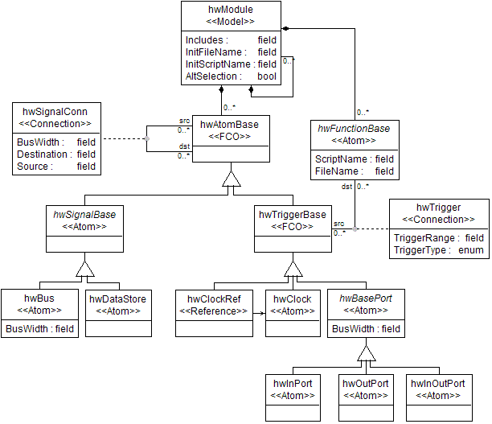
Figure 8 Basic hardware description paradigm
A module that doesn’t contain a subgraph has processes associated with it. Processes specify the behavior of a module. These processes are captured in the form of functions implemented in a hardware description language such as VHDL or SystemC. Notice that hwModule contains hwFunctionBase, an abstract base class. This class has been specialized for SystemC and VHDL. It can also be specialized to support other languages later. The functions can be event driven or sequential. Events are specified using the hwTrigger connection between processes and ports.
Hierarchy in the modeling paradigm serves two purposes. First, it helps separate intention from implementation. Using hierarchy the system is designed according to the intention, that is the high-level dataflow of the system. Then the design in refined by designing the modules in details until it is low-level enough to provide an implementation. Second, it helps to mitigate complexity. The dataflow graph of large systems can be very complex; hierarchy hides data at different levels to make the systems more manageable. The functions can be specified at any level of granularity and can be in either VHDL or SystemC. This provides the user with the flexibility to choose between different HDLs. Moreover implementations in different languages can coexist providing the user with design choices.
Data Typing Of Ports And Memory
Data type models in MILAN are used for several purposes. First, to accurately simulate communication performance the amount of data exchanged needs to be captured. Furthermore, as data type models are attached to hardware modules, or more precisely to their input and output ports, they define the interface of those components. When the components are attached using signal connections, their interfaces are checked to ensure that only compatible objects are connected. Finally, the data type models can also be used to generate the corresponding definitions in the target hardware description language to ensure their consistency.
The MILAN data type modeling paradigm allows the specification of both simple and composite types. Simple types, such as floats and integers, specify their representation size, i.e., the number of bits used. Composite types can contain simple types and other composite types. Attributes of the fields specify extra information such as array size or signed/unsigned type. Data types supported by the C programming language can be modeled in MILAN. Pre-existing data types, specified in a DSP library for example, can also be modeled. Their name and size in bytes are the only information MILAN requires.
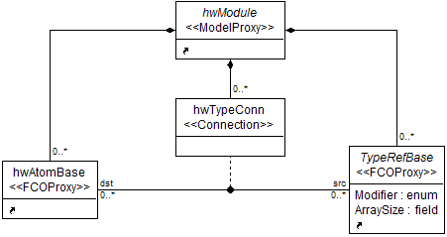
Figure 9 Typing of ports and signals
The hardware application and the data type modeling paradigms are composed together according to precise rules shown in Figure 9. Note that hwModule, TypeRefBase and hwAtomBase in the figure are classes from other diagrams. For example, hwModule is described in Figure 8. Similarly hwAtomBase refers to its corresponding class also in Figure 8. The TypeRefBase refers to the base class for all data type models that are described in another figure (not shown here). The figure shows that a hardware module can contain a reference to any number of data types and the data types can have an association with ports, signals and data stores using a connection called hwTypeConn. This association means that the port, signal or data store is typed to the associated data type. OCL constraints ensure that every port, signal or data store have exactly one type specification and that dataflow connections are only allowed between ports having compatible data types.
Parameterized Modules
In order to support parametric hardware modules, such as an FFT block with configurable number of data points, MILAN allows for the specification of such parameters as shown in Figure 10.
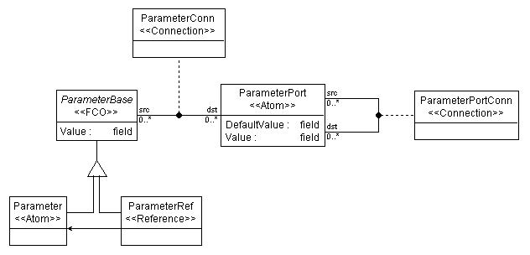
Figure 10 Parameter specification
Components contain ParameterPorts capturing their parameter interface. A Parameter can be connected to a ParameterPort supplying a value to it. Each port has a default value that is used if no Parameter is attached to it. Connections between parameter ports are also supported to allow the propagation of a parameter value down the dataflow hierarchy. parameterPortConn is constrained to connect ports sharing a parent-child relation in order to prevent parameter values propagating in an unrestricted fashion making the models hard to read. Furthermore, if a particular parameter needs to be used in several places in the models, using connections can quickly become inconvenient. ParameterRef is a reference to a Parameter making it possible for several components to refer to the same Parameter regardless of their position in the model hierarchy. Hence, the value of the parameter can be controlled from a single point. Both ParameterPort and Parameter are data typed, using the same modeling technique as for data flow ports. Typing information is used to verify that the supplied parameter is compatible with the parameter interface of the component.
Parametric modeling plays an important role in representing design spaces. A parametric component encapsulates multiple implementations that can be selected by supplying an appropriate value for the parameter. For example, an N-point FFT model encapsulates a number of FFT implementations spanning the valid range of N. Thus, a space of options can be represented in the models, instead of point-solutions.
Multiple Aspects
The hardware description paradigm is quite complex. However, the hardware description, data type specification and parameter modeling are largely orthogonal concepts. Therefore, they can be separated into different aspects to allow the user to better manage and understand the system. In the Hardware aspect, only module, ports, buses, data stores and the true implementation scripts are shown. Similarly in Type aspect, Ports, Parameters, ParameterPorts and data type references are displayed. Finally, Components, Parameters, ParameterPorts and their corresponding connections are visible in the Parameter aspect. Multiple-aspect modeling is a natural way to implement the separation of concerns and is directly supported in GME.
Software Description Paradigm
The software description paradigm is based on a dataflow representation. A dataflow graph consists of a set of compute nodes and directed links connecting them representing the flow of data. A flat graph representation does not scale well for human consumption, so we extended the basic methodology with hierarchy.
There is extensive literature on various dataflow representations. At the two ends of the spectrum are SDF [6] and ADF. Both these models of computation are supported by MILAN. Furthermore, composition of both forms of data flow in a larger system is also supported with clear semantic rules is also supported and has been discussed in greater details in [5].
Composition Of Software And Hardware
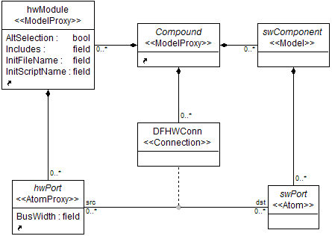
Figure 11 Composition of software and hardware
Real-world embedded systems usually have some functionality implemented in software while others in hardware. MILAN supports the composition of hardware and software models.
The metamodel in Figure 11 specifies that a Compound model can contain hardware modules and software components. Furthermore, hardware and software dataflow can be associated using the connection DFHWConn. This represents a data path between software and hardware components. Thus, a hardware implementation of a sub-system can reside in any Compound.
Alternatives
Till now we have discussed the modeling environment and its several features, however, we have not discussed how alternative designs are represented in the models. Parameterized components are one way of representing design alternatives. Being able to use multiple languages of implementation provides for alternative implementation.
MILAN also allows the user to have an explicit choice between synchronous, asynchronous data flow and hardware implementation. This is achieved by using alternatives. Alternatives are models that can contain synchronous, asynchronous software dataflow and hardware modules and the containment implies the ‘or’ condition. That is, one and only one of the given implementations will be used. Furthermore, choice between different algorithms to solve the same problem can also be captured using explicit alternatives.
These alternatives can be attached to regular data flow components in the data flow graph and it behaves like another component. Any number of alternatives can be used in the dataflow graph and they can be inserted any level of hierarchy. Depending on the choice of implementation the chosen modules will be used for simulation or synthesis. The choice of alternative can be specified explicitly in the design or can be made using a design space exploration tool [31].
Comparison With Other Hardware Description Languages
The hardware description languages considered to the comparison are VHDL, Verilog and SystemC. The first difference between the Hardware Description Paradigm (HDP) and other hardware description languages (HDLs) is that the HDP is at a higher level of granularity, more abstract and less expressive as compared to the other HDLs. The HDP can be used as a high-level modeling environment and the models can be synthesized to any of the existing HDLs making it more generic and flexible. Moreover, HDP allows the description of design spaces as opposed to the point solutions captured in the HDLs. The HDP allows designers to graphically represent structural description, which is more intuitive to the designer as compared to the textual description where it is easy to loose track on the connections. Finally, the HDP allows heterogeneous design while other HDLs apart from SystemC don’t. Even in SystemC the entire system must be represented in the SystemC extension of C++ while in HDP the software can be represented in MATLAB, C or Java.
Summary
Modeling is an abstraction of the system and captures specific details required to best represent, understand, implement and modify the system. A plethora of requirements were imposed on the heterogeneous design environment and specifically on the hardware-modeling paradigm. These requirements were met by using a variety of modeling methodologies. The highlights of the heterogeneous design environment developed are as follows:
- Modeling of hardware applications using domain specific concepts.
- Separation of concerns by modularizing components and abstracting computation from communication.
- Abstraction of architecture and implementation by capturing the design at different levels of granularity using hierarchy.
- Parameterization of components to develop generic modules for reuse as well as to design a set of solutions instead of a single solution.
- Explicit design of alternative implementations to capture design choices and thus providing better exploration of different solutions.
- Data abstraction and information hiding to manage complexity using multiple aspects of the same module.
- Compose hardware and software components together to facilitate the design of heterogeneous systems.
- Strong typing of communication ports for accurate simulation of data exchange and to catch modeling errors at design time.

CHAPTER IV
MODEL INTERPRETATION AND SIMULATION
Overview
After creating a design environment that allows designers to model embedded systems applications, there is a need to drive various simulations from these models. Simulators normally take code as input and simulate the behavior and performance of the application. Thus, code needs to be generated in order to simulate a system. This gap between models drawn by the designer and code consumed by the simulator is bridged using model interpreters.
Interpreters parse the models to extract required information. They are generally used to perform analysis on the models, run simulations, synthesize application and a variety of other tasks. In the MILAN context, a model interpreter can be used to analyze the models for syntactical correctness as well to generate code for various simulations.
MILAN has a complex modeling paradigm that allows the modeling of heterogeneous applications, because of which there are a variety of interpretation tasks that are required. Due to this reason many interpreters exist in the MILAN toolset, each responsible for accomplishing a particular task. The heterogeneous interpreter is one such interpreter that parses the models and separates the hardware and software components. Another interpreter is the software graph builder interpreter that parses the models and extracts only the software relevant information.
Apart from these generic interpreters, there are a host of language specific code generation back ends that work on the output of the interpreters to generate code for simulation. Code generators for SystemC, VHDL, C, Java and MATLAB have been developed so far. Thus we see that typically an interpreter along with some code generators will be used to generate code for simulating the application.
Figure 12 shows a high-level block diagram of an interpretation flow. Heterogeneous models, created by the user are fed to the heterogeneous interpreter. The heterogeneous interpreter parses the models and separates the hardware and software sub graphs. It also adds proxies at the hardware and software interface to facilitate co-simulation. The output of the heterogeneous interpreter is then fed to the respective code generators.
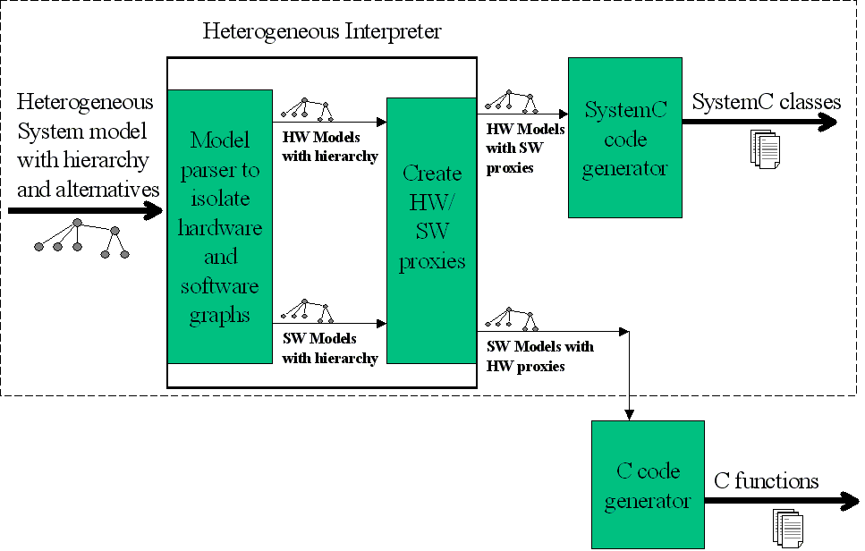
Figure 12 Block diagram of Interpretation
The design is modular and hence easy to reuse. Many different back end code generators can be used with the heterogeneous interpreter. Different code generators be used to generate code from the output of the heterogeneous interpreter. Thus, the heterogeneous interpreter implements all the language independent parsing, allowing the code generators to concentrate only on the generation of code and not other issues.
The heterogeneous interpreter supports a variety of simulation needs and can generate different kinds of simulations. The simulation choices are classified into three categories. (1) The first category consists of either full simulation or isolated simulation. This distinction is global in nature and pertains to the entire system. Full simulation is the case when the user wants an entire system design to be simulated, while isolated simulation implies that the user wants to simulate a subset of the system. For isolated simulation the chosen subset and sources and sinks are used to generate a simulation. (2) The second category consists of choosing between pure hardware simulation and co-simulation. A pure simulation is when the entire system chosen for simulation is implemented in hardware, while co-simulation is the case when parts of the system are implemented in hardware and parts in software and these parts have communication between them. (3) The third category is more local in nature and pertains to individual modules. In each module the user can choose to send either the entire subsystem for simulation or use a coarse grain implementation of the module. These three simulation categories can be mixed and matched. For example, the user can choose to simulate a full system with co-simulation and one module having a coarse grain implementation. Thus, we see that a large number of combinations are available to the user.
The subject of this thesis, the heterogeneous interpreter and the SystemC code generator (shown in the dashed box in Figure 12) will be discussed in detail in this chapter.
Heterogeneous Interpreter
The heterogeneous interpreter, as shown in Figure 12, has two stages. The first separates the hardware and software components from the heterogeneous design and the second stage constitutes of inserting proxies for co-simulation in the software and hardware graphs. Both software and hardware graphs can then be sent to different code generators.
Input and Output
The first step is to describe the input and output of the interpreter. The input to the interpreter is system design models built using GME. These models are stored in a database and can be accessed using a COM (Component Object Model) [53] API (Application Programming Interface). A high-level C++ interface called the Builder Object Network (BON) also exists that enables the access of these models as C++ objects. Thus the interpreter can access model information using the BON [37].
Applications described by the developers are stored as a network of objects. Inside GME these objects are instances of a set of generic classes in the BON. The class hierarchy of the generic BON is given in [37]. These generic classes can be extended for a specific paradigm.
For the MILAN paradigm these classes were extended according to Figure 13. The CBuilderModel class is a generic class in the BON and all other classes in the figure have been defined for MILAN. Each user-defined class corresponds to a kind of model in the design environment. The HardwareModule for example represents the model called hwModule shown in Figure 8. For each hwModule model drawn by the user an instance of the HardwareModule class is created. These objects have pointers and links to other objects creating a network of these objects. This network of objects is provided to the interpreter.
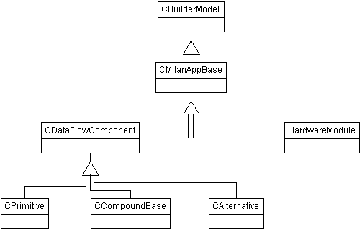
Figure 13 Class diagram of the MILAN specific classes
At the output end, the heterogeneous interpreter instantiates another set of classes that describe the pure hardware and pure software graph. Figure 14 shows the classes that describe the pure hardware data flow graph. Both Figure 13 and Figure 14 have the class called HardwareModule. The reason is that the input network of objects is extended with all the information required for the pure hardware graph. This saves the time and memory required to create and store a new network of objects. There can be only one instance of the class called HardwareMainModule. This instance can contain any number of instances of HardwareModule. HardwareModule can contain sub modules, ports and connections and represent a hierarchical sub graph. Thus the hierarchy is preserved in the pure hardware graph.
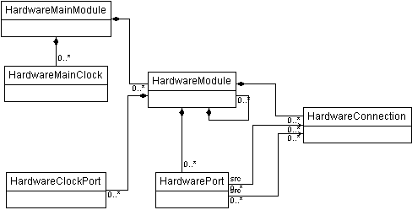
Figure 14 Class diagram of the hardware graph
The output format for the software graph is completely different from the hardware format discussed above. A different class structure was developed for the software graph called the graph classes [54]. The graph classes provide an intermediate format independent of GME. Thus, other front-end tool can be used to describe the system and the output of the tool can be converted to objects of the graph classes.
Apart from the graph classes, the BON was extended for the software modules with an API for creating the graph classes. Both the graph classes and the API to generate the graph classes from the application models were developed independently and are used by the heterogeneous interpreter to build the software graph.
Separating Hardware And Software Components
The first stage of the heterogeneous interpreter is to isolate the hardware and software graphs. At a very high level, this task is broken down into three parts.
- Create a list of all the selected hardware and software components.
- Connect the pure hardware graph
- Connect the pure software graph.
To accomplish these tasks, a set of helper classes are used. Methods of these classes traverse the heterogeneous graph and extract the required information. These classes are called shadow classes because each model in the system has a shadow object associated with it.
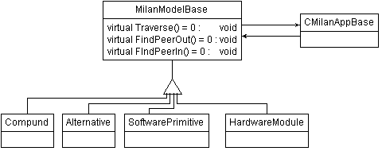
Figure 15 Class diagram of the shadow classes
Figure 15 shows a simplified class diagram of the shadow classes. The MilanModelBase in Figure 15 is an abstract class. It has a pointer to the CMilanAppBase, which is the base class for all the classes in MILAN that extend the BON (Figure 13). For every instance of CMilanAppBase there will be a MilanModelBase shadow instance. MilanModelBase has three main functions that are required to be implemented by the sub classes. The Traverse function is used to create a list of selected models. The implementation of the traverse function in each subclass is such that together they achieve the functionality of creating two lists, one each for the selected hardware components and software components.

Figure 16 Algorithm for creating the hardware graph
BuildHardwareGraphForSimulation
Input: SelectedList is a list of HardwareModules
Output: NotSelectedList is a list of HardwareModules
ProxyList is a list of Hardware Software pairs
Internal: WaitingList is a list of HardwareModules
Algorithm:
Waitinglist.Add(SelectedList.FirstElement)
While(WaitingList is not empty)
{ hwModule = WaitingList.RemoveFirst
For(each port of hwModule)
{ PeerModule = HwModule.FindPeer(port)
If(PeerModule is hardware)
{ AddNewConnection(hwModule,PeerModule)
If(PeerModule is not in selected list)
NotSelectedList.Add(PeerModule)
Else If(PeerModule hasn’t been processed)
WaitingList.Add(PeerModule)
}
Else
ProxyList.Add(PeerModule,hwModule)
}
HwModule has been processed.
}
After the list of selected modules is created the next step is to traverse the heterogeneous graph to find the direct neighbors of these components. This is achieved using the algorithm shown in Figure 16. The algorithm basically starts with a selected module and finds all the neighbors. If a neighbor is part of the selected list and has not been processed, it is added to the waiting list. If the neighbor is not in the selected list it is put in the not selected list. This process is repeated until the waiting to be processed list is empty. The algorithm achieves two purposes, finding the hardware graph required for the simulation and generating a list of not selected modules that are required to source and sink data. If the not selected list is empty, it means that the user has chosen the entire system for simulation. Otherwise the user has invoked an isolated simulation on a subset of the system.
Another important aspect of the algorithm is that it identifies the hardware software interface points. That is, whenever it finds a hardware module connected to a software module, it adds an entry to the proxy list. This list maintains an entry for each hardware-software pair having communication links between them. This information is used in the next stage where proxies are added to the graph.
After the hardware graph is isolated, the software graph is also isolated and created. This process is done with the help of the API to create the graph classes in the extended BON classes for the software components (CDataFlowComponent, CPrimitive and CCompound of Figure 13). Using the API calls are made from the heterogeneous interpreter to create the graph.
Inserting Proxies
Stage two of the heterogeneous interpreter deals with the issue of co-simulation and how to handle it. This is achieved by means of proxies. The idea is similar to the skeletons and stubs used in the Remote Method Invocation (RMI) [48] of Java. In RMI the communication between Java Virtual Machines (JVMs) are hidden from the client and sever residing in different JVMs with the help of proxies called skeletons and stub. A similar technique is employed in co-simulation of hardware and software. Adding proxy hardware components that emulate the software in the hardware graph hides the existence of software. Similarly, the hardware is hidden in the software graph with the help of proxy software components. The interpreter generates these proxies and their implementation for each hardware-software pair having communication. These proxies are added to the runtime objects and do not modify the models built by the designer.
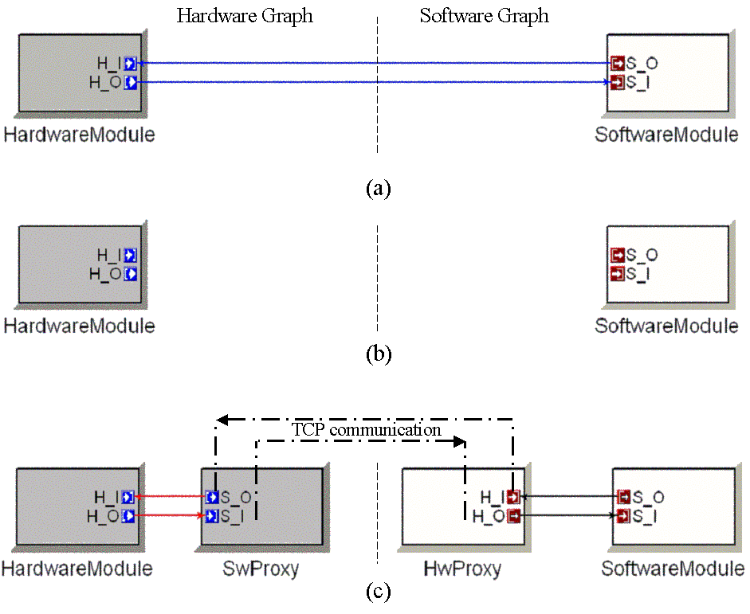
Figure 17 Three stages in the process of adding proxies.
Figure 17 shows the process of adding proxies in three stages. Figure 17 (a) shows a graph with hardware software communication. Figure 17 (b) shows the result of stage one of the heterogeneous interpreter where the hardware and software graphs are isolated. Finally in Figure 17 (c) proxies are added to both the graphs. The pair of proxies has code that implements TCP communication between them. Each proxy forwards data from its in ports to a TCP channel and receives data from a TCP channel and adds it to the out port. If there is no hardware-software communication then no proxies are added and a pure hardware simulation will be generated.
SystemC Code Generator
SystemC Document Object Model
Code generation is an integral part of compilers and other modeling tools such as Statemate [56], Rational Rose [55] and Ptolemy II [26]. The challenge is to provide an elegant solution for solving such a problem. The generated code needs to be correct, structured and formatted. In order to meet all the above requirements there needs to be a way to ensure consistency. The method employed in the SystemC Code Generator (SCG) tries to emulate the philosophy of the eXtensible Markup Language’s (XML) Document Object Model (DOM). Learning from the XML DOM we see that the representation of persistent data as runtime objects is an elegant approach. However, unlike XML DOM the SystemC DOM only implements and provides an interface for code generation and it does not support the parsing of code into objects. The reason being that the other way was not required to solve the code generator problem.
SystemC is an extension of C++ and it uses template and preprocessor directives to extend the C++ language for additional entities like modules, ports and signals. Hence, a basic generator for C++ was required as well as a SystemC specific generator. Thus, the implementation has two layers, the first layer supports the generation of basic C++ code and on top of that there is a layer for SystemC specific code.
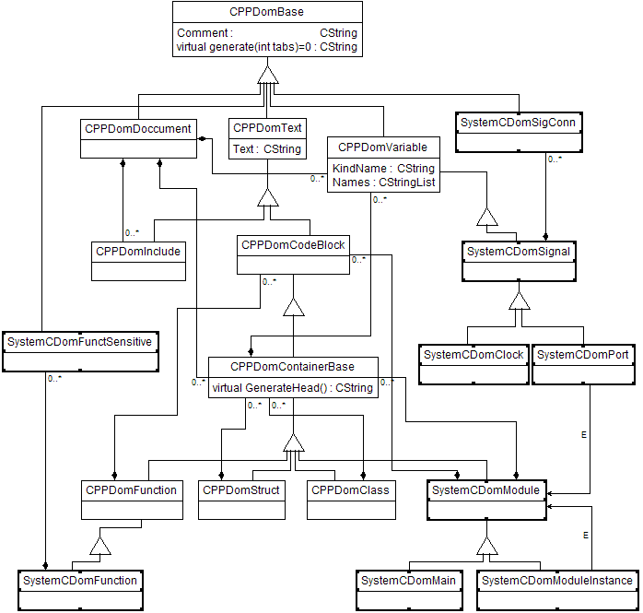
Figure 18 Class Diagram of CPP Dom and SystemC Dom
In Figure 18, the CPP Dom and the SystemC DOM that are used for code generation are shown. All the classes inherit from a common base class called CPPDomBase. This base class has a virtual method called generate, that each sub class must implement. This method contains the functionality for generating code. The CPPDomContainerBase is the base class for classes, structures and SystemC modules and thus it has another virtual function called generate head. The generate function generates code for the cpp file while the generate header function is used to generate the header file.
The CPP DOM API and SystemC Dom API allow the user to generate code by creating objects and then calling the generate function on these objects. This API forms the output interface of the SCG. The input objects have been discussed in the previous section and are described in Figure 14.
Translation
The process of translating the hardware graph to code using the SystemC DOM API starts with the HardwareMainModule class. This class had only one instance and corresponds to the main function in the code. Traversal routines have been implemented in the HardwareMainModule class and the HardwareModule class to traverse through the hierarch and create all the objects. This traversal follows a bottom up approach because the DOM object representing a high-level class cannot be created until all the classes it instantiates have their respective DOM objects. Thus, starting from the basic modules, the traversal goes up building the classes. For every HardwareModule object a SystemCDomModule instance is created. Then all the ports, member variables, sub module instances are added to the SystemCDomModule instance. Then the signal connections are added. This is followed by the addition of functions and their triggering conditions.
MILAN supports the modeling of structures and complex data types. If a class contains variables that are instances of these complex data types, the code generator generates the structure definitions and includes the definition file in the class.
Parameters in the models are treated as member variables of the class. Providing values to the parameters is an interesting task. Parameters can be modeled such that a module can receive the value of the parameter from its own parent. However, the parent might get the value from its parent. Thus, to set the values of these parameters there were two options. In the first option a new constructor could be generated for each class such that it would have in its signature all the values it needed. This solution is not elegant, as the constructor will become unreadable as the parameters grew. Secondly, complex parameters, like structures would still cause problems. The other solution for this problem is to call the default constructor and then have another function called init that would set the values of the child class and then call init on the child classes. The second solution overcame the disadvantages of the previous solution and was implemented.
Clocks (hwClock and hwClockRef in Figure 8) are modeled in a different manner than their corresponding code. In the modeling paradigm the user can add a clock to any module and at any level of granularity. However, in the code the clocks can exist in the main program only and are passed down as signals. Thus the treatment of these is a bit different. The module containing a clock will have a clock port instantiated in the corresponding code. Every module checks its children for clock ports. If a child has a clock port then the module also adds a clock port to it and propagates a signal to the child clock port. The main module instantiates all the clocks required by the children and connects the clocks to the respective ports.

CHAPTER V
CASE STUDY
To test and validate the suite of tools described so far and the design philosophies it is based upon, a case study was conducted. The aim was to use the new tools to create a real world embedded system application and to test the advantages and disadvantages of the developed tools. The first challenge was to choose a suitable example application.
Embedded image processing systems and specifically, embedded missile Automatic Target Recognition (ATR) systems face many challenges due to extremely large computational requirements and size, power, and environmental constraints [10]. Being a DARPA [49] challenge problem and because of its size and complexity, the ATR application was ideal to test the new design and development framework [38].
The ATR Application
Figure 19 ATR application block diagram
The ATR algorithm shown in Figure 19 is based on correlation filtering [39]. Each image of the input image stream is sequentially preprocessed then transformed into the frequency domain. The copies of this spectral image are then multiplied by the filter correlation matrices for multiple classes of targets of interest in parallel. The results for each of the classes are then inverse frequency domain transformed to give the correlation surface maps associated with each of the classes. The strongest correlation peaks for each image class are compared with the reference classes to yield the closeness measures. These measures are used to determine the class for the object in the image associated with the correlation peaks [39].
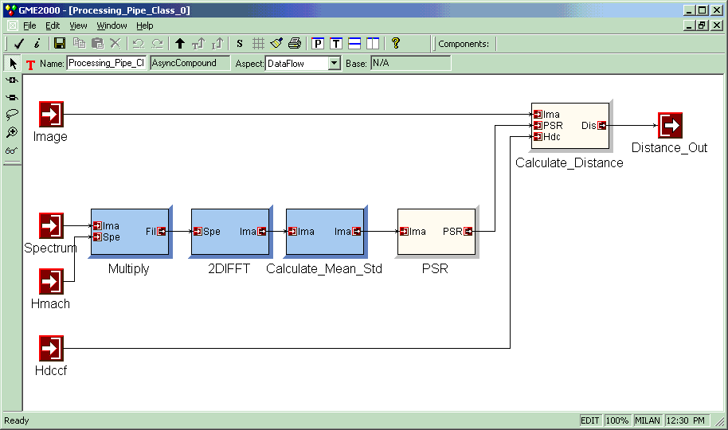
Figure 20 do_peaks model of the ATR application
The design and simulation of a system in the MILAN framework starts with application modeling. Given the size of the ATR application and the large number of design choices, both hierarchy and alternatives are used extensively. Figure 20 shows a model of the “do-peaks” block of the ATR in the MILAN framework. This model captures one of the core computations in the ATR application. When designing the application, it was determined that the functionality of the Peak to Surface Ratio (PSR) can be realized either in hardware or in software. Instead of making the selection upfront, the alternative realizations are captured in the models and the selection is postponed to a later phase of design. The PSR model in Figure 20 is an AsyncAlternative having two different implementations as shown in Figure 21.
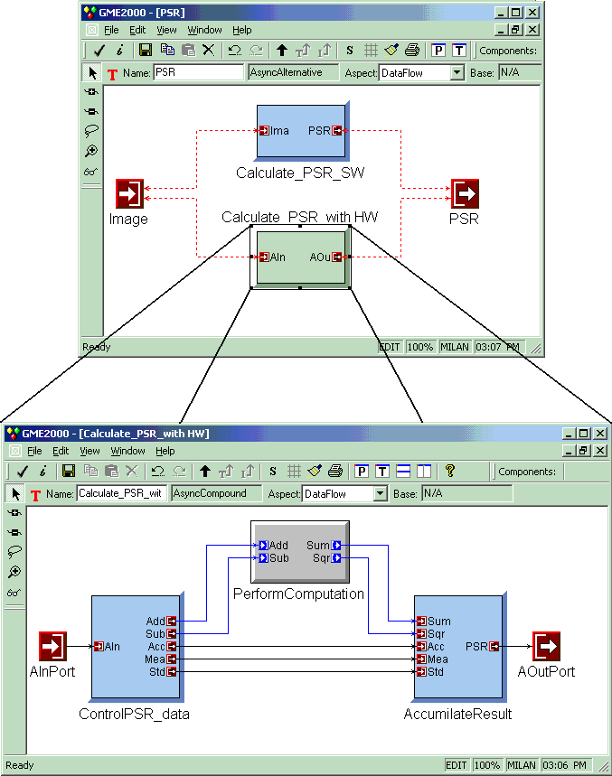
Figure 21 Alternatives in ATR application
Figure 21 shows the alternative realizations of PSR. The software implementation of PSR is an asynchronous dataflow node and uses regular C code. The alternative implementation (expanded in the figure) uses hardware calculation model for a faster and more optimized solution. The software model called ControlPSR_Data sources data to the hardware module called PerformComputation and then the AccumulateResult model accumulates the results. The PerformComputation block has a set of optimized adder and multipliers arranged to calculate the sum and sum squares of the elements of given matrix.
In the early phases of the design, it is not necessarily clear which one is a better implementation. The suitability of one over the other depends upon the actual resources that are available, the runtime execution environment that is employed, and other factors. The various simulation tools assists the designer in making these selection decisions based on the requirements of the system.
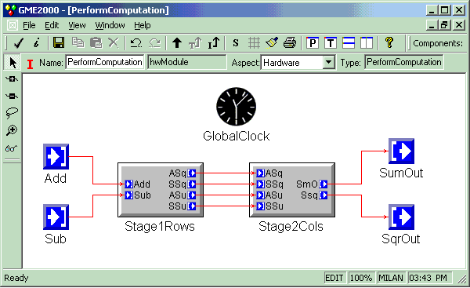
Figure 22 Sub modules of the PerformCalculation module
After choosing to develop both the alternatives the hardware model PerformComputation is refined and modeled in greater details. Figure 22 shows Implementation aspect of the hardware model called PerformComputation. It is composed of two sub modules. The Stage1Rows module performs the sum and sum of squares on the columns of an array of rows while the Stage2Cols module performs the sum and sum of squares on the row elements. Each of the sub modules is further refined to form the complete design of the system.
To verify the functional correctness of the coarse grain implementation of the alternative hardware application, the designer will choose the hardware version of the PSR and mark it to specify the use of a coarse grain implementation. Then, the user will simulate the module in isolation with the coarse grain implementation. In Figure 20 the PSR block is chosen for isolated simulation and the hardware implementation of the alternative model is selected. For this simulation, test data to source the PSR will be provided by the simulation scripts available in the CalculateMean_STD model and the Calculate_distance model will sink the data for verification.
Design the most important phase of the development process means little without implementation. To begin the implementation, developers need to verify the functional validity of their design. The first question that needs to be answered is whether the optimized algorithm is going to work. A quick high-level code is then written without worrying about the gate level details to test the validity of each sub module of the PerformComputation block.
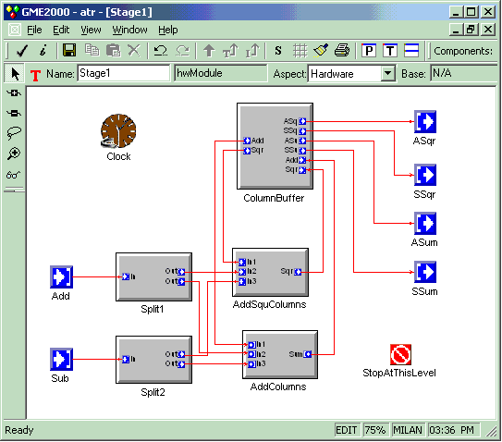
- Hardware aspect of Stage1Rows
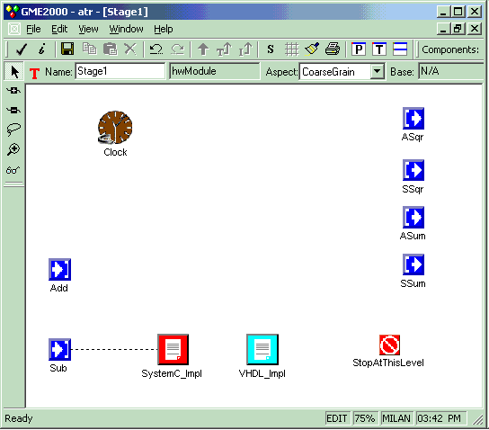
(b) Coarse grain aspect of Stage1Rows
Figure 23 Two Aspects of Stage1Rows module
Figure 23 (a) shows the true design of the Satge1Rows model, while Figure 23 (b) shows the coarse grain implementation of the same. The true design and the coarse grain implementation are orthogonal and have been captured in different aspects of the same model. The coarse grain aspect shows the high level implementation of module. It contains a SystemC-script, and a VHDL-script. The SystemC-script is a placeholder for the high level SystemC code implementing the PSR, while the VHDL-script is a placeholder for VHDL code.
After validation of the functional correctness, developers can go ahead and build the true implementation of the model. The next step will require the user to profile the hardware alternative in order to allow him to choose between hardware and software at a later stage. This will require an isolated simulation of the detailed hardware implementation of the PSR. The designer will select the hardware version in the alternative model and run isolated simulation on each sub module. After deciding on the implementation to use, the designer will want to run a full simulation of the system with the right design choice. In this example, say the hardware implementation is chosen. Then the user selects that alternative and runs the full system simulation. In this case the interpreter uses the hierarchical implementation of the PRS implemented in hardware as well as the complete implementation of the rest of the system. The full simulation allows the user to verify the design with respect to system requirements.
Evaluation Of The Case Study
Development of a portion of the ATR, which is a heterogeneous embedded system, helped us see the following advantages of the toolset and design philosophies.
- The same set of models captured the true design, coarse grain implementation, and true implementation, possibly in more than one language.
- Software and hardware sub modules of the application could be designed in the same integrated framework.
- The ease of being able to set up different simulations by the click of a few buttons and not changing the model. The same set of models can be used for isolated, hierarchical and full simulation.
- Alternative implementations are captured seamlessly and individual teams can develop different aspects of the application independently. Choosing between various alternatives is a matter of few clicks.
Finally, we see that a single framework is sufficient to design, implement, simulate and verify a heterogeneous embedded system application making the development cycle much shorter while improving the quality of the developed application.

CHAPTER VI
CONCLUSIONS AND FUTURE WORK
Conclusions
Embedded systems is a field that is fast growing and has ever increasing design and development needs. The development of support tools is not able to match the growth in this field. With increasing complexity of embedded systems there exists the need to have an integrated framework for design and development of such systems in order to speed up the design cycle and to explore various alternative solutions.
MILAN is such a framework under development, which provides an integrated environment to design embedded system applications using domain specific concepts. It allows designing of alternative solutions and abstracts the implementation from design. Separation of concerns and modular design are the pillars of MILAN.
The new hardware application description paradigm developed and integrated with MILAN allows designers to model hardware applications using domain specific concepts. The paradigm supports modular design and separates computation from communication. Separation of intention from implementation is built into the paradigm. It supports parameterization of components for reuse and flexibility. Design of alternative implementations is explicitly modeled and thus the paradigm captures design spaces as opposed to a single design. Information hiding and data abstraction is achieved by the use of multiple aspects. The hardware paradigm was then composed with the existing software paradigm to create an environment to design heterogeneous applications.
Apart form the modeling environment; model interpreters were also developed that interpret the models to generate code for different simulations. A heterogeneous interpreter was developed that traverses the models and identifies the hardware subgraph, software subgraph and the interface points. Based on the type of simulation required the interpreter filters out the irrelevant portions of the diagram. The different types of simulations that are supported are isolated simulation of a module or a group of modules, multi-granular simulation, full system simulation and hardware/software co-simulation. The heterogeneous interpreter adds proxies to both the hardware and software diagrams to facilitate hardware/software communication for co-simulation. A SystemC code generator was also developed that would take the hardware graph and generate SystemC code from it. This code can then be compiled and run to simulate the behavior of the application. For co-simulation an existing C code generator is used to generate the software side.
The framework, specifically the hardware paradigm was then used to develop various small and medium sized projects to test its strengths and weakness. The tests showed that the advantages of the environment are: (1) Ability to capture heterogeneous applications at different levels of granularity and having more than one implementation language in the same design, (2) Ease of being able to set up and simulations and quickly switching between different kinds of simulation, (3) Alternative implementations are captured seamlessly and because of modularization different teams can work on different parts of the application independently. (4) The development cycle of applications is shortened and the quality of the developed application is improved. However, the framework is not complete and needs more effort to transform it from a research tool to a professional commodity.
Future Work
Several new areas related to this research need to be explored. To start with, the framework can be extended to support generation of code for simulation in other hardware description languages such as VHDL and Verilog. Synthesis of the hardware also needs to be supported and integrated into the framework. The synthesizable portions of VHDL can be used for synthesis. Alternatively RTL code can be directly generated.
The co-simulation described in this thesis simulates the hardware while running the true implementation of the software. This is an incomplete simulation as performance metrics is obtained only for the hardware. The reason being that all the currently available simulators work offline and there is a need for online simulator to achieve a complete co-simulation. This leads to two future research directions, the development of an online instruction level simulator and then co-simulation using the simulator along with SystemC.
Currently, the behavior of the primitive modules is captured with the help of scripts written in a particular implementation language. Thus, the behavior needs to be written in every implementation language. This approach is good when implementation specific code needs to be written. However, it is inconvenient while modeling for different platforms. This problem can be overcome by providing the designer the choice of alternatively modeling the behavior in an implementation independent manner. State Charts can be used for this purpose.

APPENDIX A
Tutorial On UML Class Diagrams
Unified Modeling Language (UML) [30] is an Object Management Group (OMG) standard for diagrammatically representing object-oriented designs. UML consists of a number of diagrammatic representations of which UML class diagrams are the most widely used. The class diagrams graphically represent classes along with their member variables and functions. Inheritance, aggregation and other associations are also graphically represented. These class diagrams are a standardized and clean way to represent the design of complex systems. The important aspects of the diagrammatic representation are discussed here to provide a quick overview.
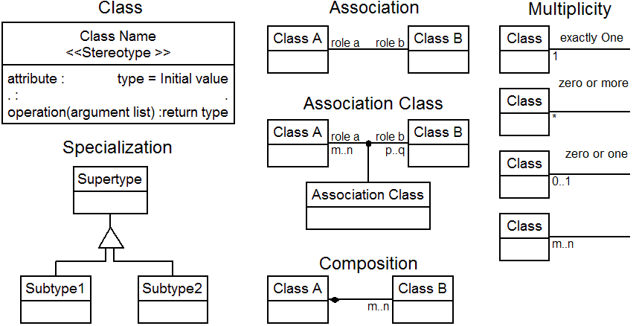
Figure 24 Basic notations of UML class diagrams [57]
Figure 24 depicts the basic notations. A class is represented as shown with the actual name of the class in place of the Class Name text. The name in angular braces depicts the stereotype of the class. A stereotype states that the class conforms to the strict rule defined by the stereotype. For example, in this paper the stereotype <<atom>> is used. The atom stereotype states that it cannot contain other classes and thus the classes with this stereotype will not contain other classes. Attributes and operations are then listed in separate containers within the class rectangle.
Class specialization is depicted using a triangular connector called discriminator. The class connected to the top on the triangle is the supertype while the classes connected to the bottom are the subtypes. Associations between classes are depicted with a line between the classes. On the association line the roles the classes play and their cardinality can also be specified. Alternatively an association class can also be specified for an association. Composition represents a special kind of association that implies a class is composed of instances of another class and the instances cannot exist outside the composed class. The composition is depicted with a line having a diamond towards the composed class. The role and cardinality of the composing class is also specified on the composition line. Cardinality basically implies the range of instances. For example, a class A is composed of 2 instances of class B, then the cardinality of class B in this composition is said to be 2. Cardinality can be specified as a fixed number or a possible range of numbers. The different notations of cardinality are shown in Figure 24.

REFERENCES
- J. T. Buck, S. Ha, A. Lee and D. Messerschmitt, “Ptolemy: A Framework for Simulating and Prototyping Heterogeneous Systems”, Int. Journal of Computer Simulation, special issue on “Simulation Software Development,” vol. 4, pp. 155-182, April, 1994.
- B. Eames, “Integrating High-Level Simulation Into A Model-Integrated Embedded System Design Toolset”, M. S. Thesis, Vanderbilt University, 2000.
- D. D. Gajski, F. Vahid, S. Narayan, J. Gong, “Specification and Design of Embedded Systems”, Englewood Cliffs, NJ: Prentice-Hall, pp. 1-6.
- Using Matlab, The MathWorks, Inc, 1999.
- Karen Bartleson, “A New Standard for System-Level Design”, Synopsis, Inc., 1999.
- M. Sgroi, L. Lavagno, A. Sangiovanni-Vincentelli, “Formal Models For Embedded System Design”, IEEE Design & Test of Computers, 17(2): 14-27, June 2000.
- L. A. Cortes, P. Eles, and Z. Peng, “A Survey on Hardware/Software Codesign Representation Models”, SAVE Project Report, Dept. of Computer and Information Science, Linköping University, Sweden, June 1999.
- A. Jerraya and K. O’Brien, “SOLAR: An Intermediate Format for System-Level Modeling and Synthesis,”, Codesign: Computer-Aided Software/Hardware Engineering, J. Rozenblit and K. Buchenrieder, Eds. Piscataway, NJ, IEEE Press, 1995, pp. 145-175.
- M. Chiodo, P. Giusto, H. Hsieh, A. Jurecska, L. Lavagno, and A. Sangiovanni-Vicentelli, “A Formal Specification Model for Hardware/Software Codesign,” Technical Report UCB/ERL M93/48, Dept. EECS, University of California, Berkeley, June 1993.
- D. Harel, “Statecharts: A Visual Formalism for Complex Systems,” Science of Computer Programming, vol. 8, pp. 231-274, June 1987.
- C. G. Cassandras, “Discrete Event Systems: Modeling and Performance Analysis”, Irwin Publications, Boston, MA, 1993.
- E. A. Lee, “Modeling Concurrent Real-Time Processes using Discrete Events,” Technical Report UCB/ERL M98/7, Dept. EECS, University of California, Berkeley, March 1998.
- J. Peterson, “Petri Net Theory and the Modeling of Systems”, Englewood Cliffs, NJ: Prentice-Hall, 1981.
- G. Dittrich, “Modeling of Complex Systems Using Hierarchical Petri Nets,” Codesign: Computer-Aided Software/Hardware Engineering, J. Rozenblit and K. Buchenrieder, Eds. Piscataway, NJ: IEEE Press, 1995, pp. 128-144.
- E. A. Lee and D. G. Messerschmitt, “Static Scheduling of Synchronous Data Flow Programs for Digital Signal Processing”, Transactions on Computers, C36 (1): 24-35, January 1987.
- Gérard Berry, “The Foundations of Esterel”, Proof, Language and Interaction: Essays in Honour of Robin Milner, 1998.
- POLIS, A Framework For Hardware-Software Co-Design Of Embedded Systems, http://www-cad.eecs.berkeley.edu/~polis/
- F. Balarin, M. Chiodo, P. Giusto, H. Hsieh, A, Jurecska, L. Lavagno, C. Passerone, A. Sangiovanni-Vincentelli, E. Sentovich, K. Suzuki, B. Tabbara, “Hardware-Software Co-Design of Embedded Systems: The Polis Approach”, Kluwer Academic Press , June 1997.
- Robert K. Brayton, Alberto Sangiovanni-Vincentelli, Adnan Aziz, Szu-Tsung Cheng, Stephen Edwards, Sunil Khatri, Yuji Kukimoto, et al. “VIS: A System for Verification and Synthesis”, Proceedings of the Eighth International Conference on Computer Aided Verification CAV, 1996.
- Rolf Ernst, Jorg Henkel, Thomas Benner, “Hardware-Software Cosynthesis for Microcontrollers”, IEEE Design and Test of Computers, Vol. 10, No. 4, pp 64-65, Dec 1993.
- A. Österling, Th. Benner, R. Ernst, D. Herrmann, Th. Scholz, and W. Ye. “Hardware/Software Co-Design: Principles and Practice”, chapter The COSYMA System. Kluwer Academic Publishers, 1997.
- Pai Chou, Ross Ortega, Gaetano Borriello, “The Chinook Hardware/Software Co-Synthesis System”, Department of Computer Science & Engineering, University of Washington, Seattle, WA, 1995.
- A. Kalavade, Edward A. Lee, “Design Methodology Management For System-Level Design”, Ptolemy Miniconference, March 10, 1995.
- E. M. Sentovich, K. J. Singh, L. Lavagno, C. Moon, R. Murgai, A. Saldanha, P. R. Stephan, R. K. Brayton, and A. Sangiovanni-Vincentelli, “SIS: A System for Sequential Circuit Synthesis”, Technical Report Memorandum No. UCB/ERL M92/41, Univ. of California, Berkeley, 1992.
- A. Kalavade, E. A. Lee, “A Global Criticality/Local Phase driven Algorithm for the Constrained Hardware/Software Partitioning Problem”, Proc. of Codes/CASHE’94, Third Intl. Workshop on Hardware/Software Codesign, pp. 42-48, Sept. 22-24, 1994.
- Edward A. Lee, “Overview of the Ptolemy Project”, Technical Memorandum UCB/ERL M01/11 March 6, 2001.
- A. Agrawal, et al. “MILAN: A Model Based Integrated Simulation Framework for Design of Embedded Systems”, Workshop on Languages, Compilers, and Tools for Embedded Systems (LCTES 2001), Snowbird, Utah, June 2001.
- J. Sztipanovits, and G. Karsai, “Model-Integrated Computing”, Computer, Apr. 1997, pp. 110-112
- A. Ledeczi, et al., “Composing Domain-Specific Design Environments”, Computer, pp. 44-51, November 2001.
- J. Rumbaugh, I. Jacobson, and G. Booch, “The Unified Modeling Language Reference Manual”, Addison-Wesley, 1998.
- S. Neema, “System Level Synthesis of Adaptive Computing Systems”, Ph. D. Dissertation, Department of Electrical and Computer Engineering, Vanderbilt University, May 2001.
- D. Burger, and M. Austin, “The SimpleScalar Tool Set, Version 2.0”, Computer Architecture News, 25 (3), pp. 13-25, June, 1997.
- S. Shiasi, and D. Grunwald, “A Comparison of Two Architectural Power Models”, Proceedings of Power Aware Computer Systems Workshop, November 2000.
- T. Bapty, S. Neema, J. Scott, J. Sztipanovits, S. Asaad, “Model-Integrated Tools for the Design of Dynamically Reconfigurable Systems,” VLSI Design, Vol. 10, pp. 281-306, 2000.
- J. Bhaskar, “VHDL Primer”, Englewood Cliffs, NJ: Prentice-Hall, 1995.
- D. J. Smith, “A Practical Guide for Designing, Synthesizing, and Simulating ASICs and FPGAs using VHDL or Verilog”, Doone Publications, 1997.
- A. Ledeczi, M. Maroti, A. Bakay, G. Nordstrom, J. Garrett, C. Thomason IV, J. Sprinkle, P. Volgyesi, “GME 2000 Users Manual (v2.0)”, Institute For Software Integrated Systems, Vanderbilt University, December 18, 2001.
- K. Nichols, and S. Neema, “Dynamically Reconfigurable Embedded Image Processing System”, Proceedings of the International Conference on Signal Processing Applications and Technology, Orlando, FL, November, 1999.
- A. Mahalanobis, B. V. Kumar, and S. R. F. Sims, “Distance-classifier correlation filters for multi-class target recognition”, Applied Optics, Vol. 35, No. 17, pp3127-3133, 10 June 1996.
- S. Mohanty, et al., “HiPerE: A Framework for Rapid System Level Power and Performance Estimation of Embedded Applications on SoC/SoP Architectures”, submitted to Design, Automation, and Test in Europe, March 2002.
- http://www.nist.gov/dads/HTML/modelofcompu.html, National Institute Of Standards And Technology (NIST), 100 Bureau Drive, Stop 3460, Gaithersburg, MD 20899-3460.
- G. E. Moore, “Cramming more components onto integrated circuits”, Electronics, Volume 38, Number 8, April 19, 1965.
- W. T. Chang, S. Ha and E. A. Lee, “Heterogeneous Simulation - Mixing Discrete-Event Models with Dataflow”, Journal of VLSI Signal Processing, Vol. 15, pp. 127-144, 1997.
- “Blif-MV: An interchange format for design verification and synthesis”, Technical report, Berkeley Logic Synthesis Group, 1990.
- “Xilinx Netlist Format (XNF) Specification Version 6.1”, Xilinx Inc., June 1, 1995.
- “IEEE standard VHDL language reference manual“, IEEE Std 1076-1987, March 31, 1988.
- “IEEE standard hardware description language based on the Verilog(R) hardware description language”, IEEE Std 1364-1995, October 14, 1996.
- “Java Remote Method Invocation - Distributed Computing For Java”, White paper, Sum Microsystems, Inc., 1995 – 2002.
- Defense Advanced Research Projects Agency (DARPA), http://www.darpa.mil/.
- S. Edwards, L. Lavagno, E. A. Lee, and A. Sangiovanni-Vincentelli, “Design of Embedded Systems: Formal Models, Validation, and Synthesis”, Proceedings of the IEEE, Vol. 85, No. 3, March 1997.
- Edward A. Lee, “What's Ahead for Embedded Software?”, IEEE Computer Magazine, pp. 18-26, September 2000.
- A. Ledeczi, “Model Construction for Model-Integrated Computing”, 13th International Conference on Systems Engineering, pp. CS103-108, Las Vegas, NV, August, 1999.
- S. Willliams and C. Kindel, “The Component Object Model: A Technical Overview”, Developer Relations Group, Microsoft Corporation, October, 1994.
- J. Davis, Personal communication, January 2001 – March 2002.
- “Using Rose”, Rational Software Corporation, Cupertino, CA 95014.
- http://www.ilogix.com/products/magnum/index.cfm, Statemate MAGNUM, I-Logix Inc., Andover, Ma.01810.
- M. Fowler, “UML Distilled Second Edition”, Addison Wesley Longman, Inc., 200.
- E. A. Lee, http://ptolemy.eecs.berkeley.edu/~eal/ee290n/glossary.html, EE290N: Advanced Topics in System Theory, Fall, 1996.
- J. Rozenblit, K. Buchenrieder, “Codesign”, IEEE Press, NY, 1995.
- A. Sangiovanni-Vincentelli, “Defining platform-based design”, EEdesign, February 5, 2002.

