COMPUTER SCIENCE

AUTOMATED COMPONENT COMPATIBILITY AND RESOURCE USAGE
VERIFICATION IN SENSOR NETWORKS

SEBESTYEN DORA

Thesis under direction of Professor Gabor Karsai

As software systems become more complex architecture design and verification become central problems. To reduce the size of the design problem, higher-level of abstractions are used to compose systems from components using hierarchy. To accomplish the verification of the whole system the same abstraction logic in the system’s design used as well as, to verify individual of the components and their compatibility.
In this thesis we present an automated verification of component compatibility and resource usage in the domain of sensor networks. In the first part of this work we introduce the problem domain, sensor networks. In the second part, a means to describe the temporal behavior of components is presented. We introduce and analyze the differences between the pessimistic (traditional or input enabled) and the optimistic approaches to verification to substantiate our approach. Two extensions of interface automata as well as the concept of the resource automata are also presented. In the third part we introduce our extensions of interface automata and a Gratis - Uppaal translator that provides a powerful verification tool. We also illustrate an implementation of the interface automaton based on TinyOS component verification with the Generic Modeling Environment (GME) and UPPAAL.

Approved ________________________________
Date ___________
AUTOMATED COMPONENT COMPATIBILITY
VERIFICATION IN SENSOR NETWORKS

By

Sebestyen Dora

Thesis
Submitted to the Faculty of the
Graduate School of Vanderbilt University
in partial fulfillment of the requirements
for the degree of
MASTER OF SCIENCE
in
Computer Science

May, 2004

Nashville, Tennessee

Approved: Date:
____________________________________________ ________________
____________________________________________ ________________
TABLE OF CONTENTS

LIST OF FIGURES iv
LIST OF TABLES vi

Chapter Page

- INTRODUCTION 1
Sensor network 3
TinyOS and nesC 5
Gratis 7
Metamodel of Gratis 8
A simple example in Gratis 8
The component compatibility problem 11
- INPUT-OUTPUT AUTOMATA 13
Input enabled automata 13
Formal definition 13
Composition and compatibility 15
Interface automata 18
The formal definition of the interface automaton 19
Composition of interface-automata 21
Verification 23
The traditional input-output automata vs. interface automata approach 25
Interface automata – optimistic approach 26
Input output automata – pessimistic approach 27
Extension of interface automata 27
Transient states 27
Projection Automata 30
Resource interfaces 31
Formal definition 31
Pure threshold interfaces 33
Büchi threshold interfaces 34
Pure energy interfaces 35
Reward energy interfaces 36
- COMPONENT VERIFICATION OF SENSOR NETWORKS 38
Representation of interface automata in Gratis 38
Hierarchical states 42
Transient states 46
Parameterized interfaces 47
Return values as guards 47
Resource interfaces 48
Verifications 49
Formal expressions 49
Component compatibility checking 50
Resource interfaces checking 52
Verification in Uppaal 54
Component compatibility 56
Resource interfaces 56
Gratis Uppaal translator 57
Uppaal verification examples 59
Verification examples 60
Example 1: User and Comp 60
Example 2: Blink application 63
Evaluation of examples 67
Automated input-output automata creation 68
- CONCLUSION 70
Results 70
Future work 71
REFERENCES 73

LIST OF FIGURES

Figure Page
- GRATIS metamodel in GME 8
- Blink.nc configuration 9
- BlinkC configuration 9
- BlinkM.nc module 10
- BlinkM module 10
- I/O automata A & B 18
- I/O automaton composition of A and B 18
- Interface automaton – Comp 20
- Interface automata – Counter & Comp 22
- Interface automaton – Counter ⊗ Comp 22
- Interface automaton – Counter || Comp 23
- Interface automata – System & Comp ⊗ Counter 24
- Interface automaton – System ⊗ Comp ⊗ Counter 24
- Interface automaton – MessageBuffer 28
- Interface automata – MessageProducer & MessageConsumer 28
- Interface automaton – MessageBuffer with transient states 29
- Interface automaton – The projection of MessageBuffer onto MessageConsumer 30
- Pure threshold interface 33
- Büchi threshold interface 34
- Pure energy interface 35
- Reward energy interfaces 36
- Interface automata extension of GRATIS 38
- Interface automata – Comp, User and Channel 39
- GRATIS – Comp interface automaton 40
- GRATIS – User interface automaton 41
- GRATIS – Channel interface automaton 41
- GRATIS – Sender 43
- GRATIS – Hierarchical Sender interface automaton 45
- GRATIS – State „2” interface automaton 45
- GRATIS to UPPAAL interpreter 59
- UPPAAL – Channel, User and Comp 60
- UPPAAL – User and Comp are incompatible 61
- UPPAAL – User || Comp compatible with Channel 62
- UPPAAL – Pure energy interface of Comp 63
- GRATIS – Main automaton 63
- GRATIS – ClockC automaton 63
- GRATIS – ClockC Hierarchical state 64
- GRATIS – ClockC (flattened) 64
- GRATIS – LedsC automaton 65
- GRATIS – LedsC red LED 65
- GRATIS – BlinkM automaton 66
- GRATIS – BlinkM Running state 66
- GRATIS – BlinkM automaton (flattened) 66
- UPPAAL – BlinkM & Main 67
- UPPAAL – BlinkM & ClockC 67
- nesC – BlinkM code part 68
- GRATIS – BlinkM automaton from code 69

LIST OF TABLES

Table Page
1. Resource interface properties………………………………………………………...58

CHAPTER I

INTRODUCTION

As software systems become more complex, architectural design and verification become a central problem. System verification proves whether the system behaves according to the design specifications and requirements. To reduce complexity, highly compound systems are broken down to smaller hierarchical components. On a high level of abstraction, the system is composed of sets of hierarchical components. Each component is an autonomous unit with its own “life”. A component can communicate with other components by taking input and output actions through its interfaces. In component based design the interface is the most important notion. The interface is the boundary of a component that defines the input and output connection points of the component. Typically, interfaces do not describe the temporal behavior of components, therefore the verification of components’ compatibility with respect to behavior is not possible. The temporal behavior of a component can be described using automata (see [1], [6] and [5]) or state-charts (see [3]). Other approaches are also possible, for example, [2] gives a formal textual notation – connector types – and describes a verification process.
The automata based modeling approach employs nondeterministic automata with a possibly infinite number of states. Automata consist of states, actions and transitions. The execution of an automaton is an alternating sequence of states and actions such that consecutive triplets of states, actions and states are in the transition relation. The input-output automata model (see [1]) describes the communication of a component with the environment using input and output actions. The actions that are invisible from outside are called internal actions. The input-output automata model gives a formal description of the components’ temporal behavior enabling formal verification.
The traditional input-enabled automata approach (see [1]) allows for the occurrence of every input action in every state, thus input actions distinct and distinguished from the internal and output actions. The pessimistic approach to verification assumes that the environment can fully control the system. The execution can be considered a game where the environment tries to lead the component into an invalid state. This approach defines two components to be compatible if their automata can be composed such that the composition rules are not violated. This approach is strict, but states an unconditional compatibility, as we will show in the second chapter.
The interface-automata theory approaches the problem from a diametrically different point of view. The optimistic approach to verification, introduced in [6], assumes the environment “helps” the components and tries to lead them away from the illegal states. This approach is closer to real component development, where the environment also intentionally reacts and is usually created by a human (i.e., another application). Therefore, it defines two components to be compatible if an environment exists where the composed automaton does not contain any illegal state. Consequently, the interface automata theory, unlike the input-enabled theory, does not deal with all the possible errors, but gives a much easier and faster verification algorithm, with its composition usually resulting in smaller automata. Because of these advantages, interface-automata were widely used, for example, in [7], [10], and [12]. The extension of the interface automata theory, the Resource Interface theory, was introduced in [9] and [11] to support the verification of the component resource usage (memory, power, etc.). Transient states were added to the language to describe non-interruptible states, and the projection of automaton was introduced to hide the “interfering” transitions to convert them to internal states (see [4]).
In this thesis we introduce an extension of the interface automata theory to achieve a suitable description language for components in the domain of sensor networks. We further introduce the notion of hierarchical state, which allows for a more perspicuous automata definition. To allow for further domain specific verification we extend the language with parameterized transitions, and with return-value based transition guards. Finally, we will show our implementation of our extended interface automata in the Generic Modeling Environment (GME) [16] and a verification process using the UPPAAL [24] verification tool. Using real world examples we will illustrate the concepts of interface automata and demonstrate their verification.
In the remainder part of this chapter, we will briefly introduce the sensor network domain, the TinyOS operating system, its programming language nesC, and outline the component compatibility problem.

Sensor network

Our research area is the field of sensor networks. The sensor networks are composed of numerous sensing devices, called nodes. Nodes usually have limited computational capacity, a sensor nodes are typically made of cheap components to keep the cost of the overall network manageable. These hardware units can easily run out of power or fail. Typical networks are composed of 10 to 10,000 nodes, usually scattered in the deployment area in ad hoc manner. The nodes usually communicate with each other through radio channels. However, other types of communication methods can be used, such as a wired network or acoustic channel. Usually the nodes share a single radio channel where the radio links between nodes are not symmetric and the power of the transmission changes over time. These factors make communication protocols hard to implement.
Sensor networks are typically used to collect data and route it to a base station (i.e. personal computer). Nodes in the network can have different functions (data collector node, data processing node, etc.), sensors (i.e.: light, temperature, accelerometer, magnetometer, microphone, humidity, etc.), and can also differ in their computational power and communication range. Some even can manipulate the environment directly. Nodes can also distribute the application tasks and dynamically adapt to the changing environment and network topology.
Sensor networks have been deployed in the Great Duck Island Monitoring Project (see [25]) for example, where it collects environmental data, temperature, humidity, and total solar radiation in an endangered duck habitat. Another example is a counter-sniper system [19] where the sensor network nodes detect shots and send the time of arrival of the muzzle blast to the base-station. The base station fuses the data to calculate the position of the shooter.

In sensor networks, the verification of component compatibility is critical. Failure to verify a component could result in system instability due to the failure of nodes in untested situations, which ultimately could bring the whole system down.

TinyOS and nesC

TinyOS (see [15] and [26]) is a component based operating system with a very small footprint designed for network-embedded sensor nodes. The TinyOS programming model is designed for event-driven applications. The sensor devices have extremely constrained hardware resources. For example, the Berkeley experimental hardware platforms (e.g. mica2 see [32]) have 7.36 MHz of CPU speed, 64 Kbytes of program memory and 4 Kbytes of RAM. The core of the TinyOS requires only 400 bytes of code and data memory.
TinyOS key features:
- Component based architecture:
TinyOS provides a set of reusable system components. Applications are composed of components using wiring specifications. Most OS components are software modules; some are thin wrappers around hardware to create a uniform framework for developers.
- Task and event-based concurrency
The concurrency model of TinyOS is based on tasks and events. Tasks can be posted by components and do not preempt each other. Tasks are usually used when timing requirements are not strict. The execution time of tasks should be short and if longer operation is needed it should be shared across several task invocations. Events also run to completion, but may preempt the execution of a task or another event. The events represent hardware interrupts and drive the TinyOS execution.

- Split phase operations:
TinyOS has no blocking operations. All long-latency operations are split-phase, meaning that operation requests and their completion are separate functions calls. Two types of split-phase functions can be used: (1) the command, typically requesting execution of an operation, and (2) the event, signaling the completion of the execution. Each component implements one half of the split-phase operation and calls the other; the wiring connects both commands and events across component boundaries.

The nesC [13], [14] is the programming language of TinyOS. It is an extension of the standard ANSI C language. The nesC compiler produces efficient code for microcontrollers. nesC retains the advantages of the C language, such as access to low level hardware, while maintaining backward compatibility with existing C code. nesC tries to eliminate the disadvantages of C, like the lack of support of writing safe code, by reducing the expressive power of C and mandating a component based structure.

A system is built from hierarchical components. A component can be either a module or a configuration. A configuration binds a set of modules as one component. A module implements a set of behaviors defined by a set of used or provided interfaces. Interface declarations are similar to the IDL (interface definition langue), which is used in e.g. CORBA [28] and Microsoft COM [29], and describe the input and output methods.
nesC supports the TinyOS event based concurrency model and concurrent access to shared data by atomic sections.

Summary of basic concepts of nesC:
- Separation of component construction from application composition: (components, assembled to form a complete application).
- Specification of component behavior in terms of a set of interfaces.
- Interfaces are bi-directional (commands, events).
- Components are statically linked to each other via their interfaces.
- nesC is designed under the expectation that code will be generated by whole-program compilers

Gratis

Gratis (see [27]) (Graphical Development Environment for TinyOS) was created to visualize TinyOS components and their hierarchy and relationships. Gratis is an add-on in the Generic Modeling Environment (see [16]) (GME). The Gratis interpreter provides a bidirectional bridge between graphical models and nesC code. It can both generate nesC code from graphical models, and build up the graphical representation of existing components. Although, it has to be noted that the interpreter generates only configuration code not procedural codes. Gratis captures most of the features of nesC: configuration, module, interface, event, command, task, wiring, etc. Therefore, Gratis is an ideal tool for understanding nesC applications and their structure and for rapid development of TinyOS applications.
The Gratis key features:
- nesC code parsing to build up the Gratis models
- support for the nesC 1.1 language
- nesC code generation from Gratis models
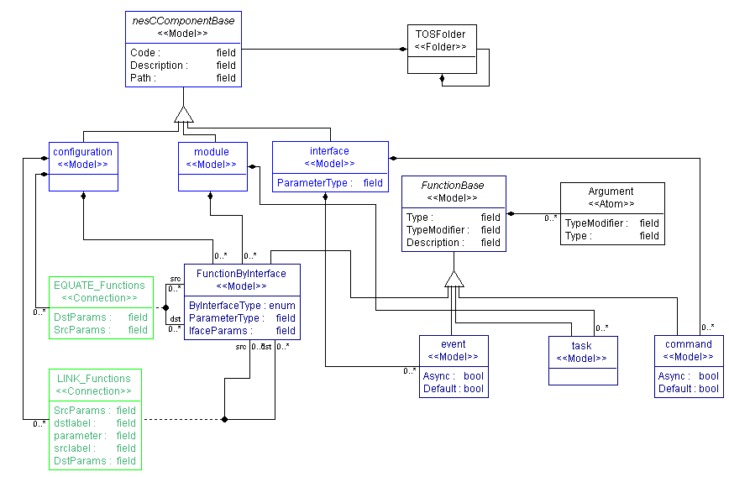
Figure 1: GRATIS metamodel in GME

Metamodel of Gratis

InFigure 1 Figure 1, the main part of the Gratis paradigm id depicted (see [16] for detailed description of paradigm synton). In the class diagram the elements of nesC language can found; configuration, module, interface, event, command and task. The FunctionByInterface represents the extensibility of the interfaces so that the components can add further functions to the interfaces thuw in a sense providige a kind of “inheritance”.

A simple example in Gratis

Blink is a simple application developed in TinyOS, it causes the Light Emitting Diodes (LEDs) on the hardware to blink. The Blink application is composed of Main, BlinkM, ClockC, and LedsC components as depicted in Figure 2. The Main component represents the starting point of the program. It initializes and starts the BlinkM component. The ClockC component is a timer, it implements the Clock interface that provides methods to configure the timer.

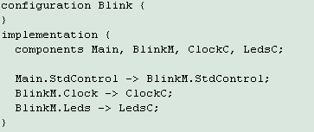
Figure 2: Blink.nc configuration
Once the frequency of ClockC component is set through the Clock interface, it periodically generates fire events. The LedsC component provides the Leds interface for controlling LEDs on the hardware platform.

Figure 3: BlinkC configuration
After the ClockC and LedsC components are properly initialized, the BlinkM component waits for fire events from ClockC, and then it switches the LEDs on/off by calling a particular method of the Leds interface.

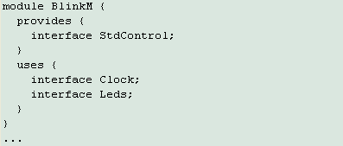
Figure 4: BlinkM.nc module
Therefore, this application simply blinks the LEDs on the hardware. The BlinkC application can be seen in Figure 3. The boxes signify modules (LedsC and BlinkM) and configurations (Main and ClockC)
.

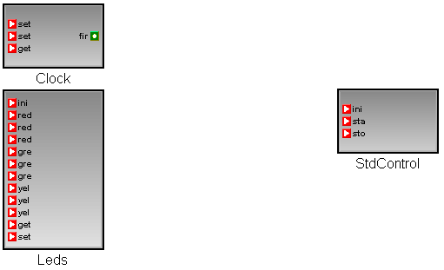
Figure 5: BlinkM module
Components can be connected through their interfaces. The ports of the component (depicted with small boxes within the component) represent the provided and used interfaces. Two components can be connected if and only if one of them provides and the other uses the same interface. Figure 4 and Figure 5 depict the nesC code of the BlinkM component and its Gratis representation, respectively.
. The BlinkM component uses (see Figure 4) the Clock and the Leds interfaces (on the left hand sideof Figure 4 Figure 5) and provides (see Figure 4) the StdControl interface (on the right hand side of Figure 5). Within the interfaces, lefde red ports (depicted as triangles) represent commands green right-side ports (depicted as circles) represent events.

The component compatibility problem

The final goal would be the total verification of a complete sensor network application, but this is unfortunately infeasible except in trivial cases. The infeasibility is driven by the fact that for non-trivial cases the size of the state space increasing exponentially, rendering exhaustive verification too costly. In practice, a good but not perfect model can be created with acceptable effort to make the verification both possible and profitable. The total verification of the original systems cannot be concluded from this partial model. By choosing a light-weight modeling language with great descriptive power and with high coverage of the problem, an good equilibrium of the requiring effort and the result can be achieved.
The nesC language naturally supports the complexity reduction of model verification since it limits component interactions to well defined sets of interfaces and encourages hierarchical decomposition. These properties of nesC allow the “static” verification, but are insufficient for the “dynamic” verification of the application. To describe the dynamic behavior of components it is natural to use a well-established automata language because it provides an easily understandable formal description that can be used during the verification process.
In the next chapter the input-output automata theory, the interface automata theory and its extensions are introduced.
CHAPTER II

INPUT-OUTPUT AUTOMATA

Input enabled automata
Input-output automata are introduced by N. Lynch in [17]. The formal definition, composition and verification of the input-output automata are introduced in this section.

Formal definition

The input, output and internal actions are disjoint sets. The input and output represent the interactions between the automaton and its environment and the internal actions symbolize the inner changes of the status of the automaton. The triplet of the sets of input, output and internal actions is called the action signature S of an automaton A, denoted by sig(A). The input(S), output(S) and internal(S) denote the input, output and internal actions of S, respectively. The set input(S) ∪ output(S) ∪ internal(S) of all actions is denoted acts(S). Since internal(S) represents the actions internal to the automaton, it is reasonable to call the actions input(S) and output(S) the external actions of S, denoted by ext(S). The set internal(S) ∪ output(S) of locally controlled actions is denoted by local(S).

An input-output automaton A can be described as a five-tuple:
1. states(A), a set of states
2. start(A), a non-empty subset of states(A), called the initial states
3. sig(A), an action signature
4. a transition relation steps(A) ⊆ states(A) × acts(sig(A)) × states(A), with the property that for every state a and every input action π there is a transition (a, π, b) ∈ steps(A).
5. part(A), an equivalence relation on local(sig(A)).

The transition relation steps(A) has the property that input actions are continuously enabled. The equivalence relation part(A) is a partition of the locally-controlled actions, which is used to model concurrent tasks of the automaton.
The step (a, π, a’) is called an input step if π is an input action. Output-, internal-, external- and locally controlled step are defined similarly. If (a, π, a’) is a step of A, then π is said to be enabled in a. Since every input action is enabled from every state, the automata are said to be input enabled.
An execution fragment of an automaton A is a finite sequence a₀, π₁, a₁... π_{k}, a_{k} or infinite sequence a₀, π₁, a₁, π₂, a₂... of alternating states and actions such that (a_{i}, π_{i+1}, a_{i+1}) is a step of A for every i. An execution fragment starting with an initial state is called an execution. The set of executions of A is denoted by exec(A). A state a is said to be reachable if there exists a finite execution in which the state a is the final state.
The schedule of an execution x is the subsequence of actions appearing in x, denoted by sched(x). The set of schedules of A is called scheds(A).
An execution module E consists of a set of states, an action signature sig(E), and a set exec(E) of executions. Each execution of E is an alternating sequence of states and actions of E beginning with a state, and ending with a state if the sequence is finite. Each execution x has an associated schedule sched(x) that consists of the subsequence of actions appearing in x. The set of schedules of E is denoted by scheds(E). An execution module E is said to be an execution module of an automaton A if E and A have the same states, the same action signatures, and every execution of E is an execution of A. For any execution module E we can always find an automaton A such that E is an execution module of A. An example of such an automaton for an execution module E is the automaton that has the same states and action signature as E, and has the transition relation: states(E) × acts(sig(E)) × states(E).
A schedule module S consists of an action signature sig(s) together with a set scheds(S) of schedules. Each schedule of S is a finite or infinite sequence of actions of S. Given an execution model E, there is a natural schedule module associated with E consisting of the action signature and schedules of E. This module is denoted by Scheds(E), and Scheds(A) is shorthand for Scheds(Execs(A)).

Composition and compatibility
To build a complex system from smaller parts the notion of composition has to be introduced. Informally, composition is the Cartesian product of the composed automata. An additional requirement is that the composed automata have to synchronize their shared actions. This means that each automaton is allowed to take steps independently, with the restriction that if one automaton takes a π-step, then all automata sharing the action of the step π must also take the π step.
The synchronization of shared actions models communication between system components: If π is an output action of A and is also an input action of B, then simultaneous performance of π models communication from A to B. The internal actions of each automaton in the composition have to be disjoint from the actions of the other automata, because the internal actions will become externally undetectable after the composition. With this restriction on the action signatures of composed automata, determining the type of an action in a composition is simple: Output actions of the component automata become output actions of the composition, internal actions of component automata become internal actions of the composition.
Formal definition of the composition:
Action signatures {S_{i} : i ∈ I} (where I is a set of components) are compatible if for all i,j ∈ I , i≠j, all of the following hold:
1. output(S_{i}) ∩ output(S_{j}) = 0,
2. internal(S_{i}) ∩ acts(S_{j}) = 0,
3. No action is contained in infinitely many sets acts(S_{i})

Objects {O_{i} : i ∈ I} are compatible if their action signatures are compatible.
The composition S =$\prod{{}_{i∈I}S_{i}}$ of compatible action signatures {S_{i} : i∈ I} is defined to be the action signature with:
- input(S) = $\underset{i∈I}{}\text{input}(S_{i})−\underset{i∈I}{∪}\text{output}(S)$
- $\text{output}(S)=\underset{i∈I}{}\text{output}(S_{i})$, and
- $$\text{internal}(S)=\underset{i∈I}{}\text{internal}(S_{i})\text{.}$$
The composition operation is commutative and associative.
The composition $A=\prod{A_{i}}$of compatible automata {A_{i}: i∈I} is defined to be the automaton with:
states(A) = $\prod_{i∈I}{\text{states}(A_{i}),}$
start(A) = $\prod_{i∈I}{\text{start}(A_{i}),}$
sig(A) = $\prod_{i∈I}{\text{sig}(A_{i}),}$
part(A) = $\underset{i∈I}{}\text{part}(A_{i}),$ and
steps(A) equal to the set of triples({a_{i}},π, {a_{i}’}) such that for all i ∈ I
  - if π ∈ acts(A_{i}) then (a_{i}, π, a_{i}’) ∈ steps(A_{i}), and
  - if π ∉ acts(A_{i}) then a_{i} = a_{i}’.
It is not hard to verify that the composition of input-enabled automata yields an input-enabled automaton.

Automata composition example

Let us consider two automata A and B. Each automaton has two states (a₀,,a₁ and b₀,b₁) as it can be seen in Figure 6, α is an output action (denoted by “!”) of A and an input action (denoted by “?”) of B, and β is an output action of B and an input action of A. Each automaton waits for the other to take an output step before taking an output step itself. Therefore, the automata A and B alternate their output steps in the execution of the composition, which is shown in Figure 7. Furthermore, since α and β are output actions of A and B, respectively, all actions of the composition of A⋅and B are output actions.

Figure 6: I/O automata A & B

Figure 7: I/O automaton composition of A and B

Interface automata
The interface automata [6] model is a light-weight formalism for modeling components and their environment. Similarly to other automata models, interface automata consist of states and transitions and use the same notations as the input-output automata model. The transitions can be associated with three different kinds of actions: input, output and internal. When modeling a software component, input transitions correspond to the invocation of methods on the component, or the returning of methods calls from other components. Output transitions correspond to the invocation of methods on other components, or returning of method calls from the component being modeled. Internal actions correspond to computations executed inside the component.

Interface automata describe the temporal I/O behaviors of components in a formal way. This modeling language uses the I/O automaton syntax. The synchronization of the automata happens through inputs and outputs.

The formal definition of the interface automaton
The interface automaton is a 6-tuple P = <V_{P}, V_{P}^{Init}, A^{I}_{P}, A^{O}_{P}, A^{H}_{P}, τ_{P}>
Where:
- V_{P}: is a set of states
- V_{P}^{Init} ⊆ V_{P}: is a non-empty set of initial states.
- A^{I}_{P}: is a set of input actions
- A^{O}_{P}: is a set of output actions
- A^{H}_{P}: is a set of internal actions
- τ_{P} ⊆ V_{P} × A_{P} × V_{P} is a set of steps.
where A^{I}_{P}∩ A^{O}_{P} ∩ A^{H}_{P} = 0 and A_{P} = A^{I}_{P} ∪ A^{O}_{P} ∪ A^{H}_{P}.

Figure 8: Interface automaton – Comp
Example of an IA (interface automata):
V_{comp} = {S0, S1, S2, S3, S4, S5, S6}
V_{comp}^{Init} = {S0}
A^{I}_{comp} = {Init?, getMsg?, nackSave?, ackSave?}
A^{O}_{comp} = {nackMsg!, ackMsg!, saveMsg!}
A^{H}_{comp} = ∅ (;)
τ_{comp} = { (S0,Init,S1), (S1,getMsg,S2), (S2,saveMsg,S3), … }
The Comp automaton (see Figure 8) describes a component that gets a getMsg? input and tries to save it by calling an output action saveMsg!. If the saving is unsuccessful it signals back a nackMsg!, otherwise it returns an ackMsg!.
The input and output transitions are described by arrows which point to or from the automaton, respectively. The actions on the left and the right hand sides represent the communication façade for different components.

Composition of interface-automata

Two interface automata P and Q are compatible if:
- their input and output actions are disjoint:
A^{I}_{P} ∩ A^{I}_{Q} = ∅ , A^{O}_{P} ∩ A^{O}_{Q} = ∅ ;
- and their internal actions are disjoint with the other automaton’s actions
A^{H}_{P} ∩ A_{Q} = ∅ , A^{H}_{Q} ∩ A_{P} = ∅ ;
The composition can be obtained as the Cartesian product, P ⊗ Q.

Composition example
The composition of the Counter and the Comp interface automata from Figure 9 is shown in Figure 10. The Comp is introduced previously. The Counter represent an automaton that sends a message to the Comp, waits for the acknowledgement (ackMsg?) and, after its arrival, sends a Count! message to another automaton.
The following rules define the composition:
- The input-output actions pairs become internal actions in the composed automata.
- The labels of the states are the concatenations of the labels of the original states.
- Those input and output actions, which have not yet been covered become input and output actions of the composed automaton.
The composed automaton describes the behavioral of the Counter-Comp automata.

Figure 9: Interface automata – Counter & Comp

Figure 10: Interface automaton – Counter ⊗ Comp

Verification

According to the optimistic approach, two components are compatible if there is exists an environment in which they can execute without failing.
In this case the composition of the two automata is obtained by restricting the product of the automata to the compatible (non-illegal) states. The illegal states model deadlock states of the system, because in case of a shared action (π_{shared}) all automata that contain π_{shared} have to perform steps in parallel.
The formal definition of an invalid state is follows:
A and B are interface automata
Illegal(A, B) = { (v,u) ∈ V_{A} × V_{B} | ∃ a∈ Shared(A,B) such that :
( a∈ A^{O}_{A}(v) and a ∉ A^{I}_{B}(u)) or (a∈A^{O}_{A}(u) and a ∉A^{I}_{B}(v)) }

In the Counter-Comp example: Illegal(Counter, Comp) = S5 (denoted by a crossed state in Figure 10).

Figure 11: Interface automaton – Counter || Comp
Therefore, we need to remove the illegal states from Counter ⊗ Comp. The resulting Counter || Comp (|| denotes the interface automata composition) automaton is described in Figure 11.

.
Figure 12: Interface automata – System & Comp ⊗ Counter

Figure 13: Interface automaton – System ⊗ Comp ⊗ Counter
However, after all illegal states are removed from the Counter ⊗ Comp automaton, the Counter || Comp automaton will not work correctly in an environment that generates an input sequence that would lead to an illegal state (in this case S5).
The System component, shown in Figure 12, is an example of a legal environment for Counter || Comp because the state (S5, q), u∈V_{System} is not reachable.
Note, that according to the pessimistic approach (described in 2.1.2) the Counter and Comp automata are not compatible.

The traditional input-output automata vs. interface automata approach

The traditional (pessimistic) and the optimistic composition rules have several important differences that stem from their different approaches. The input-output automaton theory assumes that input actions can occur at any time and they are enabled in every state. That approach also assumes that the environment, during the execution, tries to lead the automata to invalid states. The optimistic approach takes a step back and verifies the models by introducing the environment into the verification process. Therefore, the meaning and the validity of the compatibility is different in the optimistic and the pessimistic approaches. According to the traditional approach, components are compatible if their composition automaton does not contain any illegal state. The validity of the compatibility statement is true for any environment. The problem with the pessimistic approach is that it is extremely strict in most cases and does not reflect any knowledge about the intentions of the developer. Thus, the resulting models of this approach may differ significantly from the real system. The interface automata approach examines the component compatibility, actively incorporating the environment into the composition process.
The interface automata approach differs from the traditional input-output automaton theory in the strength of the assumptions on the occurrence of input actions. In particular, it does not require the input actions to be enabled in all states, because the environment is helping the components avoid illegal states. Therefore, the components are compatible in the optimistic approach if their composed automaton is not empty (because during the composition of interface automata the state space can be reduced by pruning the illegal states) and it can be composed with an environment. This approach is closer to the real life, but totally ignores error handling.
In the next sections we summarize the main advantages and disadvantages of these approaches.

Interface automata – optimistic approach

- Pros:
- The behavior of the components can be modeled in a more realistic way for certain environments.
- The complexity of the program is reduced during the composition by eliminating illegal states and converting input and output actions to internal actions.
- Cons:
- If the assumption of the friendly environment is invalid, this approach does not give correct results.
- Compatibility means that the components can work together if their environment is “good”, therefore, their compatibilities conditional.

Input output automata – pessimistic approach

- Pros:
- Environment independent compatibility: if two components are compatible then they are compatible in any environment.

- Cons:
- The composition causes state explosion, making the verification of complex systems infeasible.

Extension of interface automata

The following extensions were previously described in [4] in depth. We show them here because these improvements are also useful in our domain. [4] describes two extensions to the Interface automata: transient states and projection automata.

Transient states

Suppose we have a MessageBuffer (see Figure 14) and we want to extend it to include MessageProducer (see Figure 15) in the modele ReceiveMsg represents the sending of a message from the producer to the buffere ackReceive is the acknowledgement of the previous actione canReceive corresponds to the query of the availability status oe MessageBuffere Full and Empty are the return values of the previous inquiry. These are the interactions between the buffer and the producer. Now, if we compose MessageProducere MessageBuffer, ane Consumer in Figure 15, the result is an empty automaton.
Figure 14: Interface automaton – MessageBuffer

Figure 15: Interface automata – MessageProducer & MessageConsumer

This result looks strange, but many steps can be found during the composition where the result is an illegal state. For example, if MessageProducer calls canReceive(), the MessageProduce automaton moves to state s2, and MessageBuffer moves to state s7. At this time, if MessageConsumer calls hasMsg(), the MessageBuffer automaton cannot accept this call at state s7, so the state (s2,s7,s1) in MessageProducer⊗MessageBuffer⊗MessageConsumer is illegal. Another situation where we enter an illegal state is where MessageProducer calls ReceiveMsg(), but before this call returns, the consumer calls hasMsg(). Since these illegal states are reachable from the initial state of the automata, the whole composition is empty.
The issue here is that when we design a buffer like MessageBuffer, we assume that the sequence of the calls and their return actions are non-interruptible. In fact, when we implement such a buffer, we probably will protect all of its methods, canReceive(), hasMsg(),ReceiveMsg() and SendMsg(), as critical sections. In the actual interface automaton, there is an intermediate state between the input transition that represents a method call, and the output transition that represents the return of the call. So in the interface automaton model the methods are all interruptible.
.
Figure 16: Interface automaton – MessageBuffer with transient states
To support non-interruptible states, the notion of a transient state is introduced. These states are denoted with a “t” at the end of their names in the block diagrams, as shown in Figure 16. Transient states can only have output and internal transitions. When we compose two automata, and one of the automata is in a transient state, we do not take any output transition from the transient state, and just move along internal transition.

Projection Automata

The Projection automaton is described in [4], as well.
The main goal of the projection is to hide the unnecessary actions from the external interface. According to this method the actions, which are not participating in the interaction between the selected components, can be hidden by converting them to internal actions before performing the composition. The compatibility of the components is not changed with this operation.
.

Figure 17: Interface automaton – The projection of MessageBuffer onto MessageConsumer
The MessageBuffer projection onto MessageConsumer can be seen in Figure 17.

Resource interfaces

The theory behind resource interfaces is introduced in [9]. Resource interfaces expose requirements of components on limited resources. The formalism permits an algorithmic check whethe two or more components, when put together, exceed the available resources. The formalism can be used to compute the amount of resources necessary for satisfying the requirements of a set of components.
Interfaces with resource requirements can be modeled as games (see [20]). The states are labeled by a number (representing, e.g., memory usage) and a play/execution produces an infinite path of labels. The goal can be, for example, to minimize the amount of the used memory during a play.

Formal definition

An assume-guarantee (A/G) interface is a tuple: M = <V^{i}, Vº, Q, q₀, φ^{i}, φº, ρ>, where
- V^{i} and Vº sets of input and output variables.
- Q, finite set of states.
- q_{0,} initial state.
- φ^{I} and φ^{o,} functions that assign to each state a satisfiable predicate, called input assumption and output guarantee.
- ρ, a function that is assigns a predicate ρ(q, q’) to each pair of (q, q’). It is called transition guard.
Interfaces are games. The result of the game is a run. A run is an infinite sequence π = q₀, (v₀^{i}, v₀º), q₁; (v₁^{i}, v₁º),…of alternating states q_{k} ∈ Q, input valuations v_{k}^{i} ∈ V^{i}, and output valuations v_{k}º ∈ V^{o.}

A resource algebra A is a tuple: $A=(L,⊕,Θ)$, where
- L, a set of resource labels. The labels represent the level of consumption (or production if it is negative) of a set of resources.
- a binary composition operator ⊕: L²→ L on labels
- a value function Θ: L^{ω} → Z∞ , that assigns a value (integer or infinite) to every infinite sequence of resource labels
A resource interface is a pair R = (M¸λ) consisting of an interface M and a labeling function λ: Q → L, which maps a resource label to every state. Given an execution π = q₀, (v₀^{i}, v₀º), q₁; (v₁^{i}, v₁º),…, the possibly infinite sequence of resource labels is λ(π) = λ(q₀), λ(q₁), …. The value at q is the minimum value that the player Input can achieve for the outcome of the game from q, irrespective of the moves chosen by the player Output: val(q) = ${\text{inf}}_{σ^{i}∈\sum{{}^{i}}}{\text{sup}}_{σ^{o}∈\sum{{}^{o}}}Θ(λ(\text{out}(q,σ^{i},σ^{o})))$.The state q is Δ-compliant, for Δ ∈ Z∞ , if val(q) ≤ Δ. The resource interface R is Δ-compliant if the initial state q₀ is Δ-compliant, and the value of R is val(q₀) (the value of the states during a path from q₀).

Δ compatibility of Resource interfaces

Given two resource interfaces R = (M_{R}¸λ_{R}) and S = (M_{S}¸λ_{S}) over the same resource algebra A, define λ:Q_{R} × Q_{S} → L such that λ(p, q) = λ_{R}(p) ⊕ λ_{S}(q). The resource interfaces R and S are Δ-compatible, Δ ∈ Z∞,, if the interfaces are compatible, and the resource interface (M_{R} || M_{S}, λ) over A is Δ-compliant. The class of resource interfaces over a resource algebra A is denoted R[A].

Pure threshold interfaces

In a threshold interface the labels of the states define an amount λ(q) ∈ N of resource usage. The composition process sums the resource usage of the states from different interfaces. The resulting value represents the maximum amount of resources available at every state.
A state q is Δ-compliant if Input can play a game in such a way that Δ is never exceeded during the game started from q. The reachable states from q have to have at least λ(q) amount of resource to be Δ-compliant. The resource interfaces in R[A^{t}] are called pure threshold interfaces.

Figure 18: Pure threshold interface
Example: Figure 18 shows the game of a pure threshold interface. This is a turn-based game in which player Input makes moves in dark states and player Output makes moves in light states. Numbers inside the states represent their resource labels. The bold solid arrows represent the optimal strategies that are minimize the resource usage for the players. The value of the game (at s0) is 12.

Büchi threshold interfaces

The pure threshold interfaces allow trivial schedules that can cause the system to do nothing useful. To forbid this possibility states called the Büchi states are introduced, which require that certain state labels be visited infinitely often. Then a state q is Δ-compliant if player Input can make sure that, when starting from q, the Büchi conditions are satisfied and the resource usage never exceeds Δ. The resource interfaces in R[A^{bt} ] are called Büchi threshold interfaces. The number of Büchi conditions of a Büchi threshold interface R = (M,λ) is |α|, where α is the second component of the label λ(q₀) for the initial state q₀ of M.

Figure 19: Büchi threshold interface
Example: Figure 19 shows a Büchi threshold game with a single Büchi condition. The state with black border is a Büchi state. Because S1 is a Büchi state but S4 is not, player Input is forced to prefer state S1 over S4 in order to satisfy the Büchi condition, therefore, the optimal strategy has changed. The value of the next round of the game from S0 is now 37.

Pure energy interfaces

The resource labels of an energy interface specify the amount of energy consumed in that state. State q consumes λ(q) ∈ Z energy if λ is negative and produces energy, if this number is positive. The composition of interfaces adds together the energies of the states. The number Δ ≥ 0 provides the initial amount of energy available.

Figure 20: Pure energy interface
A state q is Δ-compliant if player Input can ensure that, when starting from q, the system can run forever so that the available energy never gets below 0. The value at q is the minimum amount Δ of initial energy necessary for q to be Δ-compliant. The resource interfaces in R[A^{e}] are called pure energy interfaces.
Example: Figure 20 shows a pure energy game. Player Input has a strategy to run forever (dashed arrows) when starting from the initial state S0 with 9 units of energy.

Reward energy interfaces

For the same reason as in 2.5.3 the Büchi states need to be introduced in the energy interfaces. Each state q is labeled with an energy consumption and also with a reward. The reward represents the amount of useful work carried out when q is visited. A reward energy algebra specifies a minimum acceptable reward Λ.

Figure 21: Reward energy interfaces
Then a state q is Δ-compliant if player Input can ensure that, when starting from q with Δ amount of energy, the reward Λ can be obtained without the available energy dropping below 0. The resource interfaces in R[A_{Λ}^{re}] are called Λ-reward energy interfaces.
Example: Figure 21 shows a Λ-reward energy game with Λ = 1. The numbers in parentheses represent rewards; states that are not labeled with parenthesized numbers have reward 0. By following the (S0, S1, S2, S3) cycle (solid thick arrows), player Input can gain sufficient energy to eventually choose the path (S0, S4, S5, S6) (dashed thick arrows) and win the reward 1. Hence the game has the value 9.
CHAPTER III

COMPONENT VERIFICATION OF SENSOR NETWORKS

Representation of interface automata in Gratis

The Gratis (see 1.3 section) paradigm has been extended by an interface automata representation technique (see Figure 22, where the extensions are denoted by bold boxes) to enable the graphical representation of input output automata. The State and the Transition concepts are added to the metamodel (se Figure 30 Figure 22e Figure 1).

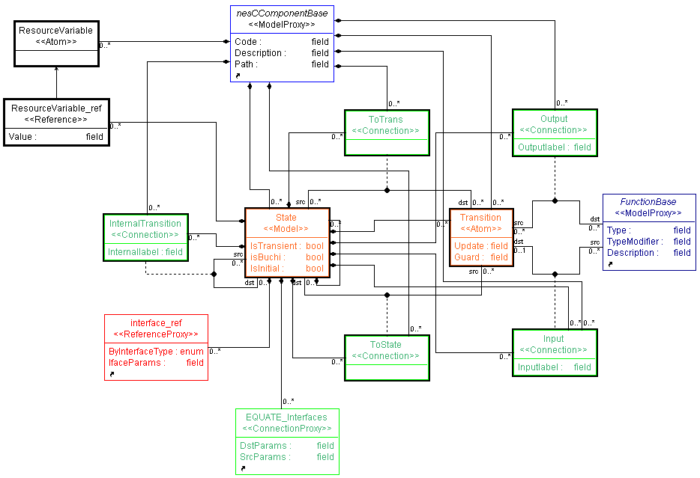
Figure 22: Interface automata extension of GRATIS
The actions are represented as connections (Input, Output and Internal). A Transition can be connected to a command or an event, which are the methods of an interface. The command and the event are inherited from FunctionBase (see Figure 1). An interface automaton can be contained by nesC elements: configuration, module and interface (inherited from nesCComponentBase, see Figure 1).

The split-phase property of nesC clearly separates the input and output actions. If an interface is provided, in other words the component implements the (input) methods of the interface, the commands become input actions and the events become output actions. If an interface is used, then commands become output actions and the events become input actions. Therefore, an interface, which defines a set of commands and events, provides the input and output actions to the interface automata in Gratis.

Figure 23: Interface automata – Comp, User and Channel

A widely used example [6] for input-output automata is the Comp, User and Channel component triplet (see Figure 23). The Comp automaton (see Figure 24) describes a component thae receives a msg! input then tries to send (sena message. If the first attempt is not successful (nack? input), it tries to send the message again. In case of a second unsuccessful sending, Comp gives back a fail! output. If thg attempt was successful either at the first attempt or the second, the component gives back an ok! output action.
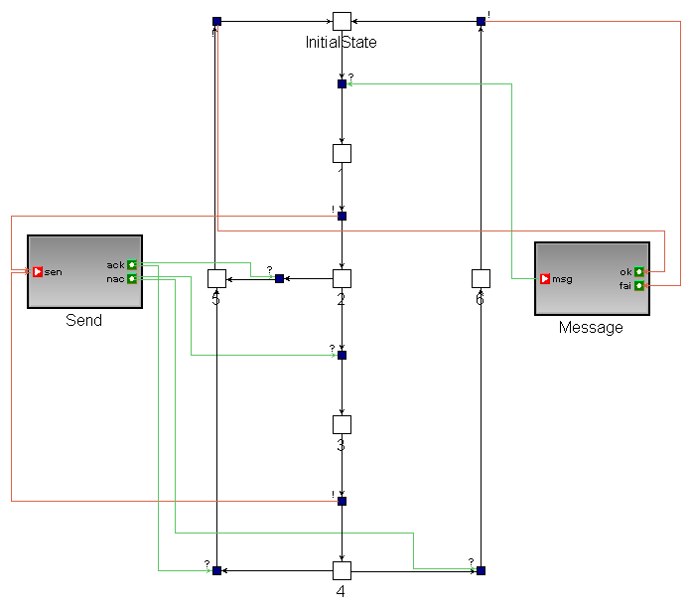
Figure 24: GRATIS – Comp interface automaton

Figure 24 depicts the graphical representation of the Comp interface automata in Gratis. The small white rectangles represent the states and the smaller dark boxes represent the transitions. On the left and the right hand side the Message and the Send interfaces can be found, respectively. The Message interface defines a msg command and an ok and fail events. Because the Message interface is provided (notd itstright-hand side position usinn our convention) in the Comp component, the msg is as input action and the ok and fail are output actione.
Input, output and internal actions, connections between transitions and interfaces, are distinguished by different colors: red, green and purple (not shown in the figure), respectively. The conventional notation for input (?), output (!) and internal (;) actions automatically appear next to the actions.
The User automaton (see Figure 25) describes a simple user component. User uses the Message interface, therefore msg is an output action and ok and fail are input actions. The component releases a msg! output action and waits for an ok? input action. Fromit it can be noticed that the User does not deal with the fail? input actionl causige a problem during the verification.

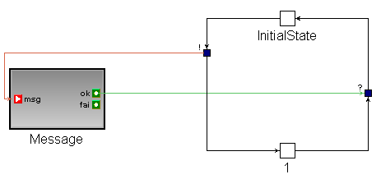
Figure 25: GRATIS – User interface automaton

The Channel automaton (see Figure 26s represents a channel. Ie waits in its Initial state until a message arrives (send? input) from the outsid..

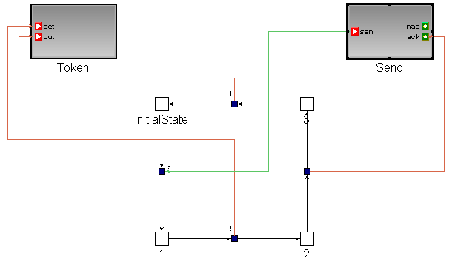
Figure 26: GRATIS – Channel interface automaton

To avoid collisions with other transmissions, the channel releases a get_Token! output signal through the Token interface to get a token. When the channel finishes transferring the message it sends back an acknowledgement (ack! output action) through the Send interface as a sign of the successful procedure. Finally, it gives back the token (put! output action) to signal that it finished sending the message.
From this example it can be seen that nesC component-based features and the definition of interfaces are a good fit to the input-output automata concept, and that Gratis adapts the automata language completely.
In the following sections some extensions to the interface automata are introduced.

Hierarchical states

Simple automata (see Figure 24 - Figure 26) can by represented well by Gratol, but compled onre containinesnumerous,states are not easily understandablye and also the creation of theof systes, is tediousstAn obviouy solution thto reduces the complexity os models i tusine tht hierarchical composition concere. The components compositiontreflects a similme philosophytsbeinincomposed of other components, to hide the complexity oe a certain level. In the automaton world this hierarchical approach can be presenteinbe hierarchical states, namely the states can contain additional automata. Consider the Sender component, which is depicted in Figure 27. The execution of the Token component is the follows: initially, it waits in its Initial state, immediately after the Start? input arrives (Main interface has Start port, but only the first three letter are depicted), it launches the timer by calling the Start method of the Timer interface. The started timer sends fire events periodically to the Sender component. The Sender asks and gets a token from the component, which handles the tokens. The Sender sends a send! message (path from the transition between 5 and 6 states to the sen(d) port of the Send interface) through the Send interface, and waits for an acknowledgement (ack?). If the message has been sent, the Sender gives back the token (put_Token!) and waits for the next event (fire?) from the timer. Meanwhile, through the Main interface the Stop? command may arrive stopping the execution.

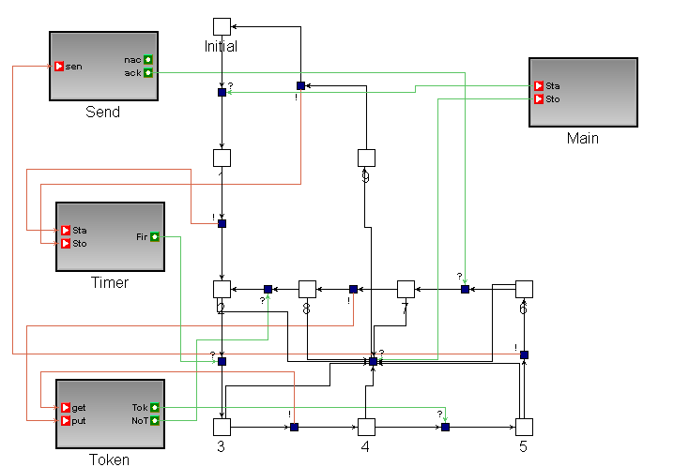
Figure 27: GRATIS – Sender

A loop (state 2, 3, 4, 5, 6, 7 and 8) can be found easily in Sender that represents a continuous execution of the automaton. The states of that loop can be handled as a unit, because the members of the set do not have transitions that lead out from the set except for the one which is common for all the states. Therefore a special state can represent the set, so that those transitions which lead into the loop become transitions that enter the special state and transitions directed from the set become transitions that exit the state. In our model, this set of states and transitions is represented by a hierarchical state. The hierarchical state attains the decomposition of the automata, thus, helps in understanding the complex automata. An automaton that contains hierarchical states is called hierarchical automaton.
A hierarchical automaton, H, can be defined as a tuple:
H = <V_{H}, V_{H}^{Init}, V_{H}^{Hierarchical}, A^{I}_{H}, A^{O}_{H}, A^{H}_{H}, τ_{P}>
Where V_{H}, V_{H}^{Init}, A^{I}_{H}, A^{O}_{H}, A^{H}_{H} and τ_{P} are defined the same as in the input-output automaton (see section 2.1.1), V_{H}^{Hierarchical} ⊆ V_{H} denotes hierarchical states. A hierarchical state is also hierarchical automaton that can be in only one state at a time . The inner input and output actions of a hierarchical state; q_{H} , are subsets of the input and output actions of the original automaton.
The following rules are valid for any hierarchical sate, q_{H}
(1) a transition that goes to a q_{H} hierarchical state (q, a^{i}, q_{H}) is a transition to the special initial state q_{H}^{SpecInit} within the q_{H}.
(2) a transition, which goes from a q_{H} state (q_{H}, aº, q) is transition for all the states contained in q_{H}.
Since verification requires a flat model, a flattening function is introduced:
fl(V_{H})→V_{P},
Where V_{H} is the set of states within q_{H} hierarchical state and V_{p} is the set of states of the of the upper level automaton or hierarchical state. The flattening function resolves the hierarchical containment of hierarchical states, based on the previously introduced rules (1) and (2), and creates labels of the flattened states by concatenating the name of q_{H} with the name of the contained states.

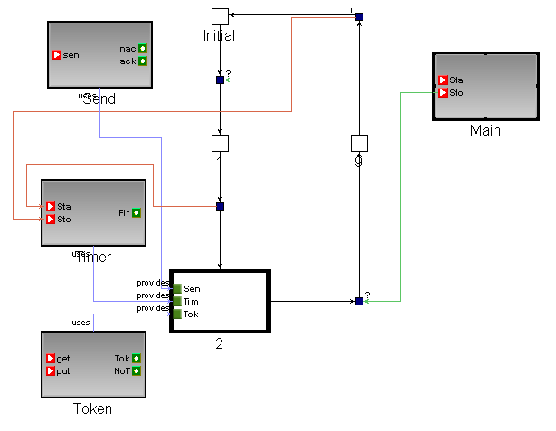
Figure 28: GRATIS – Hierarchical Sender interface automaton
In Figure 29 the modified input-output automaton of Sender is shown. State “2” contains the previously observed loop, and defines interfaces (subset of the originals).

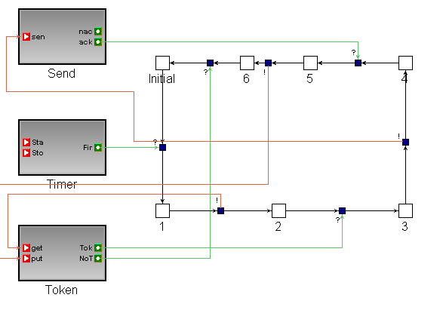
Figure 29: GRATIS – State „2” interface automaton
Figure 30 depicts the inner automaton of state “2”. The original state “2” (see Figure 27) becomes an initial state, because it was the entry point in the loop. Transitions that were driven by the Stop? action do not exist on this level. Note, however, that while the hierarchical states increase the descriptive ability of the modeling language, they increase the mapping time because of the flattening function.

Transient states

There are many cases when we do not want to allow input actions to interrupt a process. Programming languages provide various possibilities to restrict the input actions; for example interrupts (true input actions) from the hardware can be disabled, or at a higher level of programming, the desired protection of a shared resource can be achieved by a critical section or mutex. nesC also supports resolving the concurrency by the atomic statement (see [13]). To express these features in the automaton language, transient states are introduced (see in section 2.4.1). A transient state can have internal and output transitions only, input transitions are not allowed. Thus, transient states represent non-interruptible states. The property of transient state changes the resolving rule of (2) the previously introduced hierarchical states:
- (2_{transient}) an output or internal transition, which transmits from a q_{H} state (q_{H}, aº, q) is a transition for all the contained states and an input transition, which transmits from a q_{H} state (q_{H}, aº, q) is a transition for all the contained non-transient states.
Note this property also requires changing the flattening operation accordingly.
In Gratis the transient states can be denoted by the IsTransient boolean attribute of states.

Parameterized interfaces

The parameterized interface is part of the nesC language (see [13]) and represents an array of the same interface. If we imagine the parameterized interfaces as a set of channels, then the value of the parameter is the identifier of the different channels. The parameterized interface was introduced in our modeling language to suit to the nesC language, which uses this concept. In fact, the parameterized interface can be resolved with an extension of the name of the actions with the value of the parameter.
In Gratis interface references have an attribute to set the value of the parameter of the interfaces.

Return values as guards

Because our components are nesC components the input and the output actions are method calls. Different return values of the methods can represent different actions. For example a command return value can be either SUCCES or ERROR and there can be SUCCESS and ERROR actions (input or output if the interface used or provided, respectively). The concept of interface in Gratis is exactly the same as in nesC language, therefore, extra actions cannot be added to the return value. A feasible solution is to use the existing actions with different direction. It is unambiguous because in nesC if an interface is used then the commands are outputs and the events are inputs and if the interface is provided then the commands are inputs and the events are outputs. Therefore, the return values are clearly distinguishable from the input and output transitions.
To represent this guard in Gratis, the Transitions have a Guard field for the guard condition and an Update field for updating the return value. If, for example, an interface is provided, the return action of a command updates the return-variable and the return action of an event checks the guard expression.

Resource interfaces

The input-output automata notion was introduced to describe the temporal behaviors of components; thus, their compatibility can be verified. However, automata models provide further verification possibilities, since this language describes the functionality of the components. For example, based on the input-output automata models, the resource usage of the component can be examined and verified. The Pure threshold interfaces describe the current resource consumption in every state and verify that the consumption does not exceed a certain threshold during execution. The Büchi threshold interfaces mark certain states that have to be visited infinitely often to avoid the trivial execution (only needed in optimistic approach), while the condition stays the same. The energy interfaces describe the consumption and the production of resources. The difference between the threshold and the energy interfaces is that threshold interfaces describe components which get fixed amount of energy from an outside resource, but they cannot store it; the question is whether the energy is enough to run the components. The energy interfaces describe a set of components that can produce (i.e. with solar cells) and store energy (i.e. in an accumulator which can be charged initially), the question now is whether the level of the stored energy is sufficient in every moment during the execution. The collective name of these concepts is the resource interfaces (see section 2.5).
Gratis supports the description of the Pure threshold interfaces, the Büchi threshold interfaces and the Pure energy interfaces but not the Reward energy interfaces (this kind of games have no memoryless winning strategy). The Büchi states are signed by the isBuchi boolean field. The ResourceVariable elements, which can be added to the states, correspond to the resource values.

Verifications

Our main goal is to develop a tool that provides an environment to formally describe the behavior of nesC components and support their automated compatibility verification. The input-output automata based model of nesC components is introduced in the previous section. Two approaches, the input-enabled and the interface automata, for verifying compatibility were also introduced previously. The algorithms for compatibility checking of the two different approaches are very similar, or more accurately the steps of the input-enabled model verification are a subset of the verification of interface automata model. The steps of the two types of verification will be introduced side by side.

Formal expressions
To perform formal verification on the models a formal description of the desired properties is needed. The CTL (Computational Tree Logic) (see [21]) is a propositional branching-time temporal logic that can describe formal expressions. Every atomic proposition p is a CTL formula, and if f₁ and f₂ are CTL formulas, then following expressions; A[f₁ ∪ f₂], E[f₁ ∪ f₂], AX(f₁), EX(f₁), AG(f₁) and EG(f₁) are defined “for all path (s₀, s₁ …), $∃i\left(i≥0∧s_{i}↦f_{2}∧∀j(0≤j<i→s_{j}↦f_{1})\right)$”, “for some path (s₀, s₁ …), $∃i\left(i≥0∧s_{i}↦f_{2}∧∀j(0≤j<i→s_{j}↦f_{1})\right)$”, “for all next states f₁ hold”, “for some next states f₁ hold”, “A[True ∪ f₁]”, “E[True ∪ f₁]”, “EF(f₁)” and “AF(f₁)”, respectively.

Component compatibility checking

Component compatibility checks whether components can safely “work” together. In our case, the components are represented by automata, therefore, safely “working” means that during the execution the automata have to move simultaneously in their shared actions (see 2.1). (If P and Q are input output automata, then shared(P,Q) = (A^{I}_{P}∪A^{O}_{Q})∩ (A^{I}_{Q}∪A^{O}_{P})). The difference between the two approaches is that the interface automata approach tolerates the existence of invalid states as long as an environment exists that does not allow the system to reach them.
Compatibility verification
1st step: in this step the validation of the automata models is checked (P and Q interface automata). If one of these properties is not valid then the compatibility checking of the automata cannot be performed.
- A^{I}_{P} ∩ A^{I}_{Q} = ∅ :The inputs actions of P and Q are disjunctive
- A^{O}_{P} ∩ A^{O}_{Q} = ∅ :The output actions of P and Q are disjunctive:
- A^{H}_{P} ∩ A_{Q} = ∅ :P has no internal actions which is same as any actions of Q
- A^{H}_{Q} ∩ A_{P} = ∅ :Q has no internal actions which is same as any actions of P
This step can be skipped, because the actions are defined in nesC interfaces and the nesC compiler does not allow the definition of used and provided interfaces with the same name in a component.
2nd step: create the P⊗Q composition of the automata.
If no invalid state arose during the composition, then the components are compatible. If an invalid state did arise, then the components are definitely incompatible according to the pessimistic approach. However according to the optimistic approach, they can be compatible if an environment can be found in which the composed automaton avoids the illegal states. If the composed automaton is non-empty after the pruning of the illegal states, then a trivial environment always can be found (one-state automaton with all the input and output actions) such that the original automata are compatible.
The input-enabled component compatibility check can be performed without real composition. Considering from the previously described definition of compatibility where every shared action has to be performed exactly at the same time for both of the automata, we can notice that the definition of illegal states is equivalent to the definition of deadlock. Usually, deadlock can be described in verification tools. Therefore we propose to verify the component compatibility by verifying the non existence of deadlocks. Of course, if the automaton of the whole system is desired, then composition is required, but then the inspection of the invalid states is not needed.
The following property describes the deadlock: A set of processes is deadlocked if each process in the set is waiting for an event that only another process in the set can cause.
CTL expression: S_{M1}(s_{M1 0}, s_{M1 1},s_{M1 2}…), S_{M2}(s_{M2 0}, s_{M2 1},s_{M2 2}…) … are the sets of states, and R_{M1}, R_{M2} … are the transitions of the M₁, M₂ … M_{n} models, respectively.
deadlock: ∃ r ∈ R_{shared}, s_{i,} s_{k} ∈ S_{Mi}, s_{j,} s_{l} ∈ S_{Mj} | r(s_{i}, s_{k}) ∈ R_{Mi} but r(s_{j}, s_{l}) ∉ R_{Mi}, which is identical to the definition of the illegal state.

Resource interfaces checking
Resource interfaces originally follow the optimistic approach during the verification process. We, on the other hand, consider pessimistic verification. The pessimistic approach here means that the verification is performed for all the possible paths, unlike in the optimistic approach where the verification searches one appropriate path that suits the assumptions.
Resource interfaces allow the study of resources of one or more components. In case of multiple components, the composed automaton can be created before the verification.
In the definitions the following notation is used:
- λ(q): resource usage in a certain state
- Δ: the threshold
- q₀: initial state(s)
In the case of the optimistic approach condition for a

pure threshold interface is as follows:

If there is a path from q₀ such that λ(q) is less than Δ in every state along the path. The
CTL (Computational Tree Logic) expression of this property is:
EG (Δ > λ(q)).
In the case of the pessimistic approach condition for a Pessimistic:
Interfaces are puue threshold is : Iif along very path from q₀ state λ(q) is less than Δ.. The appropriate
CTL expression is:
AG (Δ > λ(q))
In the case of the optimistic approach condition for a
Büchi threshold interface is
as
follows: If there exists a path from state q₀ such that λ(q) is less than Δ in every state along the path and the Büchi states are visited infinitely often. The CTL expression of this property is
:
EG (Δ > λ(q))∧ AG (EF (Q_{Büchi})) where Q_{Büchi} is a set of Büchi states.
In the case of the pessimistic approach condition for a
Büchi threshold interface is as follows: If along every path from state q₀ λ(q) is less than Δ and the Büchi states are visited infinitely often. The appropriate
CTL expression is:
AG (Δ > λ(q))∧ AG(EF(Q_{Büchi})).

In the case of the optimistic approach condition for a

pure energy interface is as follows: If there exists a path from state q₀ such that Σ(λ(q)) + λ(initial) is bigger than 0 along the path. The λ(initial) represents the initial energy value of the system. The CTL expression of this property is:
EG (Σ(λ(q)) + λ(initial) > 0)
In the case of the optimistic approach condition for a
pure energy interface is as follows: If along every path from state q₀ the Σ(λ(q)) + λ(initial) is more than 0. The appropriate
CTL expression is:
AG (Σ(λ(q)) + λ(initial) > 0)
With the formal descriptions the formal verification of the desired properties is possible. To perform the model checking a model checker is needed. A model checker determines whether a CTL formula f is true in state s of the structure M = (S, R, P), where S a finite set of states, R is a binary relation on S (R⊆S × S), which gives the possible transitions between states and must be total; that is, $∀x∈S ∃y∈S((x,y)∈R)$ and P: S→2^{AP} assigns to each state the set of atomic propositions where are true in that state. We have chosen the Uppaal as a model checker.

Verification in Uppaal

Uppaal [30] is an integrated tool environment for the modeling, validation and verification of real-time systems modeled as networks of timed automata that are extended with data types (bounded integers, arrays, etc.). The tool is appropriate for systems that can be modeled as a collection of non-deterministic processes with finite control structures that communicate through channels or shared variables.

We have chosen Uppaal because it has many advantages. For example, its
language is automata based, which suits our input-output automata based representation. The Uppaal
supports direct checking of existence of deadlock by the deadlock Uppaal property. The verification of deadlock is a key requirement for us, because we use it for checking the compatibility of components. The Uppaal
allows integer and clock variable definitions that are used during resource interface verification in our solution. The Uppaal
input is XML (see [30]) based, that is easy to produce from a program. Another very important feature of Uppaal is its
simulator that enables the examination of execution. The simulator provides deeper understanding of the behaviors of components and is extremely useful to locate errors in the system. The Uppaal
model is based on notion of the timed automata
(see [22] ) as an extension of classical finite-state automata with clock variable. The Uppaal model-checker can check invariants and reachability properties. Other properties such as liveness can be achieved by adding debugging information to the system and then checking its reachability. During the model checking a diagnostic trace can be generated, which can be executed in the simulator.
The Uppaal model can contain states and transitions. Optionally, the transitions can denote three types of features; guard, expressing a condition on the values of clock and integer variables that must be satisfied in order for the transition to be taken; a synchronization action, which is performed when the transition is taken and synchronizes processes through channels; and a set of updates to reset clock variables and to assign values to the integer variables. The states optionally can hold invariants, which express constraints on clock values allowing us to control when an automaton remains in a particular state. A state can be urgent to take a transition immediately from the certain state if it is possible; and committed to sign that the state, which is between two transitions, is left immediately.

Component compatibility

Once the interface automata of the components are created in Uppaal, the compatibility of the components can be verified by the non-existence of deadlocks in the system (see previous section).
Property: A[] not deadlock
- If it is successful then the components are compatible, so their composition can be performed for further usage.
- If it is not successful, then a counterexample can be found, using the Uppaal simulator that can help to localize the problem.

Resource interfaces

Resource interfaces can be represented in Uppaal in the following way: The resource value of the states λ(q) and Δ can be described either by local variables or by updating the value of a local (or global) variable, so that the names of the states are unique (if the names of the states are not unique, then first a labeling operation has to be performed).
Uppa
In the following expression resvar is a local integer variable of a Model automaton that represents the resource usage and delta integer variable represents Δ.
The Table 1 describes Uppaal syntaxes of the resource interface CTL properties.

 | Optimistic | Pessimistic
Pure threshold interfaces | E[] Model.resvar < delta | A[] Model.resvar < delta.
Büchi threshold interfaces | E[] Model.resvar < delta and E<> q_{Büchi} | A[] Model.resvar < delta and E<> q_{Büchi}
Pure energy interfaces | E[] Model.resvar > zero | A[] not Model.resvar > zero

Table 1: Resource interface properties

Gratis Uppaal translator

A translator (see Figure 30) is needed to create the Uppaal models from Gratis models and:to customize the generated models, by creating and setting variables, properties, guards, update expressions, etc., to suit the desired verification. The following pseudo code represents the translation algorithm:
Get the selected components
Collect the common interfaces (INTERFACES) of the selected components and create a channel for every method of these interfaces
Perform the flattening operation on all the components:
While the current level contains hierarchical states
Go into a hierarchical state and “lift up” all the contained states (SET) and transitions
Create the transitions to the initial states of the SET which lead to the original hierarchical state
Create the transitions to all the states of the SET which lead from the original hierarchical state
Delete the original hierarchical state and the appropriate transitions
If compatibility checking
Map Gratis states into UPPAAL states
Label the created states: Component name + original name of the state.
Set the initial parameter if the “initial” parameter of the Gratis is true
Set the state to urgent // to constrain immediately step
Map Gratis transitions into UPPAAL transitions:
If the transition is a method of an interface from the set of INTERFACES (it is a channel between the components), set the synchronization attribute of the transition
Else //resource interface verification
Perform a composition (COMP) of the components (if it is possible)
Create variables for the resources
Map states of COMP into UPPAAL states
Label the created states: Component name + original name of the state.
Set the initial parameter if the “initial” parameter of the Gratis is true
Set the state to urgent
Map transitions of COMP into UPPAAL transitions
Set the updates on the variables that are needed
Create the appropriate queries

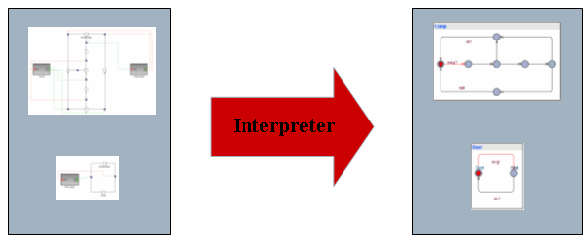
Figure 30: GRATIS to UPPAAL interpreter

Uppaal verification examples

The Gratis representation of User, Comp and Channel is a simple example which was shown in section 3.1 (see Figure 24, Figure 25 and Figure 26). (Figure 31) the Uppaal representation of the same models can be seen.
The interpreter extends the name of the states to avoid the invalid names, concatenates the interface names with the actions names to achieve unique transition names and hide the irrelevant interfaces. For example, the methods of the Send interface are hidden in Figure 32. The interpreter creates the appropriate urgent channel list that denotes synchronization channels without transition time. The interpreter also composes the system definition for Uppaal and the query for the verification.

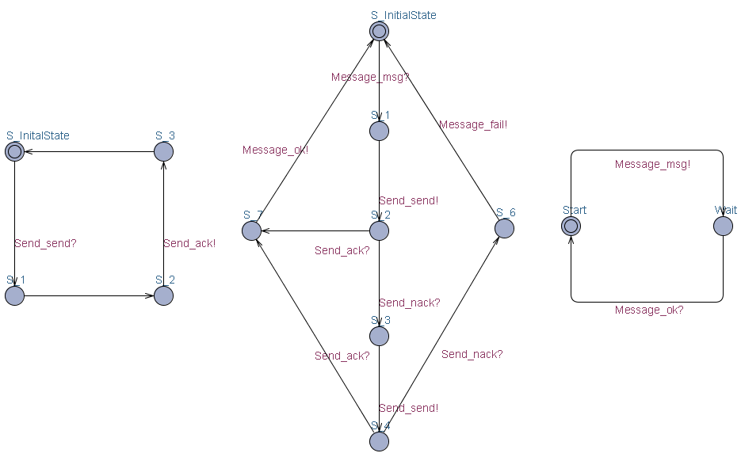
Figure 31: UPPAAL – Channel, User and Comp

Verification examples

To show the usability of the concepts and the verification process, two examples are shown in the preceding chapter. The differences between the pessimistic and the optimistic approach based verification of compatibility and resource usage are exposed in the example.

Example 1: User and Comp
We have to first create the Gratis representation (see Figure 24, Figure 25) of the User and Comp automata (previously described in 3.1). The next step is to run the InterfaceAutomaton interpreter. The resulting automata can be seen in Figure 31 (second and third automata). To start the verification the query file has to be opened.
The result of the model checking is:
“A[] not deadlock
Property is not satisfied”

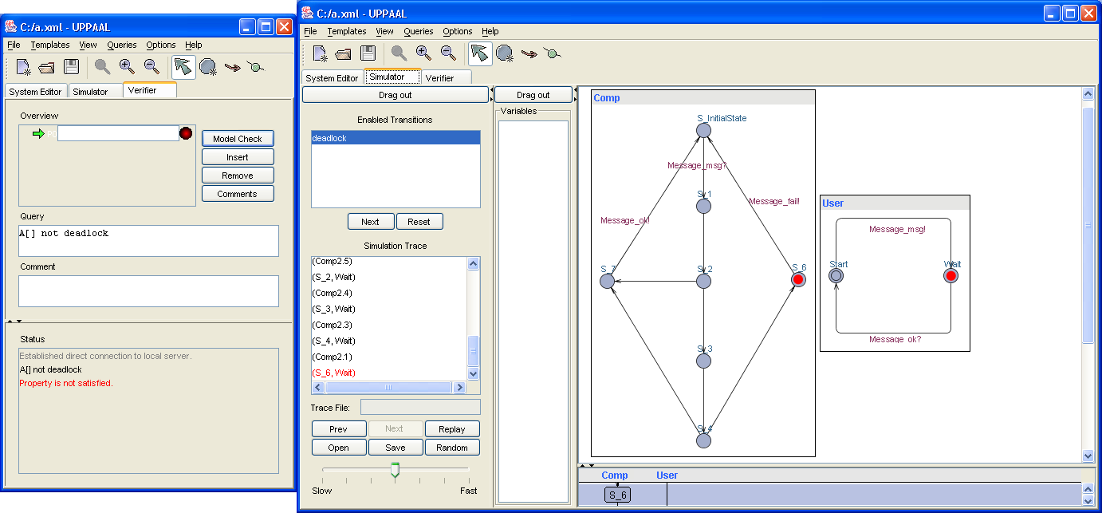
Figure 32: UPPAAL – User and Comp are incompatible

This means that the components are not compatible according to the pessimistic approach. Uppaal can show a counterexample for our property (see right window on Figure 32) that can be very useful if debugging is desired.

In the case of the optimistic approach based verification, the first step is the composition of the automata that removes incompatible states. An environment, in this case Channel, has to be also defined for the component compatibility verification. .
The generated Uppaal model is depicted in Figure 33. The result is
“A[] not deadlock
Property is satisfied”
that means User and Comp are compatible in the Channel environment.

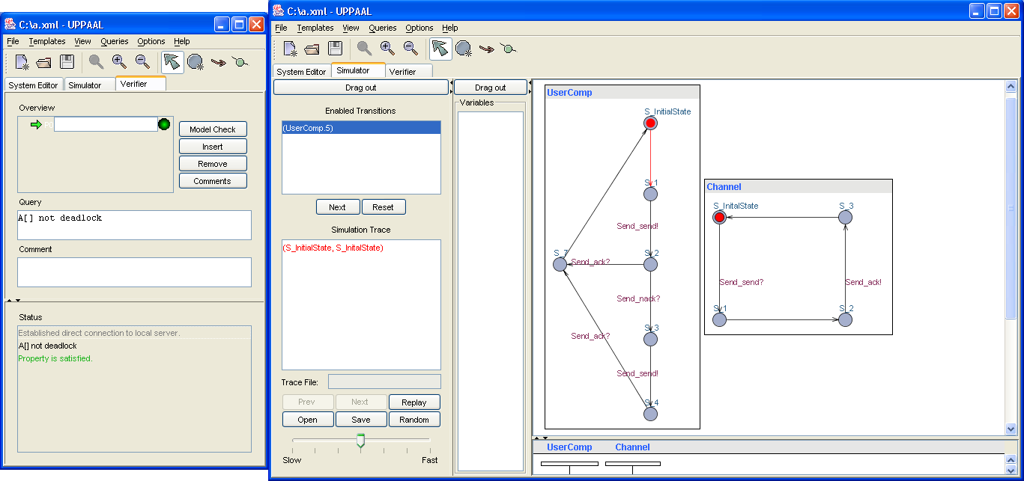
Figure 33: UPPAAL – User || Comp compatible with Channel

The verification of a pure energy interface of Comp is depicted in Figure 34. Since the original concept, to define the consumptions at states is not feasible in Uppaal, therefore the transitions define the amount of resource usage..In this case when the pure energy interface is the object of the verification, the transitions update the value of a local variable (resvar), so that the result is accumulated.
The (pessimistic) verification of the pure energy interface can be achieved by the
A[] resvar > 0
Where resvar a local variable what value represents the total energy consumption, and it has to be always greater than zero.

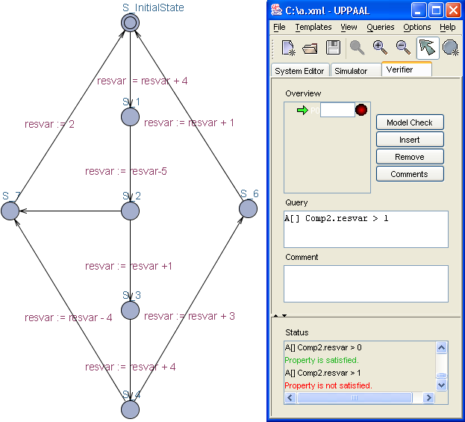
Figure 34: UPPAAL – Pure energy interface of Comp

Example 2: Blink application
The Blink application (see Figure 3) was introduced previously in the first chapter. The automata of Main (see Figure 35), ClockC (see Figure 36), LedsC (see Figure 39) and BlinkM (see Figure 41) depict the input-output automata of the components.

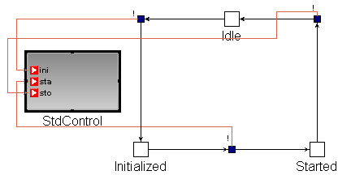
Figure 35: GRATIS – Main automaton
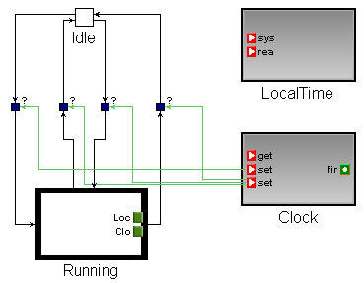
Figure 36: GRATIS – ClockC automaton

The Main (see ) automaton has only three states: Idle, Initialized and Started (the internal actions are removed for easier understanding) and it has only output actions: init, start and stop that control exactly 3 transitions. The Main automaton describes a component that executes is as follows: it waits in its Idle state (in the real world this wait is done with switching off the hardware) then generate an init! output that activates an Init call chain in the application. In the next step, it executes a start! output action that starts the application and finally it generates a stop! and the components stop their execution.

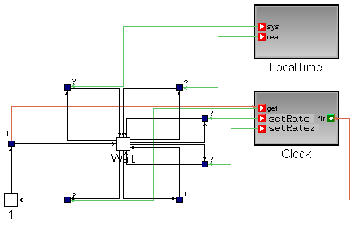
Figure 37: GRATIS – ClockC Hierarchical state
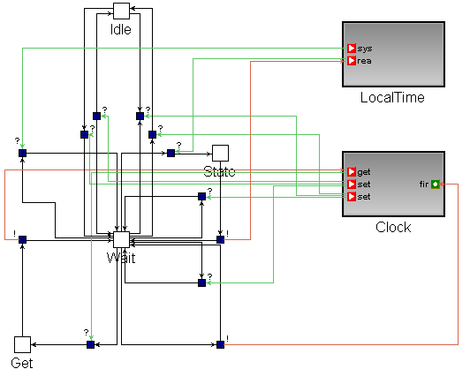
Figure 38: GRATIS – ClockC (flattened)

The ClockC (see ) configuration implements a timer. In the first level there are two states the Idle and the Running (hierarchical state), the transitions between the states are controlled by setRate and setRate2 (if the value of the argument is 0 of these methods then the timer stops). Within the Running state (see ) a simplified model (only one state) of a timer can be seen; the Clock interface setRate and SetRate2 modify the frequency of the timer, the getRate2 (Clock interface) methods is an input action and its return value described by an output action (return value as guard concept) and its guard value. The flattened automaton (see ) contains all the actions and the appropriate states.

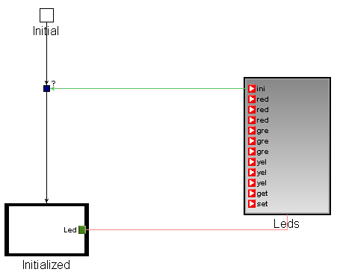
Figure 39: GRATIS – LedsC automaton

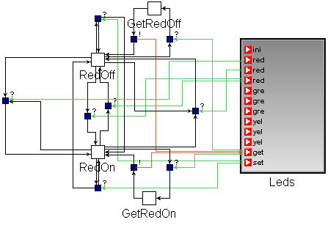
Figure 40: GRATIS – LedsC red LED

The LedsC (see ) component implements a wrapper layer on the LEDs hardware. This hardware has three different color LEDs, green, red and yellow. A LED can be switched ON or OFF therefore the state of the automaton based on the ON and the OFF states (the automaton of the red LED can be seen on ) since the status query (get?) can be happened in both states it produces other two states. The xxxToggle? (the xxx here means red, green, or yellow) input action switches the automaton between the ON and the OFF states. The full automaton of LedsC component can be created by the Cartesian product of the automata of the red, the green and the yellow LEDs.

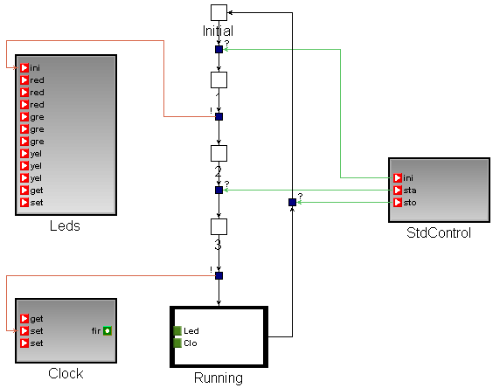
Figure 41: GRATIS – BlinkM automaton

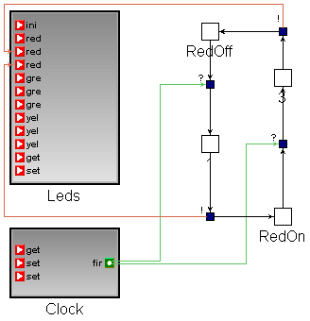
Figure 42: GRATIS – BlinkM Running state

The BlinkM module implements the Blink application (see ). The automaton starts from its Initial state. The init and start actions of the StdControl interface move the automaton to its Running state, meanwhile it initializes the LedsC through the Leds interface and start the ClockC through the Clock interface.

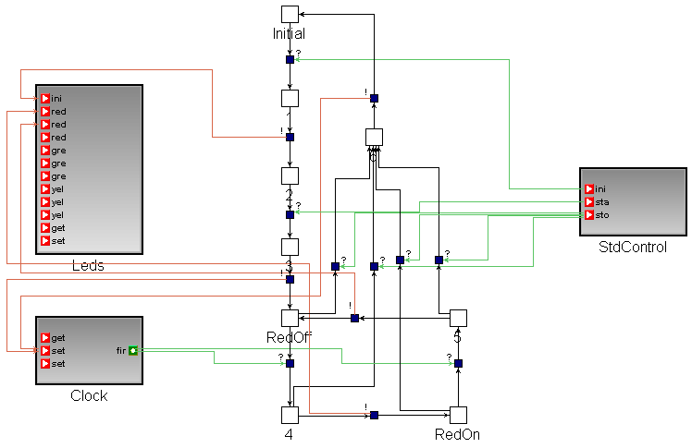
Figure 43: GRATIS – BlinkM automaton (flattened)
The automaton within the Running (hierarchical) state (see Figure 42) start from the RedOff state and when the timer fire? through the Clock interface it sends a redOn! output command to the LedsC through the Leds interface and moves to the RedOn state. From the RedOn state the automaton can move to the RedOff state if the timer fires again.The flattened BlinkM automaton (see Figure 43) contains states only its first level.

Verification in Uppaal:
Blink-Main and Blink-ClockC automata pairs are compatible, because their Uppaal model do not contain deadlock. The Blink-LedsC pair is compatible also, but their Uppaal models are not shown.

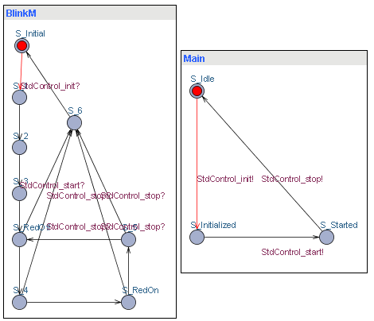
Figure 44: UPPAAL – BlinkM & Main
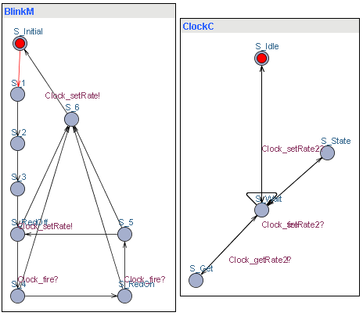
Figure 45: UPPAAL – BlinkM & ClockC

Evaluation of examples
Given the critical nature of interfacing components, it is highly desirable to verify their correct cooperation. The tool demonstrated in this work automates translates the high-level interface specifications into automata accepted by the UPPAAL verifier. Creating these translated models by hand is not only tiresome and time-consuming, but also opens up the possibility for introducing additional errors and mistakes by the user doing the translation. Getting rid of these errors is a major improvement of the verification process.

Automated input-output automata creation

Based on our experimental we have found that automaton assembly can be an extremely tedious and error-prone process. Creation of large complex components is almost impossible, because of the size of the state space. Since the nesC language is component-based and the interactions between components are well defined by interfaces, a partially automated automata creation is feasible by code parsing. Of course, the full automaton cannot be created automatically from source code, because interfaces do not describe the actions’ temporal sequence (this is why we need the automata). However, transition--state-transition three tuple can be easily generated from code. A sample code can be seen on Figure 46. The code is part of the BlinkM module implementation.

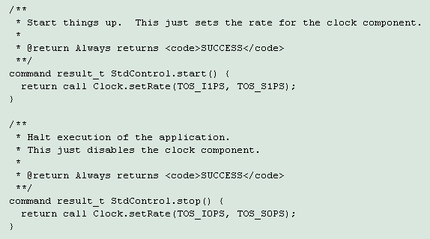
Figure 46: nesC – BlinkM code part
The StdControl is a provided interface, so the start command is an input transition that leads the automaton into a state, in the function body the Clock interface setRate method is an output transition. Therefore, the StdControl.start?-State-Clock.setRate! transition-state-transition three tuple can be created.

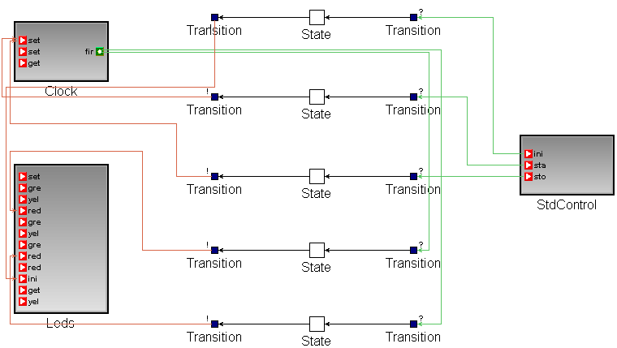
Figure 47: GRATIS – BlinkM automaton from code
To continue the same process from the second function, the StdControl.stop?-State-Clock.setRate three triplet can be created. The Gratis representation, a partial automaton, of BlinkM.nc is depicted in Figure 47.

The ANTLR (ANother Tool for Language Recognition) (see [31]) parser generator has been used to create the nesCToAutomaton parser. The parser has limited abilities, it can only parse the obvious cases when the function body contains the representation of output actions. However, an extension is feasible, because the grammar description of nesC is complete, therefore, the hidden outputs, for example, Task postings and calling of another function, can be located.

CHAPTER IV

CONCLUSION

4.1 Results

Component-based software development is progressively becoming more important for increasing the productivity of developers and the maintainability of applications. This is especially important for such resource constrained embedded systems as sensor networks. One of the main advantages of a component-based approach is that it makes software integration (i.e. component composition) and verification possible.
In this thesis a model-based solution has been proposed for automated component interface- and resource verification. The selected model representation, the input-output automata language, provides an effective way to describe the temporal behavior of components. However, some extensions, such as hierarchical states and resource interfaces, are necessary to extend the expressiveness of the original input-output automata language. Some concepts, such as parameterized interfaces and return values as guards, were applied to tailor the automata language to suit the target output language, nesC.
We extended the baseline Gratis representation of components by input-output automata allowing the formal description of the temporal behavior of nesC components and also enabling the representation of the previously introduced extensions. Our translator provides a full mapping between Gratis and Uppaal models. It also performs both optimistic and pessimistic verification by creating the desired properties, hiding unneeded actions and flattening hierarchical states, etc. Thus, the verification can be performed seamlessly and the unsatisfied properties can be identified easily. This enables debugging to instantly utilize the simulation interface of Uppaal. Complex system verification is also feasible because of the component composition-based methodology.
In summary, the proposed technology and its implementation provide a user-friendly environment for compatibility verification of nesC components. Furthermore, it also enables further extensions for resource automata-based verification.

Future work
While the framework developed in this thesis has proven to be quite useful, there are a number of ways it could be enhanced:

- Optimistic verification: While optimistic verification is feasible in this framework, it is not fully automatic. The automatically composed automata cannot be used for further composition, because they are not stored in a Gratis model.
- Interface based verification: Compatibility verification of components can be transformed into compatibility checking between interfaces and components in that model interfaces describe the desired temporal behaviors by input-output automata. Therefore, components are compatible if they are compatible via the same interface and an action of the common interface is input in one of the automata and output in the other. This feature splits the verification of components, and, hence, enables the independent development of components.
- Better composition algorithm: In this framework, we implemented a simple algorithm for component composition. A more complex, but faster algorithm should be devised and implemented to improve the efficiency of the framework.
- Code parser: An enhanced code parser would be the most useful extension of the framework, since manual automata creation is a time consuming and error-prone process. Enhanced source code parsing and automated automata creation would increase the usability of the framework.

REFERENCES

- N. Lynch and Mark R. Tuttle, “Hierarchical Correctness Proofs for Distributed Algorithms”. In Proc. 6th ACM Symp. On Principles of Distributed Computing, pp. 137—151, 1987, “http://citeseer.is.psu.edu/tuttle87hierarchical.html”

- Robert Allen, David Garlan, “Formalizing Architectural Connection”, 16th International Conference on Software Engineering, Sorrento. Department of Computer Science Carnegie Mellon University, Pittsburgh, 1994

- David Harel, Statecharts: “A Visual Formalism for Complex System”, Science of Computer Programming, 8:231-274, 1987

- Edward A. Lee, Yuhong Xiong, “Behavioral Types for Component-Based Design. Technical Memorandum” Department of Electrical Engineering and Computer Sciences University of California, Berkley, 2002, “http://ptolemy.eecs.berkeley.edu/papers/02/behavioralType/behavioralType.pdf”

- Nancy A. Lynch, Michael J. Fisher, “On Describing the Behavior and Implementation of Distributed Systems”, Theoretical Computer Science 13 (1981) 17-43 (North-Holland, Amsterdam) 1981

- Luca de Alfaro and T.A. Henzinger, “Interface Automata”. In 9th Symp. Foundations of Software Engineering. ACM Press, 2001, “http://www-cad.eecs.berkeley.edu/~tah/Publications/interface_automata.html”

- Luca de Alfaro and T.A. Henzinger. “Interface Theories for Component-based Design”, University of California, Santa Cruz and Berkeley, 2001, “http://www-cad.eecs.berkeley.edu/~tah/Publications/interface_theories_for_component-based_design.html”

- Stravos Tripakis. “Automated Module Composition”, VERIMAG, 2002 “http://www-verimag.imag.fr/~tripakis/papers/tacas03-web.pdf”

- Arindam Chakrabarti, Luca de Alfaro, T.A. Henzinger, Merielle Stoelinga, “Resource Interfaces”, Electrical Engineering and Computer Sciences, UC Berkeley, Computer Engineering, UC Santa Cruz, 2002, “http://www-cad.eecs.berkeley.edu/~tah/Publications/resource_interfaces.pdf”

- Edward A. Lee and Yuhong Xiong. “System-Level Types for Component-Based Design”, UC Berkeley, 2000, “http://ptolemy.eecs.berkeley.edu /publications/papers/01/systemLevelType/”

- Luca de Alfaro, T.A. Henzinger, Freddy Y.C. Mang, “Detecting Errors before Reaching Them”, Department of Electrical Engineering and Computer Sciences UC Berkeley, 2001, “http://www-cad.eecs.berkeley.edu/~tah/Publications/ detecting_errors_before_reaching_them.html”

- T.A. Henzinger, Ranjit Jhala, Rupak Majumdar, Shaz Qadeer, “Thread-modular Abstraction Refinement”, Department of Electrical Engineering and Computer Sciences UC Berkeley, 2001, “http://www-cad.eecs.berkeley.edu/~tah/ Publications/thread-modular_abstraction_refinement.html”

- David Gay, David Culler, Philip Levis, “nesC Language Reference Manual”, 2002, “http://nescc.sourceforge.net/papers/nesc-ref.pdf”

- David Gay, Philip Levis, Robert von Behren, Matt Welsh, Eric Brewer, David Culler, “The nesC Language: A Holistic Approach to Networked Embedded Systems”, 2003, “http://nescc.sourceforge.net/papers/nesc-pldi-2003.pdf”

- J. Hill, R. Szewczyk, A. Woo, S. Hollar, D. E. Culler, and K. S. J. Pister, “System Architecture Directions for Networked Sensors”, In Architectural Support for Programming Languages and Operating Systems, pages 93–104, 2000.
TinyOS is available at: http://webs.cs.berkeley.edu

- Akos Ledeczi, Miklos Maroti, Arpad Bakay, Gabor Karsai, Jason Garrett, Charles Thomason, Greg Nordstrom, Jonathan Sprinkle and Peter Volgyesi, The “Generic Modeling Environment”, Vanderbilt University, Institute for Software Integrated Systems, Nashville, 2001, “http://www.isis.vanderbilt.edu/Projects/gme/ default.html”

- Nancy A. Lynch, “Distributed Algorithms”, San Francisco: Morgan Kaufmann 1997

- J. Brzezinski, J-M Helary, M. Raynal, “A General Definition of Deadlocks for Distributed Systems”, ACM-IEEE Int. Conf. on Arch. And Alg. for Parallel Processing, Brisbane, 1995

- A. Ledeczi, M. Maroti, Gy. Simon, Gy. Balogh, B. Kusy, A. Nadas, G. Pap, J. Sallai and K. Frampton, “Sensor Network-Based Countersniper System” Vanderbilt University, Institute for Software Integrated Systems, Nashville, 2004,”http://www.isis.vanderbilt.edu/publications/archive/Maroti_M_2_12_2004_The_Direct.pdf “

- Martin J. Osborne, “An Introduction to Game Theory”, Oxford University Press, August 2003

- E. M. Clarke, E. A. Emerson and A. P. Sistla, “Automatic Verification of Finite-State Concurrent Systems Using Temporal Logic Specifications”, In ACM Transactions on Programming Languages and Systems, 8(2):244--263, 1986.

- R. Alur and D. Dill, “Automata for Modeling Real-Time Systems”, Theoretical Computer Science, 126(2):183-236, April 1994.

- J. Sallai, Gy. Balogh, M. Maroti, A. Ledeczi, “Acoustic Ranging in Resource Constrained Sensor Networks”, Technical report, Vanderbilt University, Institute for Software Integrated Systems, Nashville, 2004, “http://www.isis.vanderbilt.edu/projects/nest/documentation/Vanderbilt_NEST_%20Acoustic_%20Ranging.pdf”

- http://www.uppaal.com/

- http://www.greatduckisland.net

- http://www.tinyos.net

- http://www.isis.vanderbilt.edu/projects/nest/gratis/GratisIITechOver.html

- http://www.omg.org/technology/documents/formal/corba_2.htm

- The Microsoft Component Object Model, Microsoft Corporation. Available at http://www.microsoft.com/com.

- http://www.w3.org/XML/

- http://www.antlr.org

- http://www.xbow.com/

