Modeling of Agent’s Behavior in Human-robot Interaction Using Model Integrated Computing
S. Venkatachalam, A. Alford, G. Nordstrom, R. A. Peters II, M. Wilkes
Vanderbilt University
Nashville, TN 37212.

Abstract
Due to continuous increase in the need to provide more services to health care through robotic aid systems, developed for the disabled, the need for addressing human-robot interaction (HRI) has gained the utmost importance. HRI is based on a multi-agent architecture, the Intelligent Machine Architecture (IMA)[2][3], a new approach for the design of the software for intelligent machines that are principally limited by difficulty in integrating existing algorithms, models, and subsystems. A system of interactive software agents, designed within IMA, encapsulates the various hardware elements, environmental elements, behaviors and tasks. IMA suggests “a society of agents”[13] paradigm to create complex high-level functionality from any sublevels of components. The high-level agents currently employ finite state machines to sequence the activation and suppression of behavior agents. A state machine is realized by two components—state machine engine and state machine representation. Model Integrated Computing (MIC) [8] is used to model the behavior of the IMA agents. This paper presents a toolkit that designs the agent’s behavior through a state-transition metamodeling environment and builds the agent with the help of an existing Agent Builder application.

Introduction
At the Intelligent Robotics Laboratory (IRL) in the Center for Intelligent Systems (CIS) at Vanderbilt University, we have been developing a humanoid robot, the Intelligent Soft Arm Controller (ISAC), over the past several years. The robot was designed expressly for research in human-robot interaction (HRI). This has gained utmost importance and the need for combining the work of many researchers spurred the development of the Intelligent Machine Architecture (IMA) [4]. It has been found that many applications can be solved using MIC Technology [8]. This paper describes briefly the modeling environment of a finite state machine, which models and determines the agent’s behavior. The models built from this environment will be interpreted to generate the necessary data and files to create COM [16] objects, serialize, and save the data into a format acceptable to the agent execution environment, the Agent Builder, to complete the process of agent building.

Background
This paper describes the merging of two different and powerful architectures to give an improved and better performing humanoid system. Each is described below.

Intelligent Machine Architecture (IMA)
IMA is an agent based software architecture that permits the concurrent execution of software agents on separate machines while facilitating extensive inter-agent communication. ISAC’s control system is a set of IMA agents that work together to perform a small set of basic behaviors. It uses a system-level model that is agent-based. Each resource, task or domain element is modeled in software as an agent. It also uses an agent-level model that is component-object based. The IMA uses algorithms, representations, and links between agents as component-objects within each agent. Instances of these component objects can be reused in many agents, in varied configurations or for completely different purposes at the same time. The various building blocks of IMA are:
Components: These are Distributed Component Object Model (DCOM)[14][15] objects from which atomic agents are built. It is a binary standard for software objects, which supports operation across a network.
Atomic Agents: These are composed of components. They have one or more threads of execution and are independent, autonomous entities. Collections of agents that communicate and interact are used to achieve useful results.
Compound Agents: This is an interacting group of atomic agents that are coordinated or sequenced by one or more sequencer agents. [6]
The IMA is a software architecture used to create agents to enable ISAC to perform certain tasks. Our design process with IMA is to decompose the system into a set of atomic agents. Intelligent behavior emerges from the interaction of these atomic agents in the IMA system. Each atomic agent acts locally based on its internal state and provides a set of services to other agents through various relationships. To build an agent, Agent Builder is used which is an application enabling us to create agents from pre-coded IMA components. Agents are composed from a standard set of component objects that includes:
Agent Manager: It provides the scaffolding on which other pieces of the agent are built. This element also provides a meta-level interface through which another agent can inspect its composition and alter it if necessary.
Agent Decision Engine: It provides the action selection for the agent components, based on a set of productions or rules. It supports the implementation of a hierarchical state machine for agent action selection.
Agent Resources: These elements of the agents are data repositories (called representations), algorithms, toolboxes, and links to the state of other agents (called relationships). These elements are evaluated, invoked and updated by the selection of actions within the agent [11]
The control system has been designed, and the behaviors selected, that we hope will enable the robot to acquire new behaviors automatically under the tutelage of a person [2].

Multi Graph Architecture (MGA)
MGA, being developed at the Institute for Software Integrated Systems is a toolkit for creating domain-specific Model Integrated Program Synthesis (MIPS) environments. A meta-programming interface is used to specify the modeling paradigm of the application domain. The modeling paradigm is the modeling languages of the domain specifying the modeling objects and their relationships. [4]
Syntactic rules and semantic information are described using the Unified Modeling Language (UML) [17] in the MGA. These specifications, called metamodels, are used to automatically generate the MIPS environment for the domain. [1][8]
The resulting MIPS environment is used to create domain models that are stored in a model database. These models are used to automatically generate the application and/or synthesize input to different analysis tools. This process is called model interpretation. [4]
At the core of the MGA MIPS environment is the Graphical Model Editor (GME). This component is responsible for maintaining the model structures and providing the operations to manipulate them.
Model Integrated Computing (MIC) addresses the problems of the domain experts, by providing rich, domain-specific modeling environments including model analysis and model-based program synthesis tools. This technology is used to create and evolve integrated, multiple-aspect models using concepts, relations, and model composition principles routinely used in the specific field, to facilitate systems/software engineering analysis of the models, and to automatically synthesize applications from the models.

Existing State Machine Representation
The ISAC is built with the IMA and so the main requirement is to build agents. An agent is built with the help of Agent Builder software. The core of the agent is a state machine. The state machine is realized by two components working together: state machine representation that holds machine data and state machine engine, which controls the firing of events. When this agent is activated, the engine starts running.
Initial State
Face Detection
Skin Tone Segment
Finger Point Detection
Snap and Segment
The transition diagram for a state machine is shown in Fig. 1. A Camera Agent has four agents one of which is Right Camera Agent. In this figure the state machine of the Right Camera Agent is represented. From the initial state, the four possible states a Right Camera Agent can be in are Face Detection, Snap and Segment, Finger Point Detection, or Skin Tone Segment states.
Initial State
Face Detection
Skin Tone Segment
Finger Point Detection
Snap and Segment

- : State-Transition: Right Camera Agent
The state machine representation of a left camera agent in one of its states is described in Fig. 2. This figure shows what state the engine is in. It also shows the activities that are performed in that state, the transitions that can take place from that state and the events that can occur.
The state machine has a number of states. These states have attributes: period, timeout set of triggers, id, and comments to add. The ID is used to identify the state. Triggers or Activities are names of mechanism components, plus the operation and flag arguments used to invoke the mechanism. A trigger can have the additional property of DoAlways; this means that the trigger is executed each period. A transition has an ID for the new state, plus a list of events, which must fire before the transition will occur.
The state machine engine has a pulse period property, which controls the period of a timer. This timer is used to measure a state’s period and timeout. When a state is entered, the engine begins counting down the timeout and period of the state. When the period expires, the engine executes all triggers for that state that have not been executed already or are DoAlways triggers. Agent events cause the engine to change state.
- : Snapshot of the state-machine representation
Components can cause an agent event by calling DispatchAgentEvent. Each event has a type and an ID. When the engine receives an event, it passes it to the current state object.
The state then checks its set of transitions to see if one has become active. The states, transitions, activities, and events are created as COM objects and the information regarding all these attributes of States, activities, Transition and Events are stored in a file in a binary format as required by the Agent Builder software.

Framework of IMA-MIC
The current approach for agent building uses the Agent Builder Software. It has the state machine representation, in Fig 2. The drawback of this representation is it does not involve any graphical modeling techniques. It shows just the snapshot of one particular state and shows the different states a particular state machine has. It does not show the graphical relation between the states. It is mainly a text based state machine representation. Without graphical techniques, agent building quickly becomes unmanageable at highly complex and abstract levels of intelligence.
This paper describes the implementation of the Multi- Graph Architecture (MGA) to represent the finite state machine of an agent. This would enable the entire picture to be graphical. It will involve a better understanding about the modeling of an agent’s behavior. The programmers can design the state machine of an agent using this modeling environment and still build the agent with the help of the existing Agent Builder.
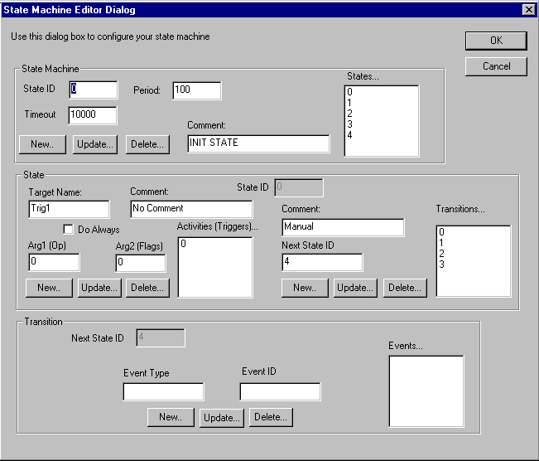The IMA-MIC environment (which is the state-transition modeling environment) takes the existing information about the state machine of the different IMA agents from the existing Agent Builder and creates the COM objects (Fig. 3). The data stored in the state machine representation is serialized from the models and transported in to a file, which is acceptable by the existing Agent Builder software. This completes the building of the agent.
MODELS OF STATE MACHINE REPRESENTATION
IMA-MIC ENVIRONMENT
EXISTING
AGENT
BUILDER
SOFTWARE
IMA ARCHITECTURE

MIC ENVIRONMENT
SERIALIZED DATA IN BINARY FORMAT
INFORMATION
CREATES COM OBJECTS
SENDS DATA AND COLLECTION OF COM OBJECTS
INFORMATION

- : Design of the IMA-MIC concept
Once the agent is built, the agent can be activated in the Agent Builder software, which executes the thread in the state machine engine, which in turn activates the robot.

Defining the New Standards
The key concept when using the GME environment is defining the paradigm. A paradigm definition defines the entities and relationships allowed in a given domain [1]. The basic modeling objects are atoms and models. in our framework, atoms are elementary objects (with attributes) while models are the compound objects. The modeling paradigm determines what kinds of parts are allowed in models. The modeler determines the specific type and number of parts a given model contains, using UML to specify the syntax of the modeling language. This specification is called a metamodel. In short the metamodel defines the models and atoms and how they are allowed to be connected to each other in the specified domain.

Specifying the Agent Behavior Paradigm
The behavioral models capture the system behavior in terms of attributed hierarchical state machines. Attributed refers to the ability to assign attributes to a state. The behavior of a model is described using a metamodel. The metamodel, which is built using the metamodeling environment, generates domain specific modeling rules to configure the graphical modeling editor to help us build domain-specific models. The behavior of an agent is usually described by the states and transitions.

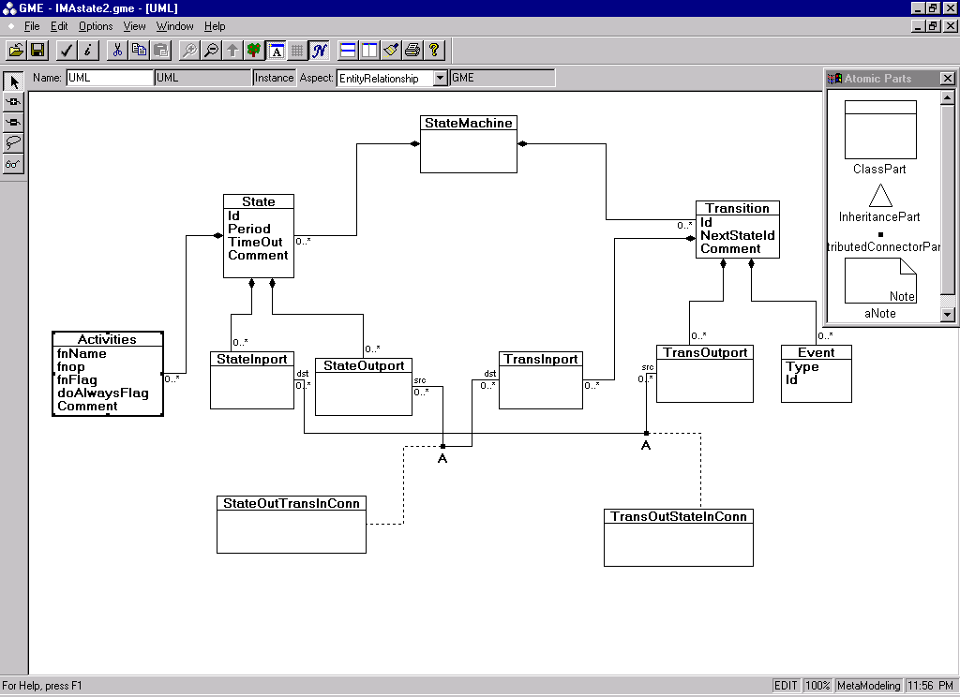
- : Snapshot of the UML diagram: defining the metamodeling environment
Fig. 4 is a snapshot of the UML diagram defining the IMA-MIC (state-transition-modeling) environment. The state machine contains states and transitions, which in turn contain activities and events. The state machine contains states and transitions, which are models. The states contain activities, which are performed, when in that particular state. The transition contains events. These events cause the engine to change the state. If a transition is active, the engine goes to the new state. In GME, models cannot be connected to each other. They have ports as a link in them to enable connections between models. To facilitate the ease of connection they are named related to the models. The state and transition are connected to each other through ports, which highlights the concept of “module interconnect”. [12]

Visual Modeling of Agent Behavior
This IMA-MIC environment is used to specify the behavior of any agent. Fig 5 is a snapshot of the state machine representation. It shows all the various states an agent (Right Camera agent) would possibly be in when this agent is activated. It is more simply explained in the Fig 1.
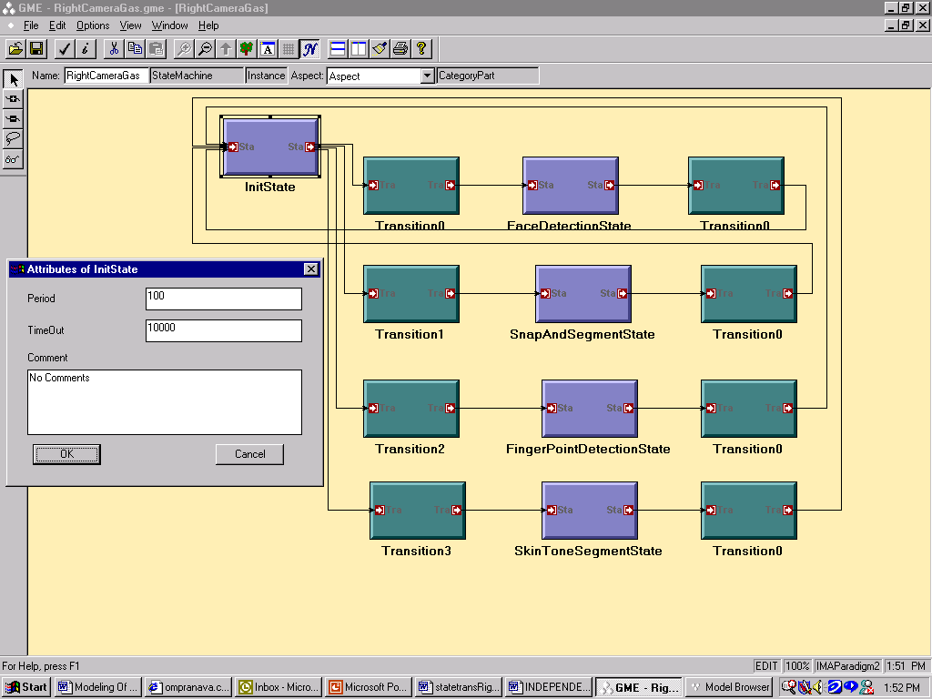
- : Snapshot of the state-machine representation of Right Camera Agent
This figure helps the agent designers to graphically model the agent’s behavior. The states contain activities or triggers. All the information required to build the agent is stored as attributes in these models.
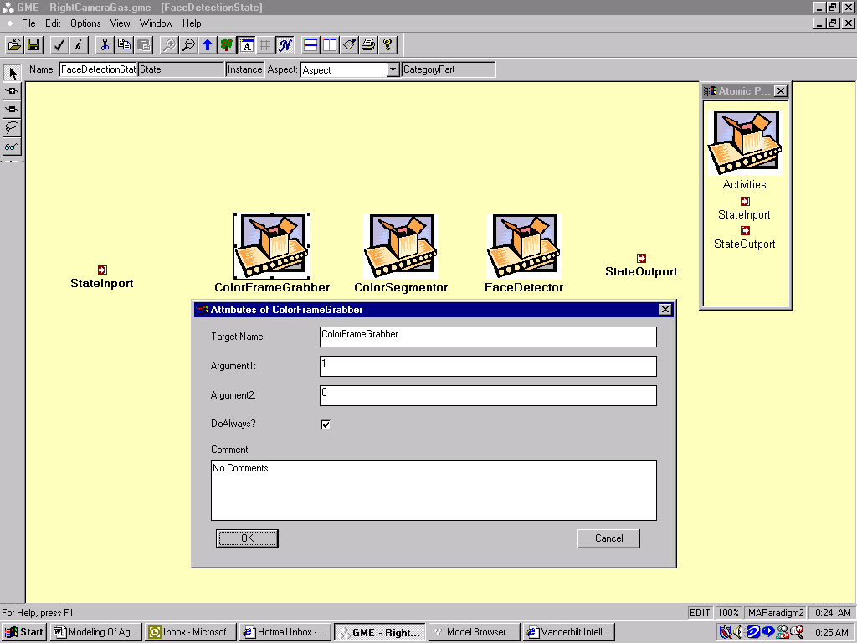
- : Snapshot of the inside of the Face Detection State model, which contains the activities and its attributes
Fig. 6 shows the activities contained inside FaceDetectionState, which has the attributes as mentioned in the implementation section. It has ColorFrameGrabber as a mechanism, which takes in two arguments: operator and a flag. This activity will be processed during the entire period specified in the FaceDetectionState because its DoAlways flag is selected. It also shows the atomic part selection box, from which we can drag and drop any of the atomic parts: Activities, StateInport or StateOutport.
The transition contains events, which have attributes, event type and event id. The attributes of a transition are shown in the snapshot.
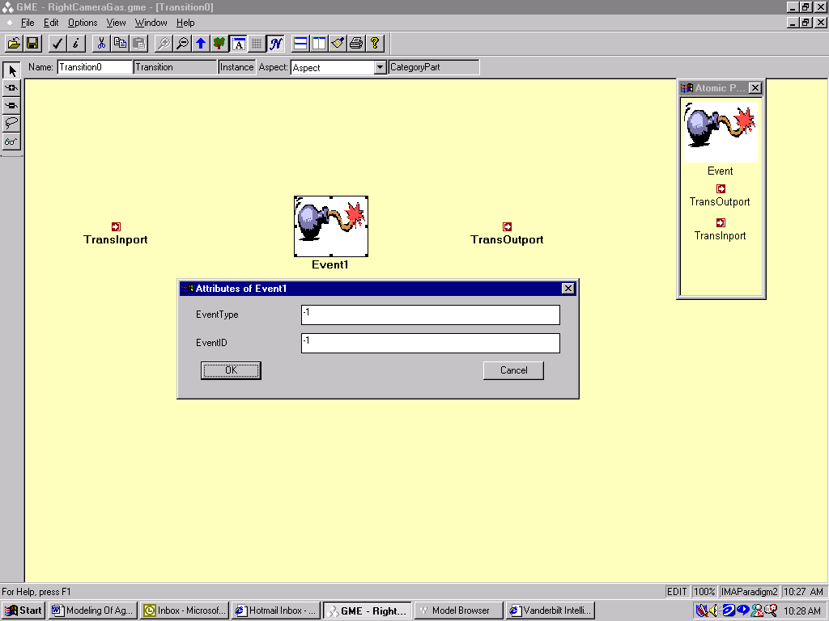
- : Snapshot of the inside of the Transition model, containing an event and its attributes
Fig. 7 shows the event inside Transition0 and the attributes of the event. The attributes of event: event id and event type describes which event is fired and the next state depends on this information. It also shows the atomic part selection box, from which we can drag and drop any of the atomic parts: event, transitioninport or transitionoutport.

Semantic Meaning of these models
The interpreter interface enables model interpreters to be written in any language that supports COM. The interface allows full access to the models, to extract information or to modify them. The interpreter is implemented as a dynamic link library (DLL). The model of the finite state machine of an agent is built. The models are semantically made meaningful by the interpretation. The model of the state machine is interpreted semantically to generate the necessary file to build the agent. This would involve the extraction of behavioral information and semantic translation of these models to create COM objects. Contained within the interpreter is an understanding of how to build COM objects.
A state model is interpreted as a COM object and so are the transition model, event atom, and activity atom. After the interpreter has successfully created these COM objects, the attributes and the data are serialized into a binary formatted file. This file is used by the Agent Builder Software to complete the process of agent building. The detailed explanation of how the interpreter is coded is beyond the scope of this paper.

Future Work
The design of the behavior and structure of the agent is an iterative process. Handwritten code must be minimal. The structure and behavior of an agent should be modeled graphically using the MIC concept. Agent will have two aspects: structural and behavioral. Designing both aspects of the agent model and just interpret them to generate the code would give birth to a “Visually Modeled IMA”, which would interact with runtime environment and also graphically simulate the actual behavior of ISAC.

Conclusion
Designers need to be able to rapidly prototype agent behaviors, refine and enhance their behavior, integrate those behaviors with other behavior and analysis tools and evolve their behaviors over time. A design environment for agent behavior can provide the designer with proper amounts of feedback regarding the use of languages to model the behavior. MIC presents a very good solution for modeling agent-based distributed behavior, giving the domain experts freedom to exploit different situations concerning the HRI. We are developing an IMA-MIC environment based on the humanoid robot interaction and the GME modeling environment. This environment will allow agent builders to model behavior using the state-transition modeling environment (IMA-MIC), which would decrease the time spent on modeling an agent behavior and increase the quality of design. The domain experts, the researchers at IRL, have shown interest in this tool after using the prototype and are very excited about using the fully developed tool in the near future.
References:

- Ledeczi A., Maroti M., Karsai G., Nordstrom G.: "Meta-programmable Toolkit for Model-Integrated Computing", Proceedings of the Engineering of Computer Based Systems (ECBS) Conference, pp. 311-317, Nashville, TN, March, 1999.
- Peters II, R. A., Wilkes, D.M., Gaines, D. M., and Kawamura, K.: “A Software Agent Based Control System for Human-Robot Interaction” Proceedings of the Second International Symposium on HUmanoid RObots (HURO’99), October 8-9,1999, Tokyo, Japan.
- Alford, W.A., Rogers, T., Wilkes, D. M., and Kawamura, K.: “Multi Agent System for a Human-Friendly Robot” Proceedings of the 1999 IEEE International Conference on Systems, Man, and Cybernetics (SMC ’99), pp.1064-1069, October 12-15,1999, Tokyo, Japan.
- Sztipanovits, J., et al: “MULTIGRAPH: An Architecture for Model-Integrated Computing,” Proceedings of the IEEE ICECCS’95, pp.361-368, Nov. 1995.
- Kawamura, K., Alford, A., Hambuchen, K., Wilkes, M.,: “Towards a Unified Framework for Human-humanoid Interaction” ,In Proceedings of the first IEEE-RAS International Conference on Humanoid Robots (in submission), September 2000
- K. Kawamura, R.A. Peters II, D.M. Wilkes, W.A. Alford, T.E. Rogers, "Towards Interactive Human-Humanoid Teaming: Foundations and Achievements", IEEE Intelligent Systems Magazine (submitted for publication), July 2000
- Ledeczi A.: "Model Construction for Model-Integrated Computing", Proceedings of the 13th International Conference on Systems Engineering, pp. CS103-108, Las Vegas, NV, August. 1999.
- Nordstrom, G., Sztipanovits, J., Karsai, G.: "Metalevel Extension of the MultiGraph Architecture", Proceedings of the IEEE ECBS'98 Conference, pp. 61-68, Jerusalem, Israel, April. 1998.
- Sztipanovits J., Karsai G., Franke H.: "Model-Integrated Program Synthesis Environment", Proceedings of the IEEE Symposium on Engineering of Computer Based Systems, pp. 348-355, Friedrichshafen, Germany, March 11-15, 1996.
- R.T. Pack, D. M. Wilkes, G. Biswas, and K. Kawamura, "Intelligent Machine Architecture for Object-Based System Integration", Proceedings of the 1997 IEEE/ASME International Conference on Advanced Intelligent Mechatronics, Waseda University, Japan, June 1997.
- R.T. Pack, D.M. Wilkes, and K. Kawamura, "A Software Architecture for Integrated Service Robot Development", 1997 IEEE Conf. On Systems, Man, and Cybernetics, Orlando, pp. 3774-3779, September 1997.
- Rice, M.D. and Seidnam, S.B.,”A formal model for Module Interconnection Languages”, IEEE Transaction of Software Engineering, Vol 20, No.1, pp.88-100, January 1994.
- Minsky, M., The society of Mind. Simon and Schuster, Inc., New York, NY, 1985.
- L. Li, A. Forin, G. Hunt and Y. Wang, "High-Performance Distributed Objects over a System Area Network," Usenix NT Symposium, 1999
- Yi-Min Wang, O.P. Damani, and Woei-Jyh Lee, "Reliability and Availability Issues in Distributed Component Object Model (DCOM)," Fourth Int'l. Workshop on Community Networking Proc., IEEE, New York, NY, 1997, pp. 59-63.
- Jones, S.P.; Meijer, E.; and Leijen, D., "Scripting COM components in Haskell," Proceedings Fifth International Conference on Software Reuse, IEEE, Los Alamitos, CA, 1998, pp. 224-233.
- Rumbaugh, J., Jacobson, I., Booch, G., The Unified Modeling Language Manual, Addison-Wesley Longman, Inc., Reading, Massachusetts, 1999

